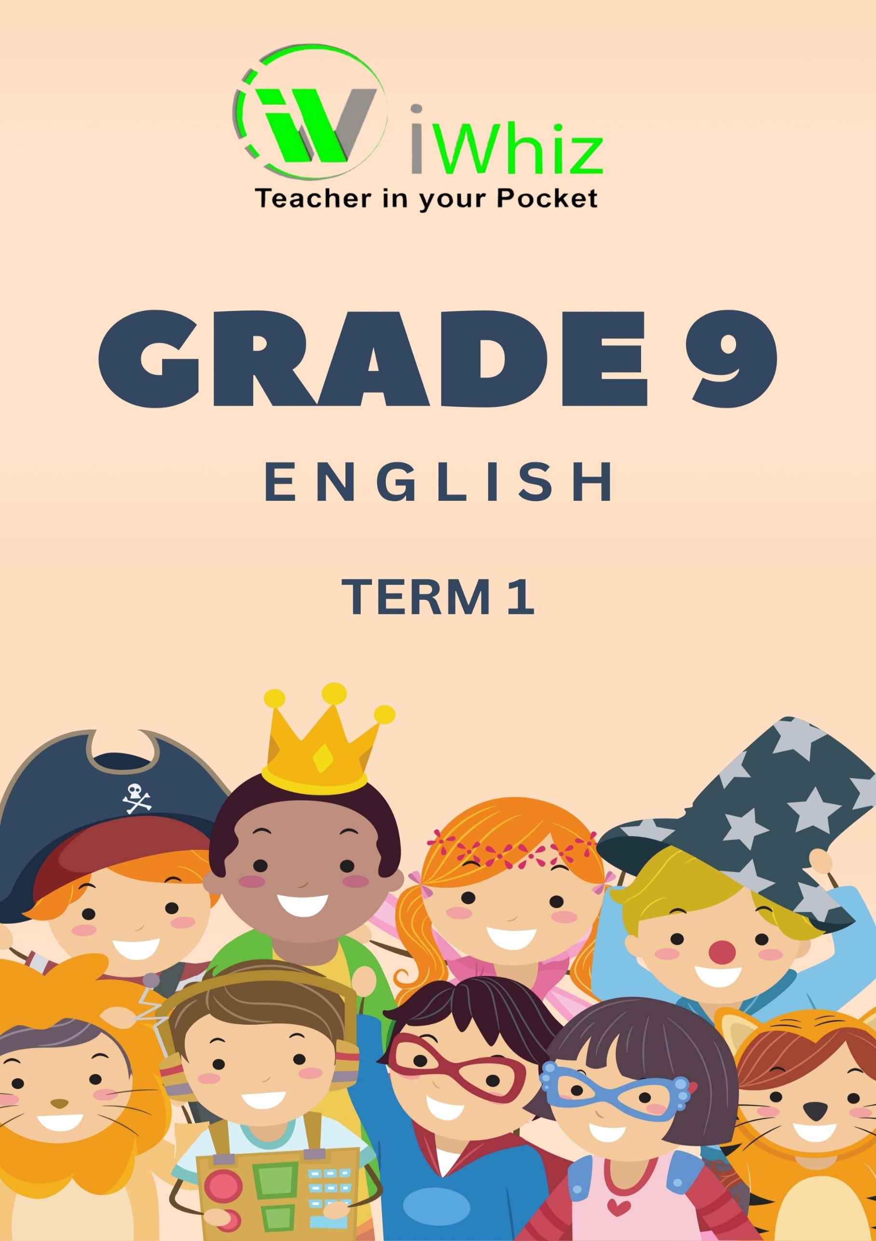



https://www.youtube.com/watch?v=SJ4_nONtYeY
WATCH FOR TESTIMONIALS

WATCH FOR TESTIMONIALS

Grade 9
Marks: 60 Time: 1 Hour

INSTRUCTIONS AND INFORMATION

- This question paper consists of THREE sections:
- SECTION A: Comprehension
- SECTION B: Summary
- SECTION C: Language Structures and Conventions
- Read ALL the instructions carefully.
- Answer ALL the questions.
- Pay special attention to spelling and sentence construction.
- Write neatly and legibly.

Section 1: Comprehension
Read the passage below and answer the questions that follow.
THE STRENGTH WITHIN
Lebo had always dreamed of becoming a doctor. Growing up in a small village, she witnessed how a lack of medical care affected her community. Determined to make a difference, she studied hard despite many challenges. Some nights, she had to complete her homework by candlelight because of power outages, but she never let those obstacles stop her.
When she reached high school, things became even more difficult. Her father lost his job, and her family struggled financially. There were days when she went to school hungry, but she remained focused. Instead of giving up, she sought help from her teachers and spent extra hours in the library. "Hard times don’t last, but strong people do," her grandmother always reminded her.
Finally, her perseverance paid off. She graduated at the top of her class and received a scholarship to study medicine. As she stood on the stage during her graduation ceremony, she looked at her proud family and knew that all the struggles had been worth it. She was ready to go back to her village and change lives, just as she had always dreamed.

Questions:
  - Provide a suitable title for the passage. (1)

1.2 What is the main idea of the passage? (2)

1.3 Explain, in your own words, what happens in paragraph 2. (2)

1.4 Identify and explain the tone of the passage. (2)

1.5 What does the word "resilient" mean in the context of the passage? (2)

1.6 Rewrite the following sentence in the passive voice:
"The students completed the project on time." (2)

1.7 Find an example of figurative language in the passage and explain its effect. (2)

1.8 What is the purpose of this passage? Choose ONE: to inform, entertain, persuade, or instruct. (1)

1.9 Identify and explain the main conflict in the passage. (2)

1.10 Summarise the passage in two sentences. (3)

TOTAL SECTION A: 20 MARKS
Section B: Summary
Read the following passage and summarise it in 5 sentences.
PLANNING AN EVENT
The first and most important step in planning a successful event is to think carefully about why you want to host it and what you want to achieve. Make sure that all the steps you take lead to the goals and objectives.

Any event takes an intensive team effort to handle all of the details. Allocate roles and responsibilities early on in the process. There are many areas to cover, details to attend to and decisions to make – someone needs to do it.

Give yourself enough time! Ideally, you should have four to six months to plan, depending on the nature of the event. Your event's date will have a big impact on how many people will attend. Keep public holidays, long weekends and school holidays in mind.

When you choose a venue, look at the options from your guests' viewpoint. Make sure that the location is safe and well lit, easily accessible and with plenty of parking.

Costs can spiral out of control when you do not stay within a budget. Think about how much you can afford to spend on this event and ask yourself if this budget will allow you to achieve your objectives.

Some events might need the use of microphones, lighting and computers for them to be successful. Test all technical equipment before the time to avoid a last-minute rush.

If you decide to serve food at your event, ensure that you respect cultural and religious variations; also accommodate those with special dietary requirements.
[Adapted from Macmillan Year Planner, 2017]

Instructions:
- Your summary should have five sentences only.
- Use your own words as far as possible.
- Do not include examples, opinions, or unnecessary details.
- Write in full sentences.
- Your summary must be in point form.

Summary writing:

TOTAL SECTION B: 10 MARKS

Section C: Language Structures and Conventions
3.1 Identify the part of speech of the underlined words:
a) The excited crowd cheered loudly. (1)

b) The students carefully completed their work. (1)

c) He bought a huge cake for his birthday. (1)

d) They ran quickly to catch the bus. (1)

e) She has a great love for music. (1)

3.2 Rewrite the following sentence in reported speech: (2)
"I love reading novels," said Thandi.

3.3 Rewrite the following sentence in the future tense: (1)
She walked to school every day.

3.4 Correct the subject-verb agreement in the sentence below: (1)
The team of players are ready for the match.

3.5 Choose the correct homophone: (1)
a) The book is over (there/their/they're).

3.6 Punctuate the following sentence correctly: (2)
thabo said i will meet you at sams house at 4 pm
3.7 Combine the following sentences into one sentence using a conjunction: (1)
She was tired. She continued working hard.

3.8 Identify the main clause in the following sentence: (1)
Although it was raining, they played soccer outside.

3.9 Convert the following active sentence into passive voice:(1)
The chef prepared a delicious meal.

TOTAL SECTION C: 30 MARKS

