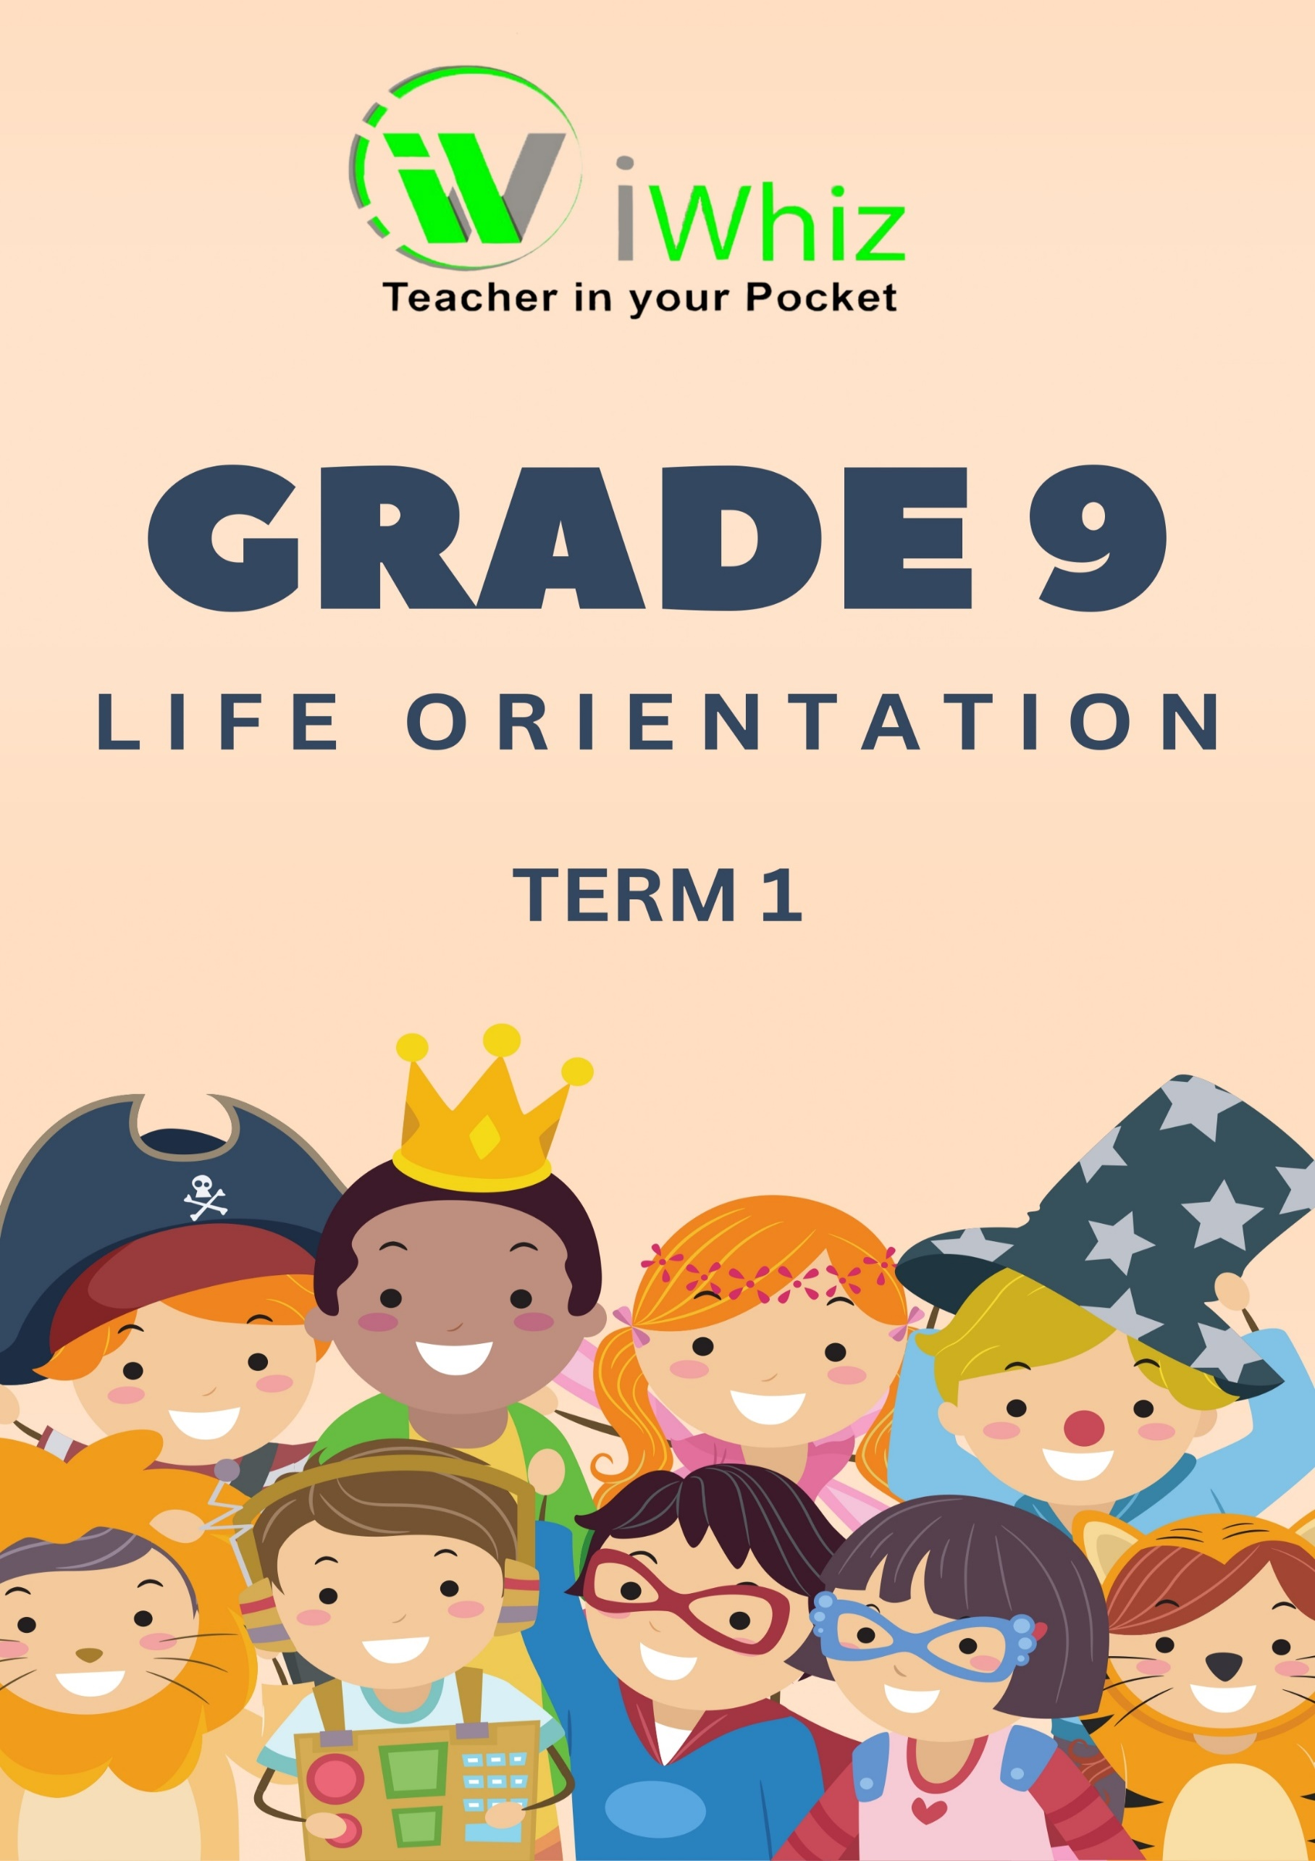



https://www.youtube.com/watch?v=SJ4_nONtYeY
WATCH FOR TESTIMONIALS

WATCH FOR TESTIMONIALS

Section A
Question 1
Choose the correct answer

- Which of the following is NOT a factor that influences personal lifestyle choices?
A. Media
B. Weather
C. Family
D. Peers

- Assertiveness in decision-making means:
A. Allowing others to make choices for you
B. Being confident and firm in your decisions
C. Ignoring advice from others
D. Changing your mind based on pressure from friends

- A positive way to manage time effectively is to:
A. Avoid planning your day
B. Procrastinate tasks until the last minute
C. Set priorities and follow a schedule
D. Work without taking breaks

- Which of the following is a protective factor against risky sexual behaviour?
A. Peer pressure
B. Substance abuse
C. Abstinence
D. Engaging in multiple relationships

- Which of the following is an adverse consequence of teenage pregnancy?
A. Increased independence
B. Emotional and financial struggles
C. More free time to socialise
D. Decreased responsibility

- Which of the following is NOT a protective factor against teenage pregnancy?
A. Abstinence
B. Education about contraception
C. Peer pressure to engage in sexual activity
D. Good family support

- The best way to make an informed decision is to:
A. Listen only to your friends
B. Consider the pros and cons before deciding
C. Do what is easiest
D. Follow what social media suggests

- A sexually transmitted infection (STI) is:
A. A disease spread through unprotected sexual contact
B. A disease caused by poor hygiene
C. Only caused by bacteria
D. Not preventable

- What is the best way to deal with negative peer pressure?
A. Be assertive and say "no"
B. Do what your friends say
C. Ignore your feelings
D. Follow the group to avoid conflict

- How can keeping a journal help with personal development?
A. It improves writing and reflection skills
B. It helps one become famous
C. It is only useful for schoolwork
D. It has no benefits
(10)
Question 2
Match the terms in Column A with their correct description in Column B. Write only the letter (A–J) next to the number.

Column A |  | Column B
- Goal-setting |  | A. The ability to resist negative influences confidently
- Time management |  | B. Disease spread through unprotected sexual contact
- Assertiveness |  | C. A process of setting targets for personal growth
- Peer pressure |  | D. Helps in developing habits of planning and reflection
- Abstinence |  | E. Making decisions based on the influence of others
- Sexual health |  | F. The ability to organize and complete tasks efficiently
- Community support |  | G. A commitment to avoiding risky sexual activity
- Self-discipline |  | H. A condition that affects emotional, social, and physical well-being
- STIs |  | I. Ability to control one's actions and make wise choices
- Journal keeping |  | J. Groups that provide help and guidance to individuals in need

(10)
TOTAL SECTION A: 20 MARKS

Section B
Question 3
  - Explain three factors that influence personal lifestyle choices. (3)

3.2 Why is assertiveness important when dealing with peer pressure? (3)

3.3 Identify three strategies to deal with unhealthy sexual behaviour. (3)
3.4 Discuss three negative consequences of teenage pregnancy for both the mother and child. (3)

3.5 How can time-management skills help you become more accountable? (3)

3.6 List three benefits of keeping a journal. (3)

3.6 Read the scenario below and answer the questions that follow:
Lebo is a Grade 9 learner who struggles to complete assignments on time because she spends too much time on social media. As a result, she often submits her work late and feels stressed about deadlines.

3.6.1 Identify the problem Lebo is facing. (1)

3.6.2 Suggest two ways Lebo can manage her time better. (2)

3.6.3 How can poor time management affect Lebo’s academic performance? (1)

3.7 Read the following statement and answer the questions:
Many teenagers engage in unhealthy sexual behaviour because of peer pressure and lack of information. However, making responsible choices can prevent negative consequences.

3.7.1 Identify two risk factors that lead to unhealthy sexual behaviour. (2)

3.7.2 Explain two ways teenagers can protect themselves from these risks. (2)

3.8 You are asked to advise a friend who is struggling with peer pressure to engage in unhealthy activities.
3.8.1 What advice would you give them to handle this situation? (2)

3.8.2Name two support systems they can reach out to. (2)

TOTAL SECTON B: 30 MARKS

