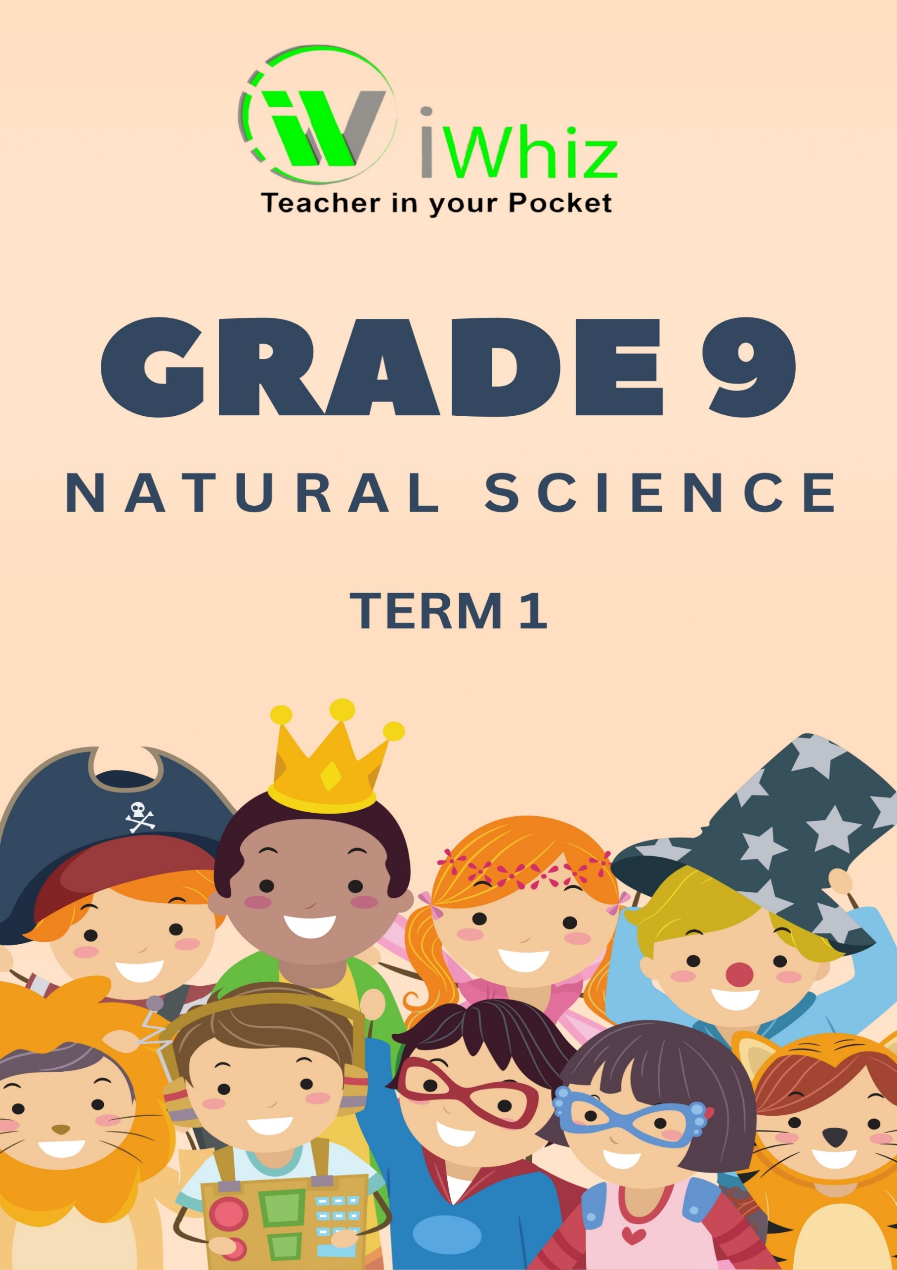



https://www.youtube.com/watch?v=SJ4_nONtYeY
WATCH FOR TESTIMONIALS

WATCH FOR TESTIMONIALS

50 Marks
INSTRUCTIONS
- Read all the questions carefully before you start answering.
- Write neatly and legibly in the spaces provided.
- Answer all questions. Attempt every question, even if you are unsure.
- Use a blue or black pen for written answers and a pencil for drawings and diagrams.
- Label all diagrams clearly if required.
- If you make a mistake, neatly cross it out and write the correct answer.
- Manage your time well. Check your answers before submitting.
- No cell phones, textbooks, or notes are allowed during the test.
- When you’re finished, review your work to ensure accuracy.

Section A
Question 1
1.1 The basic unit of life is the:
A. Organ
B. Tissue
C. Cell
D. System

1.2 Which system is responsible for transporting oxygen in the body?
A. Respiratory system
B. Digestive system
C. Circulatory system
D. Nervous system

1.3 The male reproductive cell is called a:
A. Ovum
B. Sperm
C. Zygote
D. Embryo

1.4 The function of red blood cells is to:
A. Transport oxygen
B. Fight infections
C. Produce hormones
D. Filter waste

1.5 Digestion starts in the:
A. Stomach
B. Small intestine
C. Mouth
D. Liver
1.6 The organ that produces digestive enzymes and regulates blood sugar levels is the:
A. Stomach
B. Pancreas
C. Liver
D. Small intestine

1.7 Which gas is inhaled during breathing?
A. Carbon dioxide
B. Oxygen
C. Nitrogen
D. Hydrogen

1.8 Which part of the heart pumps oxygenated blood to the rest of the body?
A. Left atrium
B. Right atrium
C. Left ventricle
D. Right ventricle

1.9 The process by which food is broken down into smaller pieces and absorbed into the blood is called:
A. Circulation
B. Digestion
C. Respiration
D. Excretion

1.10 Which type of blood vessel carries oxygen-rich blood away from the heart?
A. Veins
B. Arteries
C. Capillaries
D. Nerves
(10)
Question 2
(Match COLUMN A with the correct answer in COLUMN B by writing only the correct letter next to the number.)
COLUMN A (Structure or Function) |  | COLUMN B (Description)
2.1.1 Alveoli |  | A. Carries oxygenated blood
2.1.2 Small Intestine |  | B. Produces sperm cells
2.1.3 Arteries |  | C. Tiny air sacs in the lungs
2.1.4 Testes |  | D. Absorbs nutrients into the bloodstream
2.1.5 White Blood Cells |  | E. Helps in fighting infections
2.1.6 Trachea |  | F. Pumps blood throughout the body
2.1.7 Red Blood Cells |  | G. Tube that carries air to the lungs
2.1.8 Large Intestine |  | H. Transports oxygen in the blood
2.1.9 Alveoli |  | I. Absorbs water from digested food
2.1.10 Heart |  | J. Tiny sacs in the lungs where gas exchange occurs

TOTAL SECTION A: 20 MARKS

Section B
Question 3
3.1 Name two differences between plant cells and animal cells. (2)

3.2 Identify the part of a cell that:
a) Controls cell activities. (1)

b) Provides energy for the cell. (1)
c) Controls what enters and leaves the cell. (1)

3.3 Explain the function of the following reproductive organs:
a) Ovaries (1)

b) Uterus (1)

3.4 State one physical change that occurs in males and females during puberty. (2)

3.5 What is fertilization? (1)

3.6 Arrange the following digestive organs in the correct order in which food passes through: (2)
stomach, mouth, small intestine, oesophagus, large intestine
3.7 Name the digestive juice that helps break down fats. (1)

3.8 What is the main function of the large intestine? (2)

[25]

Question 4
4.1 Label the following parts in the diagram of the human heart. (6)
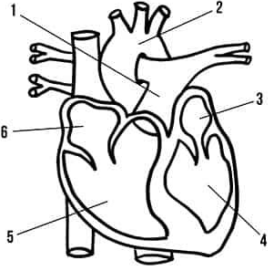

4.2 Explain the difference between veins and arteries. (3)

4.3 Describe the process of gas exchange in the alveoli. (2)

4.4 If a person is running, explain why their heart rate increases. (1)

4.5 Name two harmful effects of smoking on the respiratory system. (3)

[15]
TOTAL SECTION B: 30 MARKS

