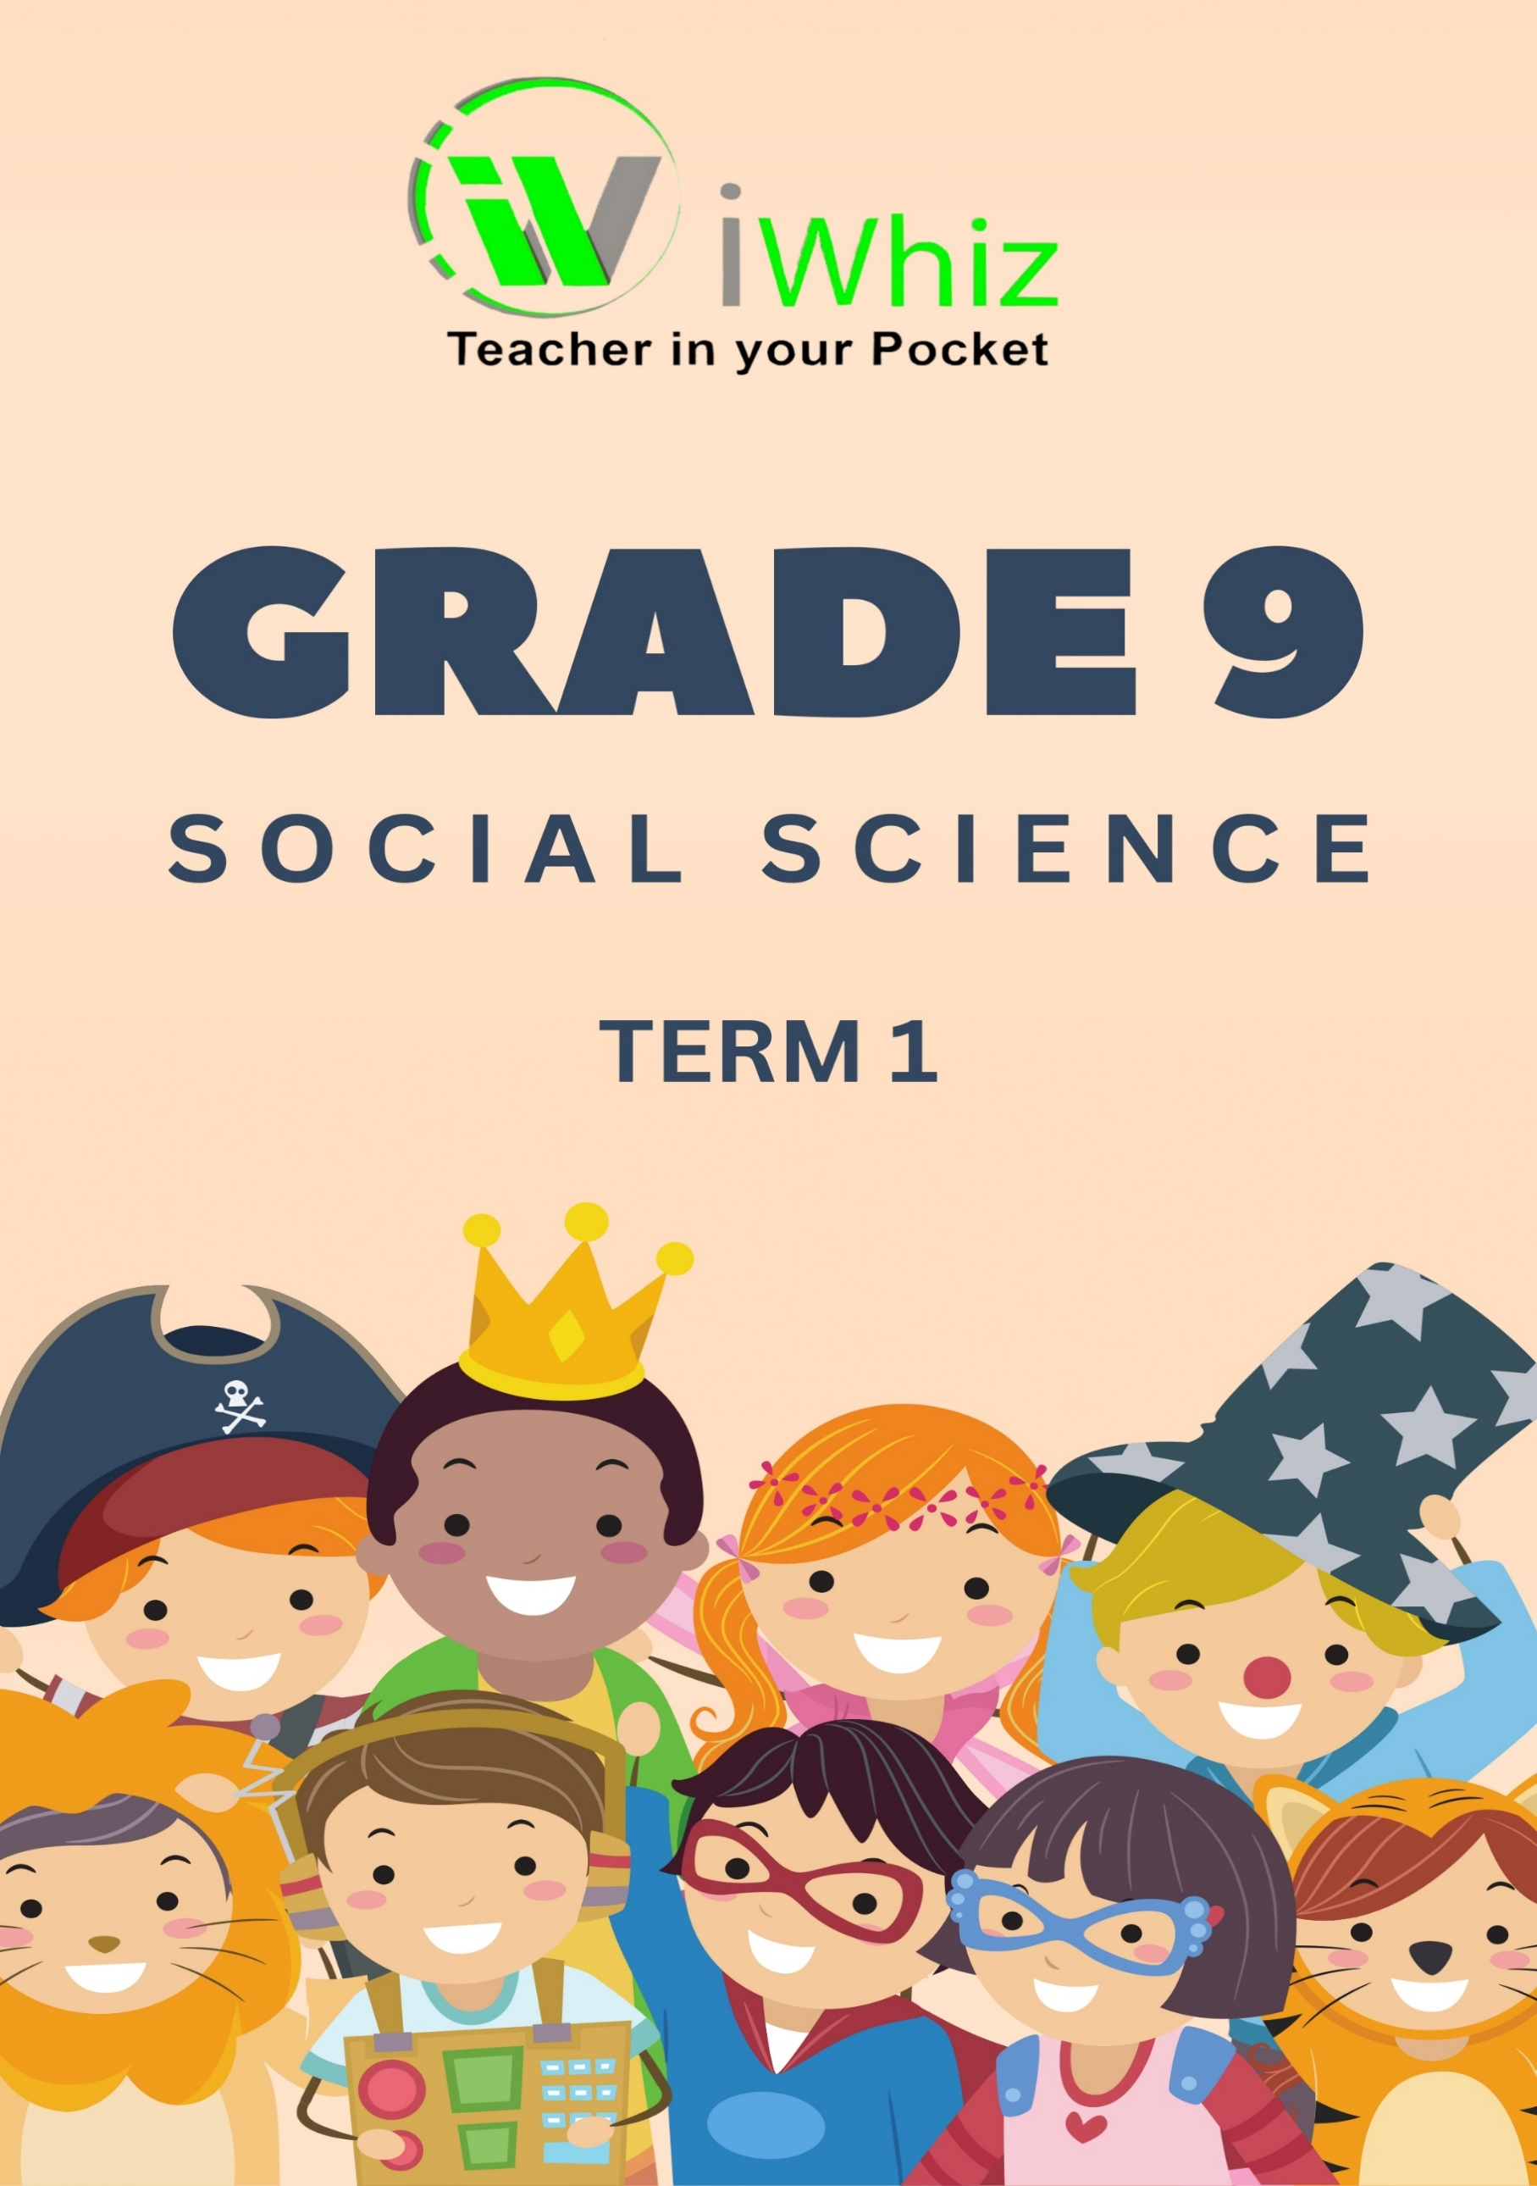



https://www.youtube.com/watch?v=SJ4_nONtYeY
WATCH FOR TESTIMONIALS

WATCH FOR TESTIMONIALS

Section A
Question 1
Read the following questions and circle the correct letter.
- Which event started World War I?
- Germany’s invasion of Poland
- Germany’s invasion of Italy
- Germany’s invasion of Britain
- Germany’s invasion of Austria

- Contour lines are lines on a map joining places of the same …
- Rainfall
- Altitude
- Cloud cover
- Wind speed

- When did World War II begin and end?
A. 1919 and 1945
B. 1929 and 1955
C. 1939 and 1945
D. 1949 and 1975

- What is the term for the difference in elevation between two adjacent contour lines?
A. Gradient
B. Interval
C. Scale
D. Aspect

- Lebenstraum means…
- The struggle
- Living space
- Air force
- Dictator

- What is the scale of a 1:10,000 orthophoto map?
A. 1 cm on the map represents 100 meters in reality
B. 1 cm on the map represents 1,000 meters in reality
C. 1 cm on the map represents 10 meters in reality
D. 1 cm on the map represents 10 kilometres in reality

- The Axis Alliance consisted of:
- Germany
- Italy
- Japan
- All of the above

- Which of the following is typically shown on a 1:50,000 topographic map?
A. Detailed Street names and building heights
B. Elevation contours, rivers, and roads
C. Satellite images
D. Local traffic conditions

- The Allied Powers consisted of:
- Britain
- France
- Poland
- All of the above

- Which of the following is a type of map projection?
A. Orthophoto
B. Mercator projection
C. Elevation map
D. Digital elevation model

(10)

Question 2
Match the terms in COLUMN A with the correct definition in COLUMN B. Write only the correct letter (A–E).
Column A | Column B
- Contour lines | A. A significant turning point in WWII when Germany was defeated in Russia
- 1:10,000 Orthophoto map | B. A surprise attack by Japan on the United States in 1941
- 1:50,000 Topographic map | C. A map that includes roads, rivers, and contour lines
- Steep terrain | D. The leader of Nazi Germany during WWII
- Aerial photograph | E. Used to influence public opinion in support of the Nazi regime
- Adolf Hitler | F. A map with a scale where 1 cm represents 100 meters in real life
- Battle of Stalingrad | G. A type of map that uses corrected aerial photographs to show detailed images of the area
- Pearl Harbor | H. A map that represents the elevation of land and shows landforms
- Nazi Propaganda | I. When contour lines are close together
- Battle of Midway | J. A battle where Allied forces defeated Japan in the Pacific in 1942

- _________________________________________________________________________________
- _________________________________________________________________________________
- _________________________________________________________________________________
- _________________________________________________________________________________
- _________________________________________________________________________________
- _________________________________________________________________________________
- _________________________________________________________________________________
- _________________________________________________________________________________
- _________________________________________________________________________________
- _________________________________________________________________________________
(10)
Section B
Question 3: Geography
3.1 A topographical map of Johannesburg South
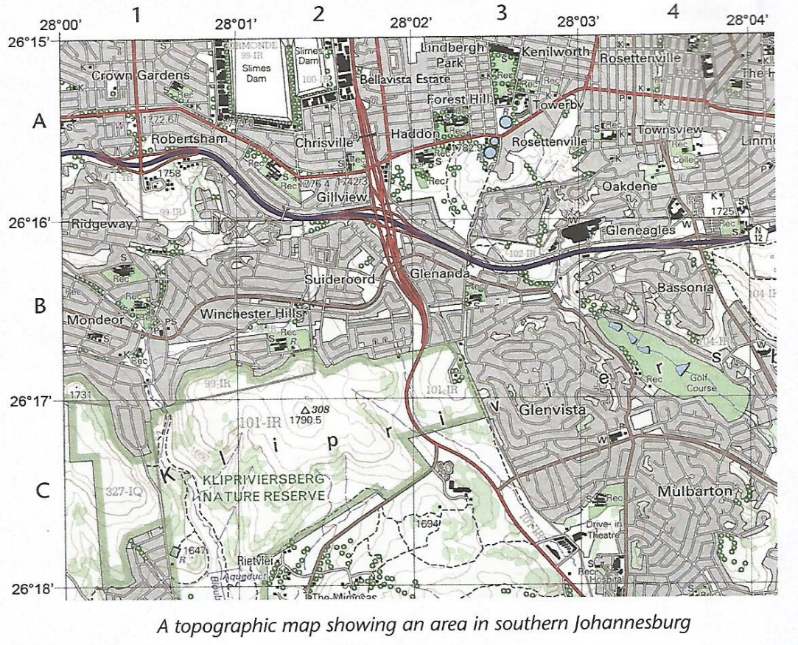
    - A topographical map of Johannesburg South (2)

3.1.2 Which feature can be used for entertainment in the southwest part of the map? (1)

3.1.3 Between Rosenttenville and Murlbaton which area is an upmarket area? (2)
3.2 Refer to the sketch below and answer the questions below:
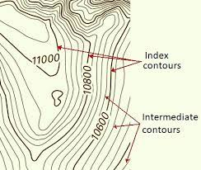
3.2.1 Distinguish the difference between the Index and Intermediate (4)
Index contours:

Intermediate Contours:

3.3 Define the following concepts:
- Photograph (2)

- Orthophoto map (2)
- Texture (2)

Question 4: History
4. 1 Describe the role of the Soviet Union in the defeat of Nazi Germany. (2)

4.2 Study the image below and answer the questions that follow.
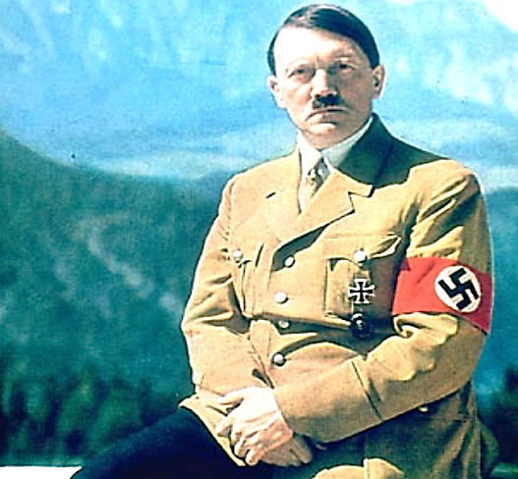
4.2.1 Who is the man in the picture above? (1)
4.2.2 What was the name of his party? (1)

4.2.3 What did he promise the people of Germany that made him so popular that nearly half the country voted for him? (3)

4.3 Answer these short questions:
4.3.1 Who was the leader of Nazi Germany? (1)

4.3.2 What was the purpose of the Nuremberg Laws? (1)

4.3.3 What event marked the beginning of World War II in Europe? (1)

4.3.4 What was the significance of the attack on Pearl Harbor? (1)

4.3.5 What were the consequences of the atomic bombings of Hiroshima and Nagasaki? (1)

4.4 Describe the causes and consequences of the attack on Pearl Harbor. How did it change the course of the war in the Pacific? (3)

