

GRADE 10 HISTORY – SOURCE-BASED QUESTIONS


https://www.youtube.com/watch?v=SJ4_nONtYeY
WATCH FOR TESTIMONIALS

WATCH FOR TESTIMONIALS

KEY QUESTION: HOW DID SHAKA ZULU EXPAND THE ZULU KINGDOM FROM A MINOR CHIEFDOM TO A DOMINANT POWER BETWEEN 1816 AND 1828?
SOURCE 1A: The Rise of the Zulu Kingdom
The Zulu Kingdom rose to power in the early 19th century under the leadership of Shaka Zulu. Before his rule, the Zulu were a small chiefdom in what is now KwaZulu-Natal. However, through military innovation, diplomacy, and strategic alliances, Shaka transformed the Zulu into a formidable empire.
One of his key strategies was the introduction of new warfare tactics. He replaced the traditional long throwing spear with the short stabbing spear (assegai) and developed the "buffalo horns" formation, which allowed his warriors to encircle and defeat enemies efficiently. His disciplined and well-trained army conquered neighboring chiefdoms, incorporating them into the growing Zulu state.
Despite his success, Shaka's rule was also marked by brutality. Those who resisted were met with severe punishment, leading to the forced migration of many groups. His leadership style and military reforms played a crucial role in shaping the southern African political landscape.
"The Zulu Kingdom: Rise and Expansion" - Author Unknown

SOURCE 1B: A Map of the Zulu Kingdom at its Peak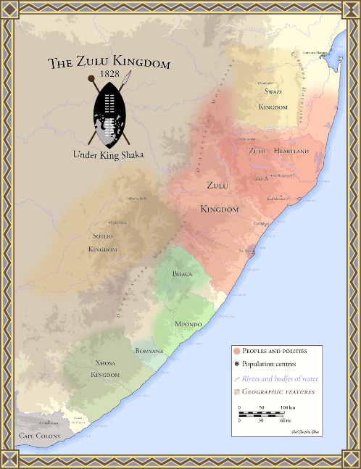
SOURCE 1C: Shaka’s Military and Administrative Reforms
Shaka's leadership transformed the Zulu Kingdom not only through warfare but also through governance. He introduced a centralized administration, appointing trusted leaders to govern newly acquired territories. He reorganized the army, creating regiments (amabutho) that lived and trained together, ensuring loyalty to the king.
He also expanded the use of fortified settlements (amakhanda), where soldiers were housed and trained. His reforms ensured that the Zulu state remained powerful even after his assassination in 1828. Despite his military focus, Shaka also encouraged trade, particularly in cattle, which became a symbol of wealth and power in the Zulu Kingdom.
"Zulu Warfare and Administration," by N. Dlamini

SOURCE 1D: The Absolute Power of Shaka Zulu
Shaka ruled as an absolute monarch, controlling every aspect of Zulu society. His authority was unquestioned, and his decisions shaped the kingdom’s direction. He established a system of tribute, where conquered chiefdoms were required to provide warriors and resources to the Zulu.
His rule was both admired and feared. While he was seen as a unifier of the Zulu nation, his use of extreme discipline and harsh punishments also made him a controversial leader. His policies, particularly his military expansion, led to the period of upheaval known as the Mfecane (the Crushing), which saw widespread displacement across southern Africa.
"The Rule of Shaka Zulu" – Historical Analysis Journal

- Which military innovation, according to the source, did Shaka introduce to improve the effectiveness of the Zulu army? (1 x 1) (1)

- Name two strategies Shaka used to expand the Zulu Kingdom. (2 x 1) (2)

- According to the source, why did many people migrate during Shaka’s reign? (1 x 1) (1)

- Identify two economic activities of the Zulu Kingdom. (2 x 1) (2)

- Which geographical area did the Zulu Kingdom cover at its height? (Refer to Source 1B) (1 x 1) (1)

- Define the concept "absolute monarchy" in your own words. (2)

- Explain why Shaka's military strategy was effective in expanding the Zulu Kingdom. (4)

- Why was cattle important in the Zulu Kingdom’s economy? (2)

- What conclusions can be drawn about Shaka’s leadership style based on Source 1D? (2)

- How did the regimental (amabutho) system help maintain Zulu control over conquered territories? (2)

- Compare Sources 1A and 1C. How does Source 1C support the information given in Source 1A regarding the expansion of the Zulu Kingdom? (4)

- Comment on the reliability of Source 1D for a historian researching Shaka’s rule. (4)
- How did Shaka’s leadership influence southern African history? Use Source 1C and your own knowledge to answer. (2)

- Discuss the impact of the Mfecane on African societies in the early 19th century (2)

- Using the information from the sources and your own knowledge, write a paragraph of six lines (about 60 words) explaining how Shaka expanded the Zulu Kingdom between 1816 and 1828. (6 marks)

ESSAY QUESTION: EUROPEAN EXPANSION AND CONQUEST IN THE 19TH CENTURY – THE BRITISH INVASION OF THE ZULU KINGDOM
The British defeated the Zulu Kingdom in 1879 during the Anglo-Zulu War.
Do you agree with this statement? Support your answer with relevant arguments. [50 Marks]
Essay Guidelines
- Introduction: State your argument and provide context for the Anglo-Zulu War. (5-7 lines)
- Body: Use the PEEL method (Point, Evidence, Explanation, Link) to structure your paragraphs.
- Conclusion: Summarize your argument and reflect on the war’s impact.

ZULU KINGDOM QUIZ – 15 QUESTIONS
- Where was the Zulu Kingdom located?
A: East Africa
B: West Africa
C: Southern Africa
D: North Africa
- Who was the founder of the Zulu Kingdom?
A: Shaka Zulu
B: Cetshwayo
C: Dingane
D: Mpande
- What year did Shaka become king?
A: 1805
B: 1816
C: 1828
D: 1879
- What was the name of Shaka’s famous military formation?
A: Shield Formation
B: Spearhead Formation
C: Buffalo Horns Formation
D: Encirclement Formation
- What event led to the decline of the Zulu Kingdom?
A: The Mfecane
B: The Anglo-Zulu War
C: The Boer Wars
D: The Great Trek
- True or False: The British defeated the Zulu at the Battle of Isandlwana.
- What was the role of the amabutho in Zulu society?
- Who succeeded Shaka after his assassination?
- What weapon replaced the traditional throwing spear in Shaka’s army?
- Which European power invaded Zululand in 1879?
- What was the primary language spoken by the Zulu Kingdom?
A: Xhosa
B: Zulu
C: Swahili
D: Sotho
- What innovation did Shaka introduce to improve the Zulu army’s mobility?
A: Use of horses
B: Lightweight shields
C: Barefoot marching over long distances
D: Camouflaged uniforms
- What was the capital of Shaka’s Zulu Kingdom?
A: Isandlwana
B: Ulundi
C: KwaBulawayo
D: Nongoma
- How did Shaka reform Zulu warfare tactics?
A: He introduced guns from European traders
B: He made soldiers fight individually
C: He created age-based regiments and close-combat fighting
D: He used alliances with other kingdoms to fight battles
- What natural resource was important to the Zulu economy?
A: Gold
B: Cattle
C: Diamonds
D: Iron
(Total: 15 Marks)

