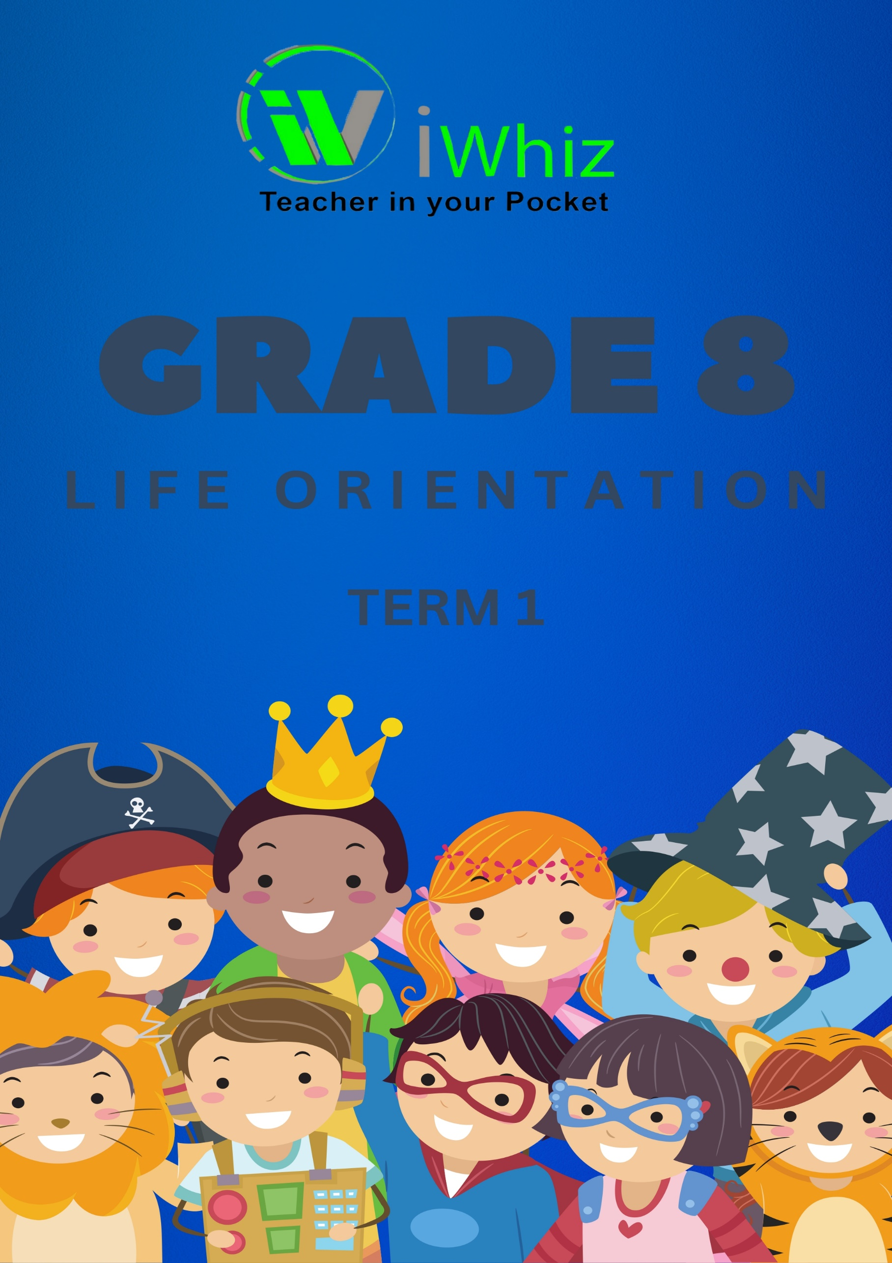

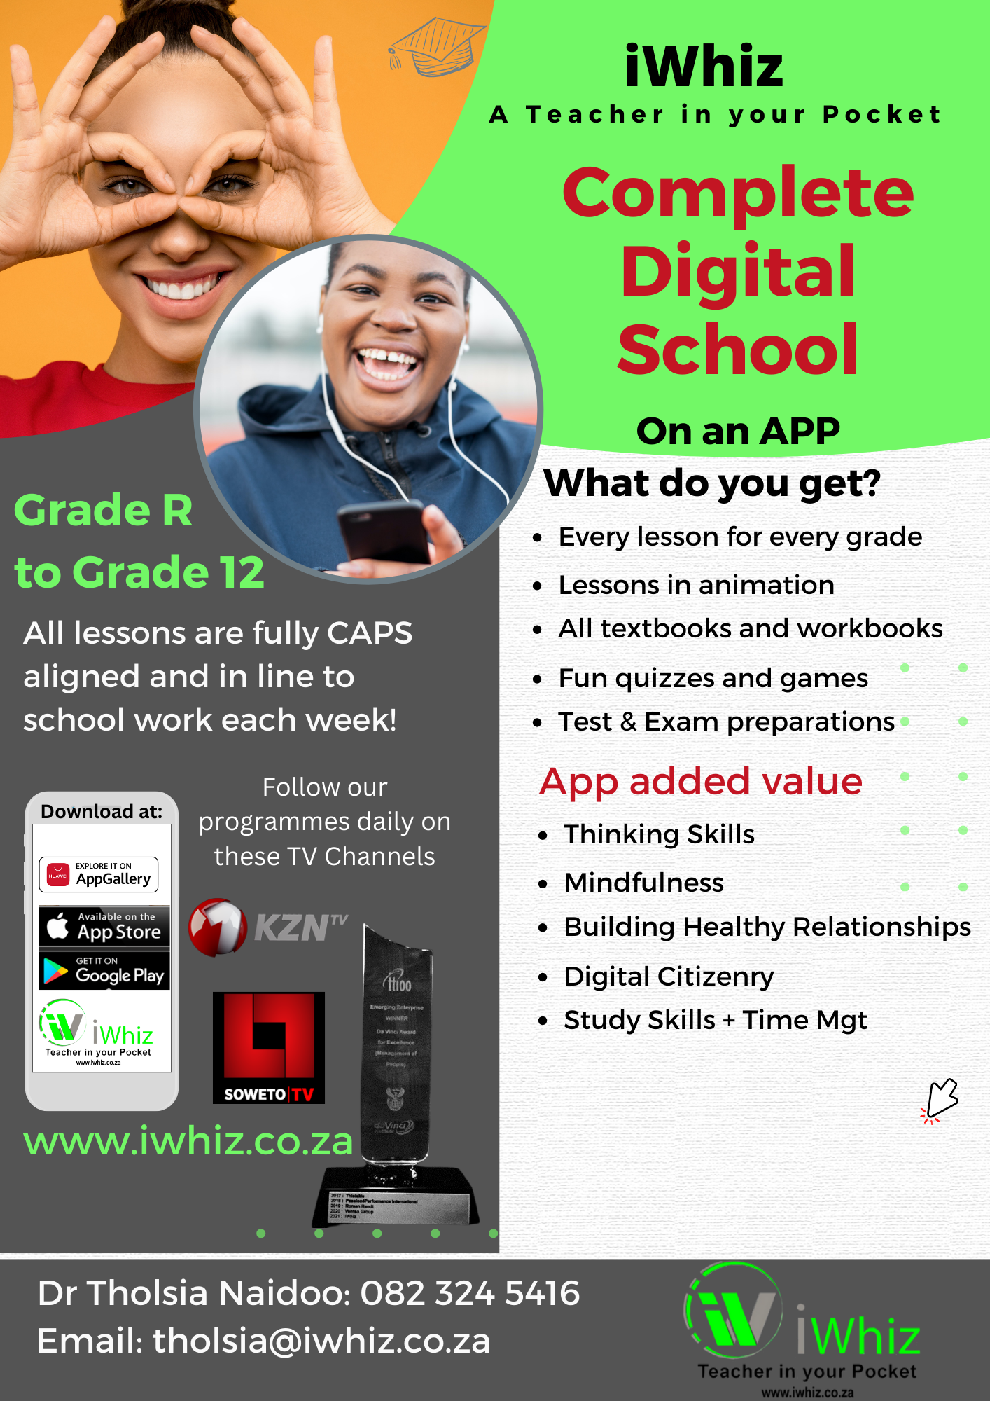

https://www.youtube.com/watch?v=SJ4_nONtYeY
WATCH FOR TESTIMONIALS

WATCH FOR TESTIMONIALS

Grade 8 Life Orientation Term 1 Test
Total: 80 marks
Time: 1 hour 30 minutes

Instructions:
- Answer all the questions.
- Read questions carefully before answering.
- Write neatly and clearly.
- Marks are allocated next to each question.

Section A: Multiple Choice (10 marks)
- Which of the following is a basic human need?
a) A smartphone
b) Shelter
c) Designer clothing
d) Fast food
- Self-awareness means:
a) Understanding your own emotions and thoughts
b) Controlling others’ emotions
c) Ignoring your feelings
d) Copying someone’s personality
- Which of these is an example of a good personal hygiene habit?
a) Brushing teeth twice a day
b) Skipping showers
c) Wearing the same clothes every day
d) Not washing hands after using the toilet
- What is the primary purpose of goal setting?
a) To have fun all the time
b) To have direction and motivation
c) To waste time
d) To impress others
- Peer pressure can be:
a) Only negative
b) Only positive
c) Both positive and negative
d) Never a problem

(5 more multiple-choice questions follow in the same format)

Section B: Short Answer Questions (30 marks)
- Define self-concept and explain how it develops. (4)

- List and describe two positive influences of peer pressure. (4)

- Identify three ways to effectively deal with stress. (3)

- Why is goal setting important in personal development? (3)

- Explain the importance of personal hygiene in maintaining a healthy lifestyle. (4)

- Name and briefly describe four basic human needs. (4)

- What is the difference between self-esteem and self-confidence? (4)

- Give two examples of short-term goals and two examples of long-term goals. (4)

Section C: Case Study (20 marks)
Read the scenario below and answer the questions that follow.
Sipho’s Dilemma
Sipho is a 14-year-old learner who recently joined a new school. He has been trying to make friends, but he feels pressured by some classmates to skip class and participate in activities he knows are wrong. He wants to fit in but also wants to stay focused on his education.
Questions:
14. What challenge is Sipho facing in this scenario? (2)
15. How can Sipho assert himself in a respectful way to say no? (4)
16. What are the possible consequences if Sipho gives in to peer pressure? (4)
17. Suggest three ways Sipho can find positive friends who share his values. (6)
18. Describe a real-life situation where you had to make a tough decision under peer pressure. What did you do? (4)

Section D: Illustration and Application (20 marks)
- Draw and label a diagram showing the five basic human needs according to Maslow’s hierarchy. (10)
(Your diagram should be clear and neatly labeled.)

- Write a short paragraph (5-6 sentences) explaining how a balanced lifestyle affects mental, emotional, and physical well-being. (10)

