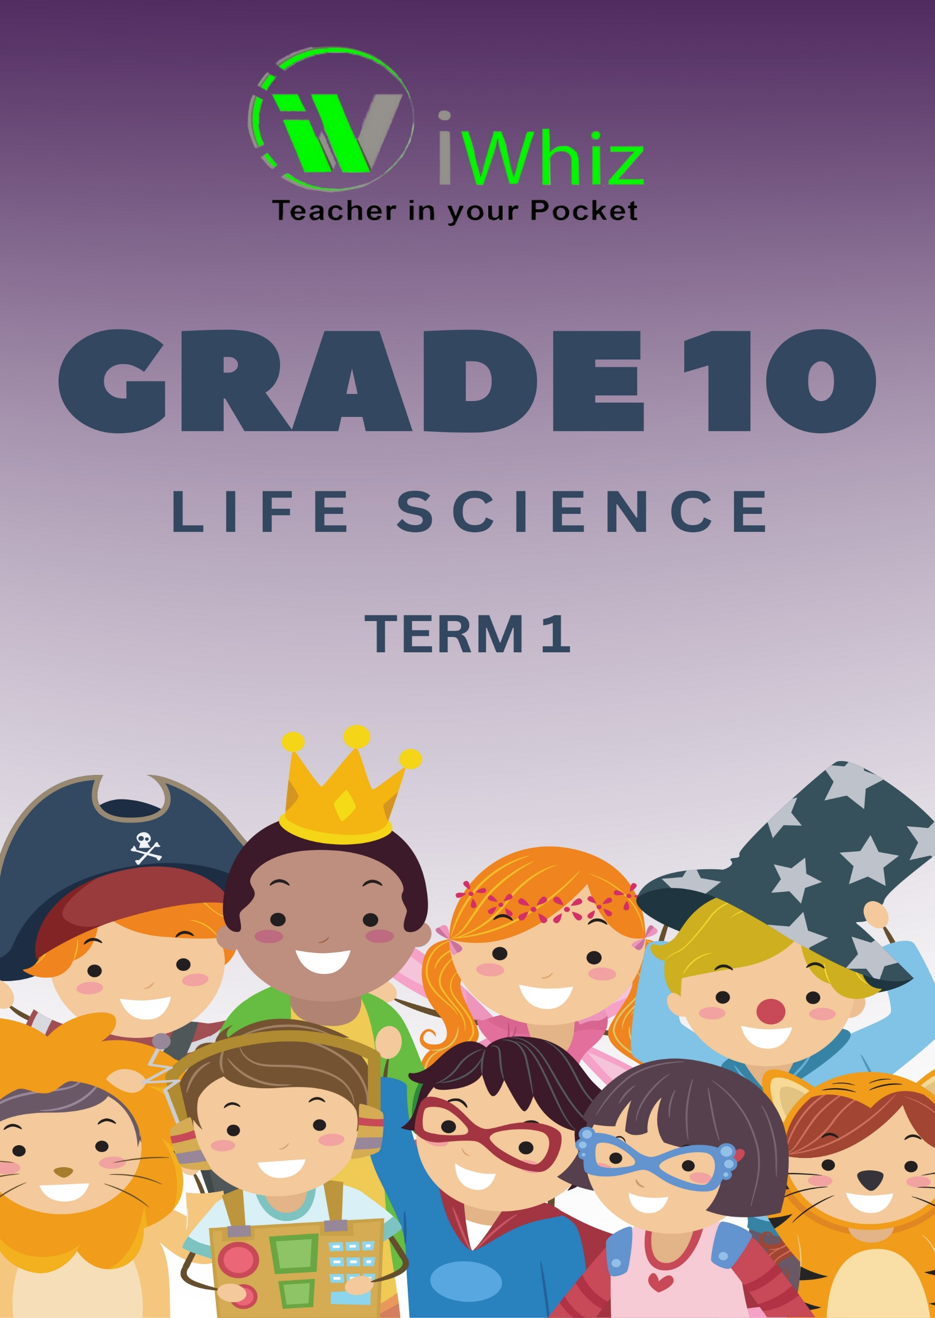


https://www.youtube.com/watch?v=SJ4_nONtYeY
WATCH FOR TESTIMONIALS

WATCH FOR TESTIMONIALS

Marks: 150 Time: 2½ hours
Section A

Question 1
  - Various options are provided as possible answers to the following questions. Choose the correct answer.
    - Which of the following serves as a macronutrient for plants and animals?
      - Iron
      - Phosphorus
      - Iodine
      - Sodium

    - The micronutrient that occurs in thyroxin and causes goitre when deficient is:
      - Magnesium
      - Iodine
      - Iron
      - Sodium

    - Calcium is required by humans to:
      - Assist in the clotting of blood
      - Control the water balance in blood
      - Prevent muscular cramps
      - Produce the hormone thyroxin

    - Proteins differ from carbohydrates in that:
      - They all function as enzymes
      - Some are hormones
      - They all supply the main source of food for energy
      - They all react negatively with Millon’s reagent

    - The vitamin that prevents scurvy is found in:
      - Butter, plant oils and milk
      - Milk, fish liver oil and cheese
      - Citrus fruit, tomatoes and spinach
      - Meat, liver and whole-grain bread

    - All enzymes are:
      - Proteins
      - Inorganic compounds
      - Vitamins
      - Hormones
  - Give the correct biological term for each of the following descriptions.
    - The most important inorganic solvent in nature.

    - An organic nutrient that can serve as an insulating material against cold.

    - A scale of 1 to 14 that indicates the level of acidity or alkalinity of a solution.

    - The monomers that make up proteins.

    - The cell organelle that is concerned with the production of ATP.

    - An organelle in plant cells that store starch.

    - The organic compound that forms the main constituent of the cell walls in flowering plants.

    - An organelle in the cytoplasm of plant cells that is responsible for the bright colour in many flowers.

    - Cells in phloem, which, in addition to companion cells are responsible for the translocation of dissolved food.

    - The mutually attractive force that develops between water molecules in the xylem.

  - Indicate whether each of the statements in Column 1 applies to A ONLY, B ONLY, BOTH A AND B, or NONE of the items in Column 2.

Column 1 | Column 2
1.3.1 Deficiency may cause rickets | - Calcium  - Vitamin D
1.3.2 Process(es) in which enzymes are involved | - Anabolic  - Catabolic
1.3.3 Essential in hydrolytic reactions | - Carbon dioxide  - Water
1.3.4 Used to test for the presence of starch | - Fehling’s solution  - Benedict’s solution
1.3.5 Ratio of hydrogen to oxygen is less than 2:1 | - Carbohydrates  - Lipids
1.3.6 Plays a role in the synthesis of chlorophyll | - Iron  - Magnesium
1.3.7 Deficiency may cause muscular cramps | - Sodium  - Calcium
1.3.8 Plays a role in the clotting of blood | - Vitamin K  - Calcium

[8]

  - The histograms below show the percentages of carbohydrates, fats, proteins and water in eight types of food.
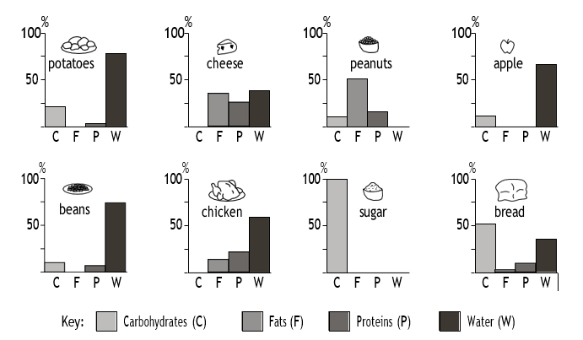

From the histograms name TWO types of food that:
    - Contain more than 25% of a nutrient that is involved in the formation of an insulating layer. (2)

    - Would best help to prevent kwashiorkor (protein – energy malnutrition). (2)

    - Will form only monosaccharides and amino acids after digestion. (2)

    - Are not involved in the formation of cell membranes. (2)

    - Contain more than 50% of a nutrient that is the primary source of energy. (2)

  - Study the diagram below and then answer the questions that follow.
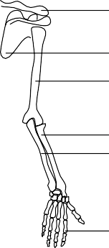
1
2
3
4
5

6

    - Provide labels for the parts numbered 1 to 2. (2)

    - Name the type of joints that form: (2)
      - Between parts 2 and 3

      - Between parts 3 and 4.

    - List TWO functions of the human skeleton. (2)

Section B- Question 2
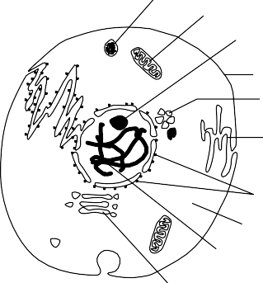
  - Study the diagram of a cell and then answer the questions that follow.
1
2
3
8
9

4
5
6
7

10

    - Does this diagram represent a plant cell or animal cell? (1)

    - Give TWO reasons for your answer to Question 2.1.1 (2)

    - Write down the numbers and names of TWO organelles which are
Surrounded by a single unit membrane. (4)

    - Write down the number and name of ONE organelle which is surrounded
By a double membrane. (2)

    - State ONE function of organelle 2. (1)

    - Explain TWO ways in which organelle 2 is structurally suited for its function. (4)

  - Draw and label a diagram to represent a chloroplast. [6]
  - The diagram below shows a cell that is about to undergo mitotic division. Answer the questions based on it.

Rod-like structures

    - What are the rod-like structures in the cell? (1)

    - Each rod is made up of many small units. What is each unit called? (1)

    - Name TWO regions in a flowering plant where dividing cells may be found (2)

    - How many of the rod-like structures will be found in each of the
Daughter cells? (1)

    - How many cells will there be at the end of this cell division? (1)

    - State THREE ways in which mitosis is biologically important. (3)

  - Study the following diagrams and then answer the questions which follow.
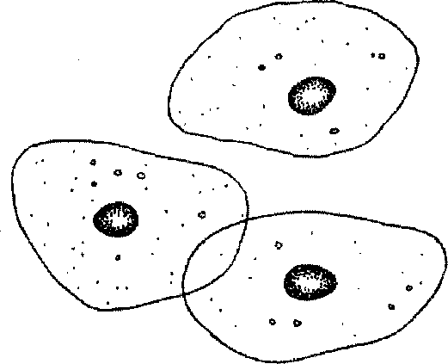
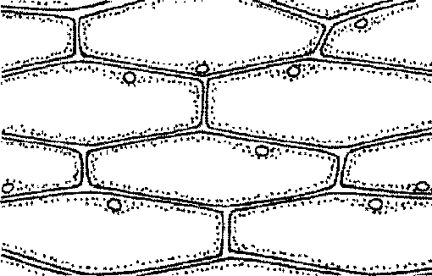
C
A B

    - Which of the drawings (A or B) represent:
      - Plant cells? (1)

      - Animal cells? (1)

    - Tabulate TWO visible differences between cells A and B. (4)

    - List TWO visible similarities between cells A and B. (2)

    - Explain why structure C is said to ‘control all the activities of the cell’ (3)
  - Movement of water from the soil into the plant is across a water potential gradient.
    - Describe the movement of water from the soil until it reaches the xylem of
The root. (7)

    - List THREE ways in which the root hair is structurally suitable for the
Absorption of water. (3)

Question 3
  - Various forces play a role in the upward movement of water in plants. Describe the upward movement of water from the xylem of the root until it reaches the air cavities
Of the leaves.
  - Study the diagram of the human heart and then answer the questions based on it.

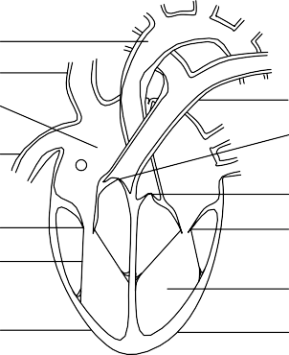
6
7
8 1
2
9
3
10 4
11
5
A B
3.2.1 State the number and name of the blood vessel that carries oxygenated blood. (2)

3.2.2 Explain why there is a difference in the thickness of the walls of marked A and B. (2)
3.2.3 Name the following parts: 2, 3, 4 and 11. (4)
3.2.4 Explain how the structure of part 11 makes it suitable for its function (3)
4.1. In the Olympic Games held in Athens in 2004, a long distance athlete had 500 ml of his own blood removed, stored and returned to his body a few days before he completed the marathon. This increases the haemoglobin content in the blood. This practice, called blood doping, is banned by athletics officials. Study the graph below, showing the haemoglobin content of the blood in the athlete’s body over a period of 35 weeks and answer the questions that follow.
Changes in the haemoglobin concentration of the blood of an athlete over time
115
bloo | d
rem | oved

Haemoglobin as a percentage of normal haemoglobin
110
105
100
95
90
85
0 5 10 15 20 25 30 35
Time in weeks
    - In which week was the blood removed from the athletes body? (1)

    - How many weeks did it take for the athlete’s haemoglobin level to go back
To normal after the blood had been removed? (1)

    - Explain what advantage this athlete would have had, compared to an athlete who did not undergo blood doping. (2)

    - Why do you think that officials would find it difficult to detect this form
Of blood doping? (2)

    - Do you consider this act of blood doping to be acceptable or not? (1)

    - Explain your answer in 4.1.5. (2)
  - An athlete’s heartbeat was recorded before, during and after a race for a total time of 100 minutes. The results are shown in the table below.
Time (minutes) | 0 | 10 | 20 | 30 | 40 | 50 | 60 | 70 | 80 | 90 | 100
Heartbeat per minute | 60 | 60 | 61 | 62 | 84 | 105 | 108 | 100 | 88 | 70 | 64
    - Use the data from the table and draw a graph. Use the x-axis for time and the y-axis for heartbeats per minute. (10)

    - What is the heartbeat at rest? (1)

    - After how many minutes: (1)
- did the athlete start the race (1)

- was the athlete’s heartbeat 84 times per minute, and (1)

- did the athlete stop running? (1)

    - How long does one complete heartbeat last at: (1)
- rest, and (2)

- the end of the of the race? Show your calculations. (4)

TOTAL: [150]

