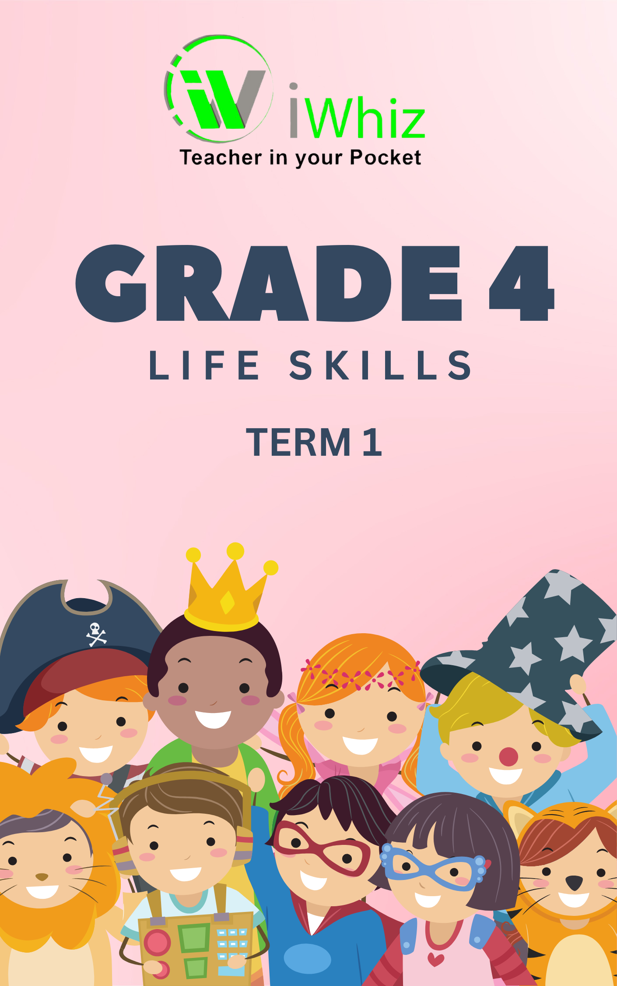

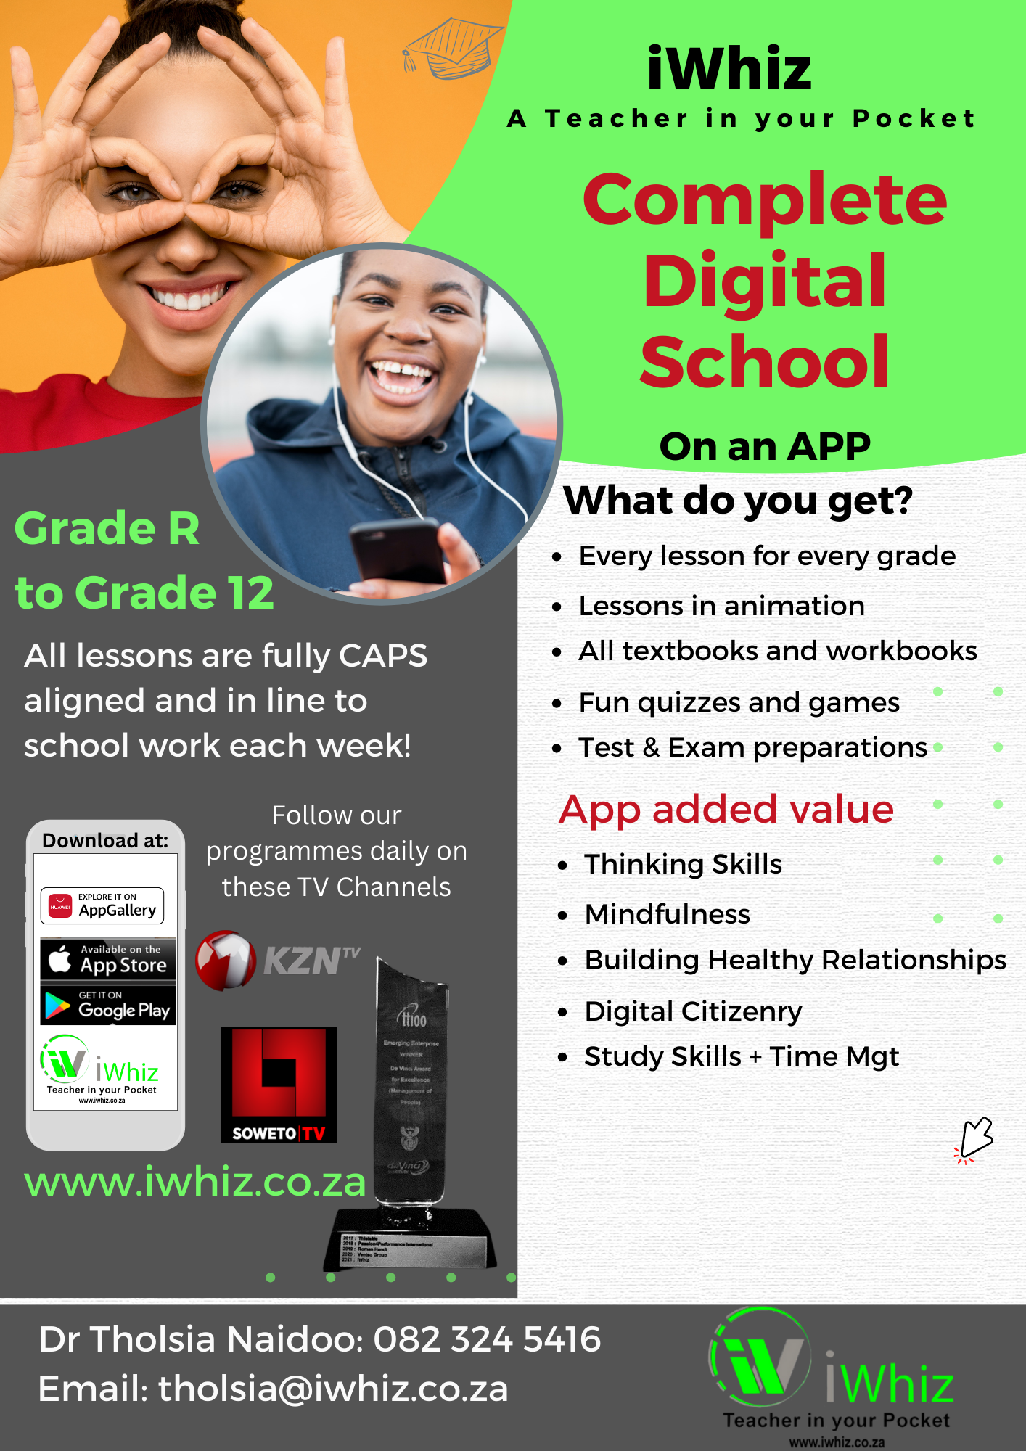

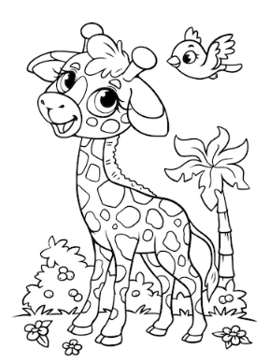
Grade 4 Life Skills (50 Marks)
Good Luck Friends
Time: 1 hour 30 minutes
Instructions:
- Read all questions carefully.
- Answer in full sentences where needed.
- Check your spelling and punctuation.
Good luck!

Section 1: Multiple Choice Questions (MCQ) 15 Marks
(Choose the correct answer by circling A, B, or C.)
- What does "personal strength" mean? (1)
(a) Something you are good at
(b) Something you cannot do
(c) A type of food
- Which of these is an example of a personal strength? (1)
(a) Forgetting homework
(b) Helping friends when they are sad
(c) Fighting with classmates
- How can you improve your weaknesses? (1)
(a) Ignore them
(b) Use your strengths to get better
(c) Give up
- Why is it important to respect other people’s bodies? (1)
(a) Because everyone deserves to feel safe and comfortable
(b) So people will like you
(c) Because teachers say so
- Which of these shows self-respect? (1)
(a) Eating healthy food and staying clean
(b) Staying up late every night
(c) Ignoring personal hygiene

- How should you respect other people’s privacy? (1)
(a) By knocking before entering a room
(b) By reading their personal messages
(c) By taking their things without asking
- What is a bad habit that can harm your body? (1)
(a) Drinking lots of water
(b) Eating fruits and vegetables
(c) Using harmful substances like cigarettes or alcohol
- What can you do to avoid conflict at school? (1)
(a) Listen carefully and be kind
(b) Yell when you disagree
(c) Ignore people
- If two friends are arguing, what is a good way to help? (1)
(a) Encourage them to fight
(b) Help them talk and find a solution
(c) Take sides and make the fight worse
- What should you do if someone disrespects your body? (1)
(a) Stay quiet
(b) Tell a trusted adult
(c) Do nothing
- Which of these is a good way to deal with stress? (1)
(a) Exercise, read, or talk to someone
(b) Get angry and break things
(c) Ignore your feelings
- Which of these is an example of a successful experience? (1)
(a) Winning a competition by practicing a lot
(b) Not studying and failing a test
(c) Forgetting to do homework
- How can reading about role models help you? (1)
(a) It teaches you about confidence and success
(b) It wastes time
(c) It is boring
- Why is it important to have a safe environment at home and school? (1)
(a) So everyone feels happy and secure
(b) So teachers have less work
(c) So people can fight freely
- How can you help create a safe environment? (1)
(a) Be kind and helpful to others
(b) Ignore people who need help
(c) Start fights with classmates

Section 2: Matching 10 Marks
(Match the words in Column A with their correct meaning in Column B.)
Column A |  | Column B
1. Strength |  | A. A safe and happy place
2. Role model |  | B. Someone you look up to and learn from
3. Privacy |  | C. Something you are good at
4. Conflict |  | D. A good habit, like being responsible
5. Respecting your body |  | E. Treating your body well and staying healthy
6. Self-respect |  | F. The right to personal space and boundaries
7. Conflict resolution |  | G. A disagreement or fight between people
8. Safe environment |  | H. Talking and listening to solve a problem
9. Unhealthy habit |  | I. Smoking or using harmful substances
10. Successful experience |  | J. Winning a race after practicing a lot

Total: 10 Marks

Section 3: Short Answer Questions 25 Marks
A. One-mark questions (1 mark each = 10 marks)
- Name one personal strength you have. (1)

- What is one way to show respect for someone’s privacy? (1)

- Why is it important to respect your own body? (1)

- Give an example of a successful experience. (1)

- Name one reason why people should avoid conflict. (1)

- What is one thing all people need to survive? (1)

- What is one way to deal with conflict in a peaceful way? (1)

- Why is reading about role models helpful? (1)

- What should you do if you see someone being bullied? (1)

- Name one thing that makes a home or school a safe place. (1)

B. Two-mark questions 2 marks each
- List two ways to turn a less successful experience into a positive learning experience. (2)

- Why should we avoid substance abuse? Give two reasons. (2)+(2)

- What are two good ways to show respect for other people’s bodies? (2)

- Write two strategies to avoid conflict. (2)+(2)

- How can reading about safe environments help learners in real life? (2) + (1)

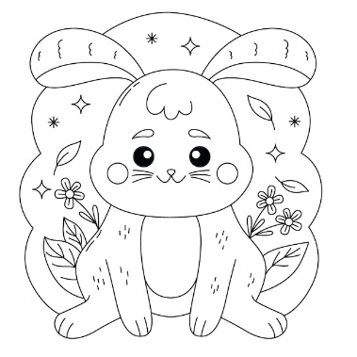
Well Done! You have completed your test.

