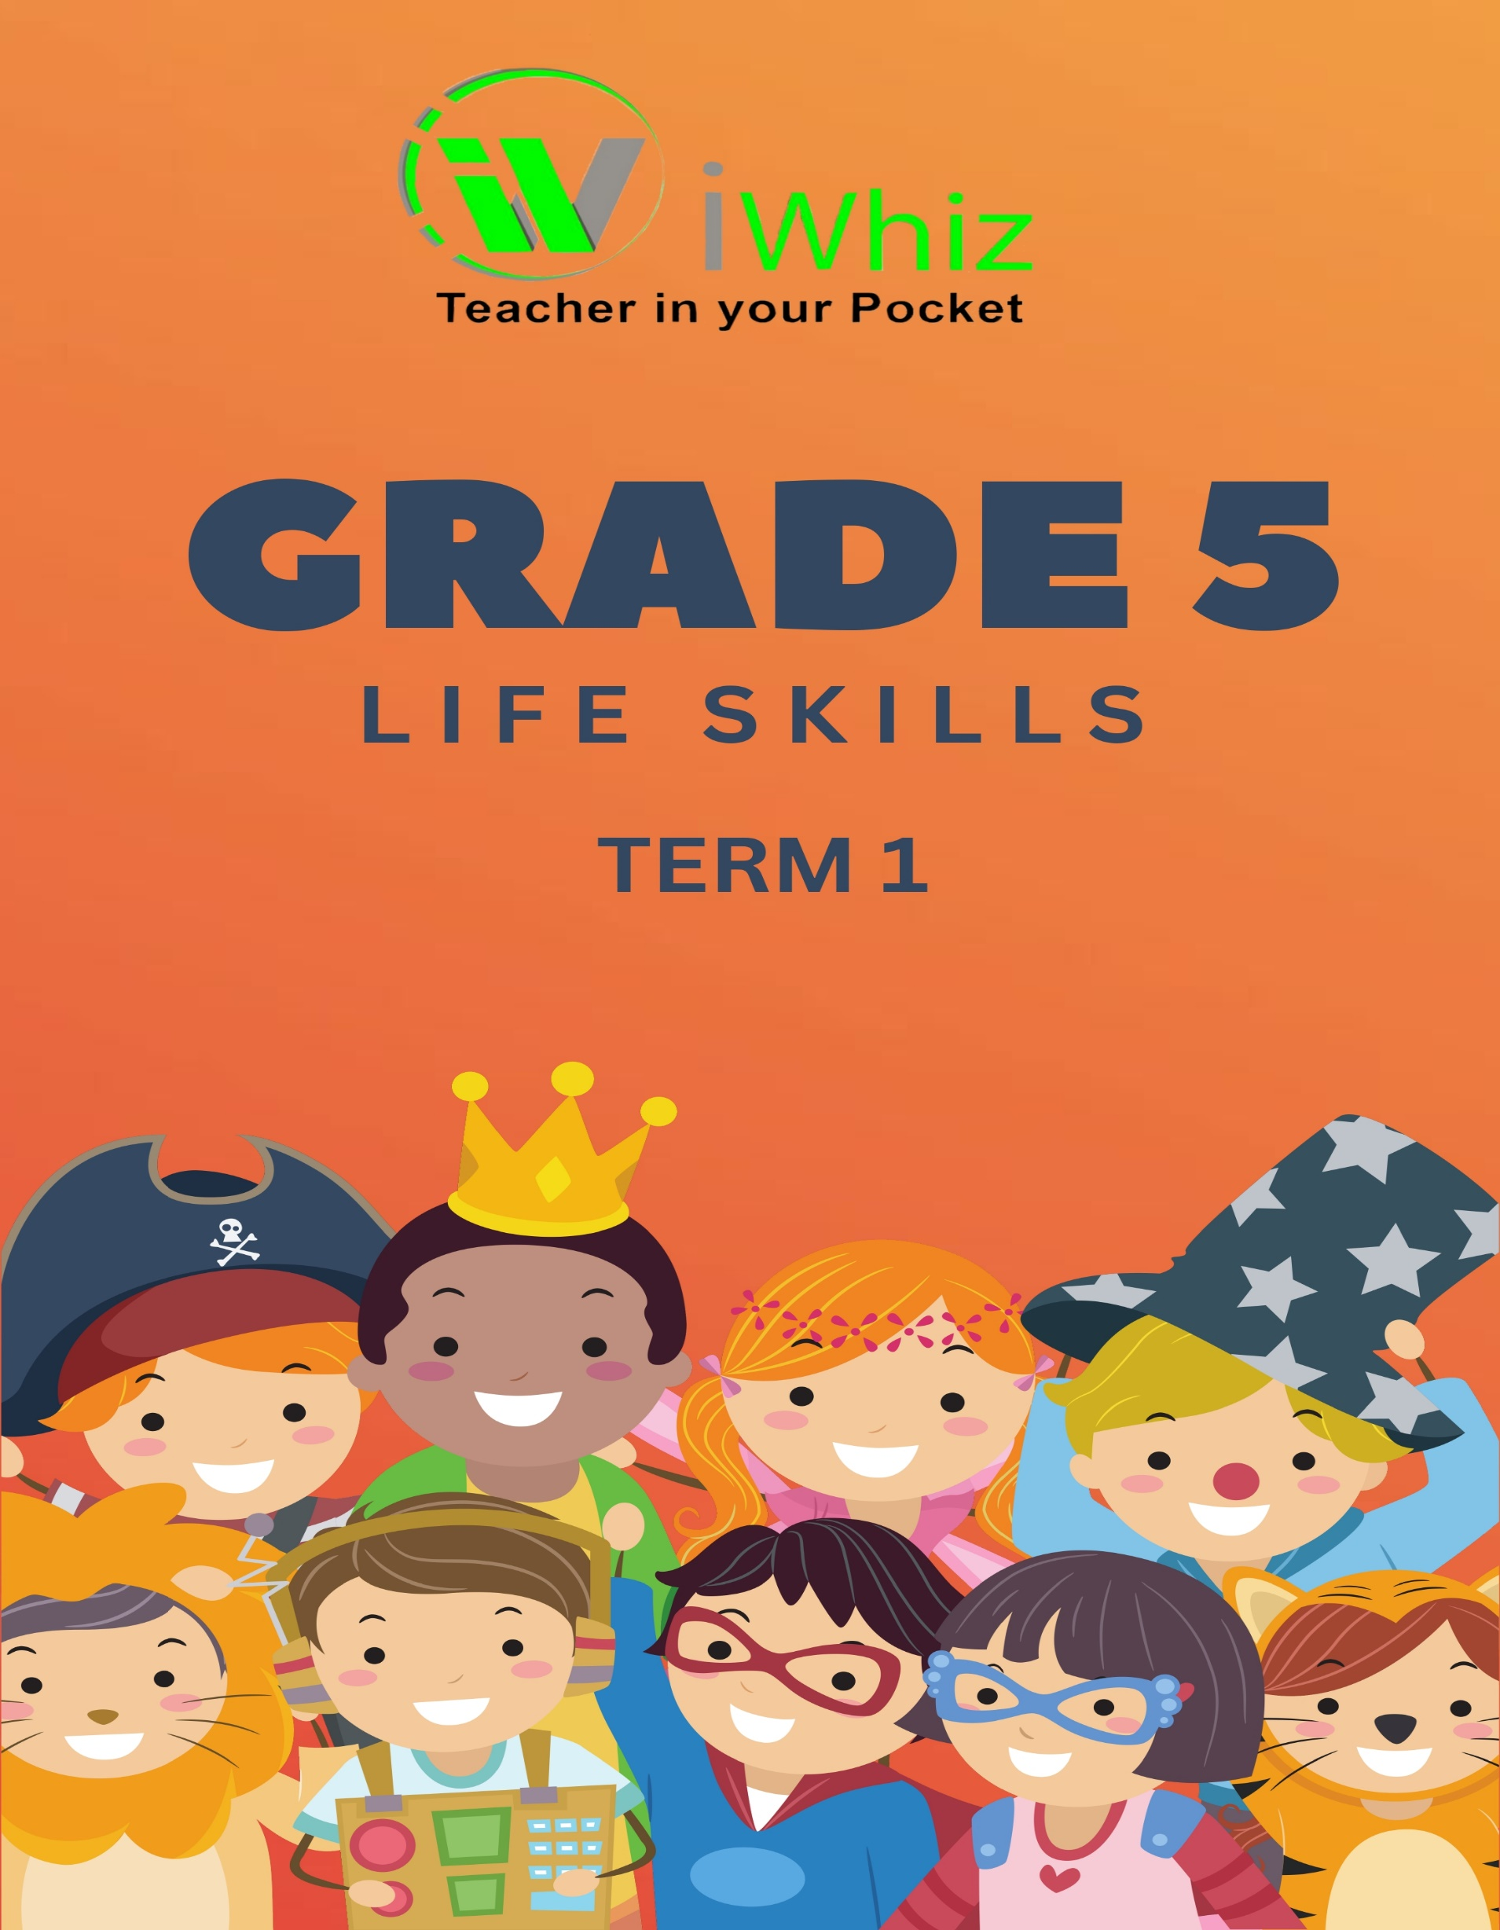
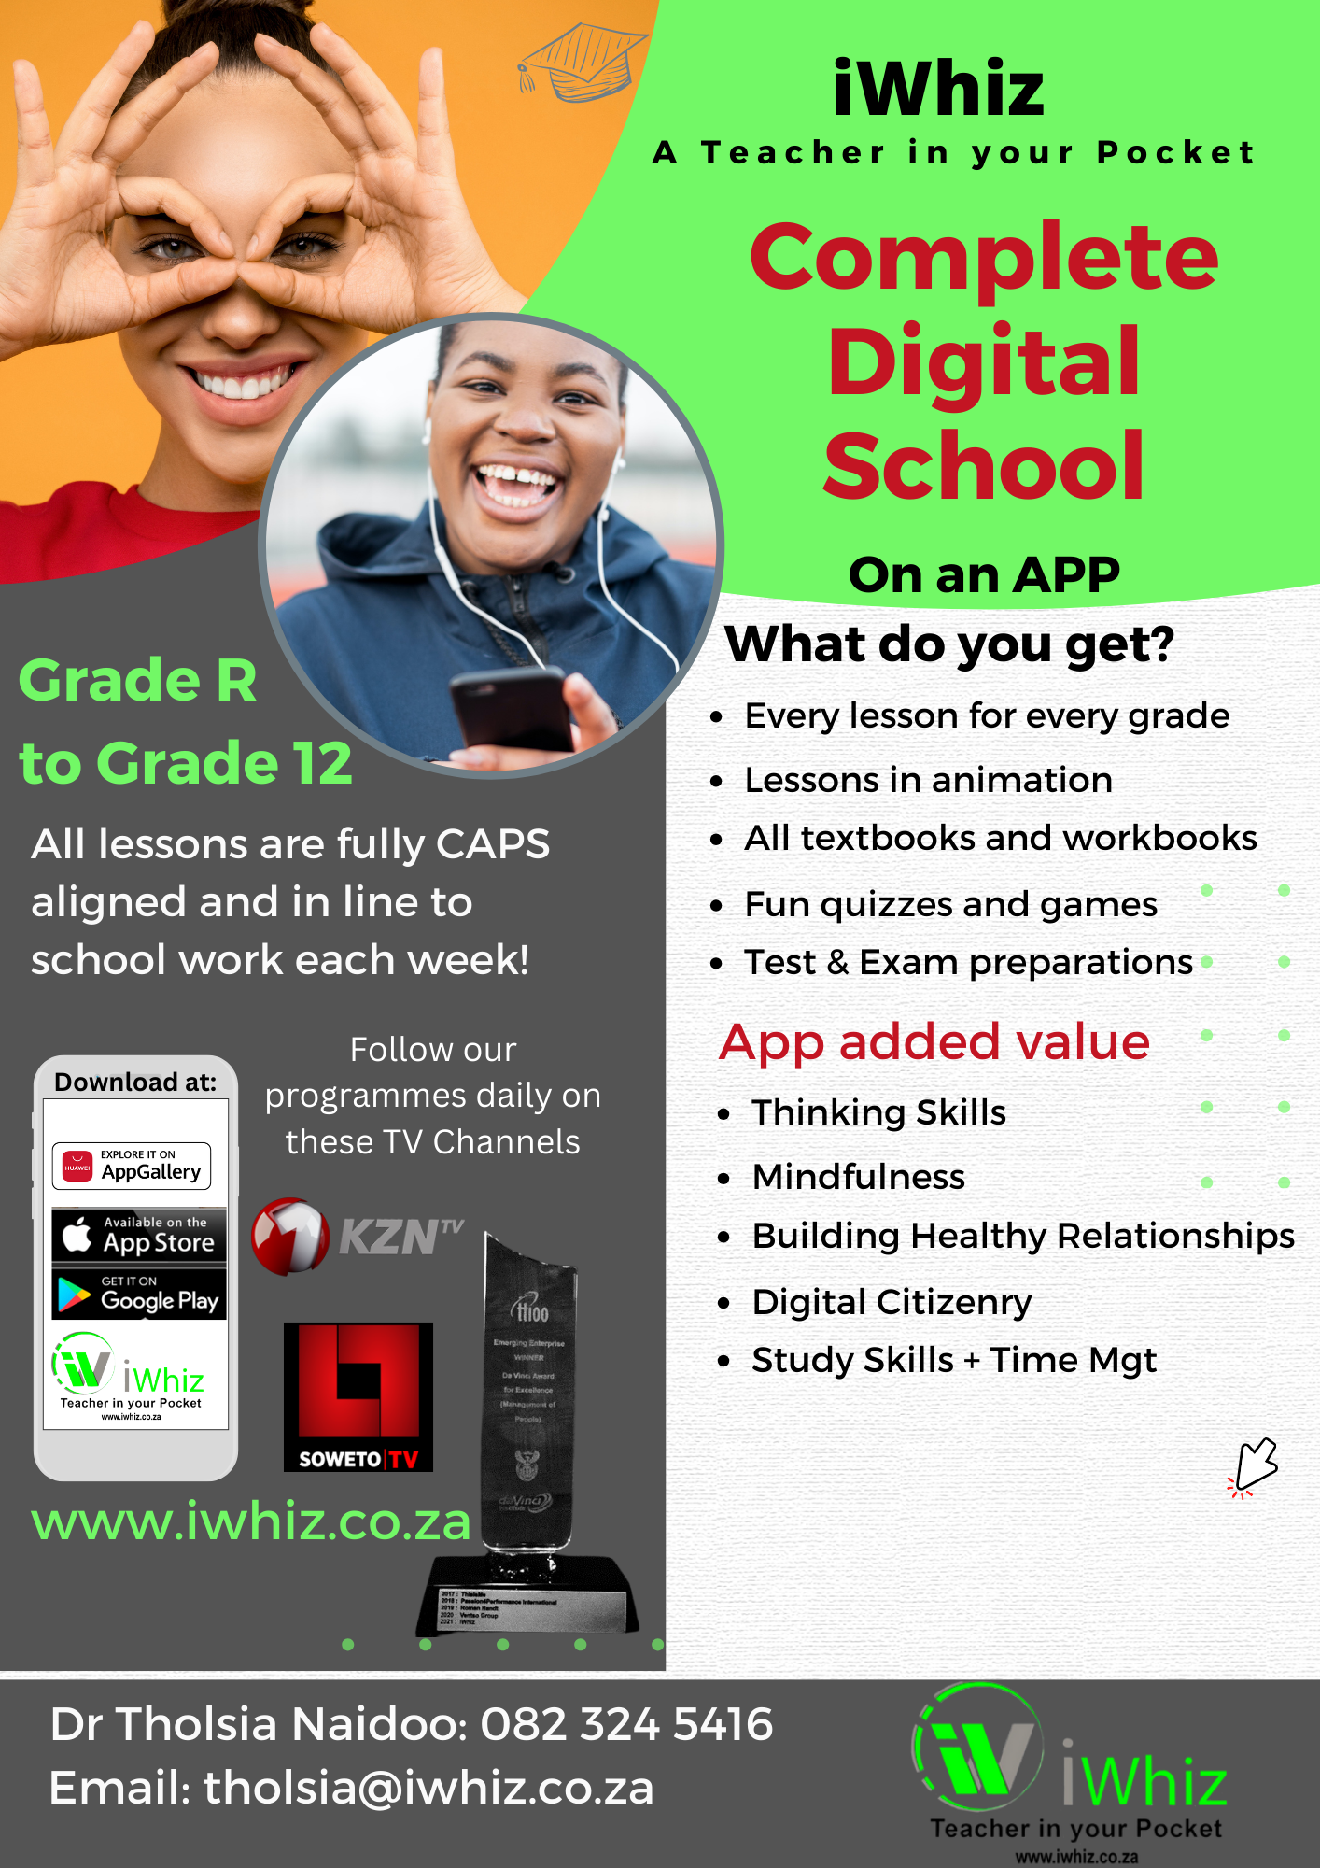
https://www.youtube.com/watch?v=SJ4_nONtYeY
WATCH FOR TESTIMONIALS

WATCH FOR TESTIMONIALS

INSTRUCTIONS
- Attempt this section on MCQs sheet only.
- Use Black ball point pen or marker for only one circle for correct option of a question
- No marks will be awarded for cutting, overwriting and multiple circle shading.
Grade 5 Life Skills Test

- Which of the following is healthy way to manage stress?
There are three sections, i.e. Section A, B, and C
Time Allowed: 10minutes Max Marks: 15

Section-A

- Ignoring the problem
- Exercising regularly
- Overeating
- Procrastinating

- What is the main function of the heart in the human body?

- To digest food
- To pump blood
- To filter waste
- To control movement

- Which food group is the primary source of energy for our bodies?

- Proteins
- Carbohydrates
- Fats
- Vitamins

- What does the term 'empathy' mean?

- Feeling sorry for someone
- Understanding and sharing another person's feelings
- Ignoring others' emotions
- Agreeing with someone's opinion

- Which of the following is a non-renewable resource?

- Solar energy
- Wind energy
- Coal
- Hydroelectric power

- What is the purpose of recycling?

- To increase waste production
- To conserve resources and reduce pollution
- To create more landfill sites
- To waste time and money

- Which activity best promotes cardiovascular fitness?

- Reading a book
- Watching television
- Jogging
- Playing video games

- What is the significance of Heritage Day in South Africa?

- Celebrating technological advancements
- Honoring cultural diversity and heritage
- Promoting international trade
- Commemorating military victories

- Which of the following is a characteristic of a good leader?

- Dictatorial behavior
- Inability to listen
- Integrity and honesty
- Selfishness

- How can one demonstrate respect towards others?

- Interrupting when they speak
- Listening attentively
- Ignoring their opinions
- Speaking over them

- What does the term 'biodiversity' refer to?

- The variety of life in a particular habitat or ecosystem
- The uniformity of species in an area
- The number of domestic animals in a region
- The similarity between different species

- Which practice contributes to personal hygiene?

- Skipping baths
- Regular handwashing
- Wearing dirty clothes
- Sharing personal items

- What is the primary benefit of teamwork?

- Increased conflict
- Diverse ideas and shared responsibilities
- Reduced productivity
- Individual recognition

- Which of the following is a renewable resource?

- Natural gas
- Oil
- Timber
- Uranium

- What is the importance of setting personal goals?

- To have unrealistic expectations
- To lack direction
- To provide motivation and a sense of purpose
- To avoid responsibility

Section-B
INSTRUCTIONS
- Match each item in Column A with its corresponding description in Column B
- Write the letter of the correct description from Column B next to each item in Column A
- Each description in Column B may be used once, more than once, or not at all.
Max marks: 14

Column A | Column B | Answer
1 Sewage | A when the land, water and air is made dirty
2 Expire | B should always be in high cupboard that is locked
3 Medicines | C contain chemicals that are dangerous to drink or breathe in
4 Pollution | D never panic, shout ‘fire’ so everyone can leave the building
5 Household detergents | E waste matter flushed down toilets
6 When there is a fire | F fires cans spread very quickly
7 My body’s parts | G The five senses: sight, hearing, taste, touch, smell
8 Healthy foods | H Brain, heart, lungs, kidneys, muscles
9 Different types of exercise | I Water helps in digestion and hydration
10 Why we need to exercise | J Feelings like happiness, sadness, anger
11 The importance of water for the body | K Avoiding dangerous situations and hazards
12 Hygiene practices | L Important for growth and energy
13 Emotions and feelings | M Aerobic, strength training, flexibility
14 How to stay safe | N Hand washing, brushing teeth, bathing

Section-C
INSTRUCTIONS
- Match each item in Column A with its corresponding description in Column B
- Write the letter of the correct description from Column B next to each item in Column A
- Each description in Column B may be used once, more than once, or not at all.
Max marks: 25

Read the case study and answer the questions that follow
IT’s NOT HOT TO SMOKE
People who smoke tobacco think that it makes them feel good, but the truth is that it is dangerous and could eventually kill them. People die every day from heart and lung disease caused by the nicotine, tar and other harmful substances in tobacco and tobacco smoke.

There is a warning on all cigarette packs to warn smokers that they are putting their health at risk by choosing to smoke. One of these health risks is the tar from tobacco smoke that clogs up their lungs. Cigarettes also contain chemicals that cause cancer. Smokers’ skin wrinkles and they age faster. Smoking also turns teeth yellow and makes their breath smell bad. The nicotine in cigarettes is addictive and harmful. The ingredients in cigarettes make their blood vessels narrower so that the blood in their veins flows less easily.

Children and teenagers often do not realise the dangers of smoking before they start. They may start smoking because everyone around them smokes or they think it makes them look grown up.

Passive smoking is when you inhale other people’s smoke. This can also damage your health. Usually special areas are set aside in restaurants where people are allowed to smoke. Adults should not smoke in their houses or cars if children are with them. Pregnant women or mothers who are breastfeeding should not smoke because it will harm their babies.

Smoking is addictive and it can be hard to stop. This is why you should never start smoking in the first place.

Children and teenagers often do not realize the dangers of smoking before they start. They may start smoking because everyone around them smokes or they think it makes them look grown up.
Passive smoking is when you inhale other people’s smoke. This can also damage your health. Usually, special areas are set aside in restaurants where people are allowed to smoke. Adults should not smoke in their houses or cars if children are with them. Pregnant women or mothers who are breastfeeding should not smoke because it will harm their babies.
Smoking is addictive and it can be hard to stop. This is why you should never start smoking in the first place.

- List 3 negative consequences of smoking. (3)

- What does nicotine do to the body’s blood vessels and what is the result of this? (2)

- Is cigarette smoking harmful? Explain your answer. (2)

- What is passive smoking? (1)

- How could you discourage children in your class from starting to smoke? (1)

- Why should pregnant and breastfeeding mothers not smoke? (1)

Explain the function of each and provide one example.

- Carbohydrates: (3)

- Protein: (3)

- Diary: (3)

- Fruit and vegetables: (3)

- Why is it important to wash your hands regularly, especially before eating? (3)

Total marks: 50

