



https://www.youtube.com/watch?v=SJ4_nONtYeY
WATCH FOR TESTIMONIALS

WATCH FOR TESTIMONIALS

Grade 10 Term 1 Test
100 marks
2 hours

Instructions:
- Answer all questions
- Write neatly and legibly
- Answer each section on a new page
- Do not leave any questions blank

Question 1: Algebraic Expressions

- Is the square root of 16 a rational or irrational number? (2)

- Determine between which two integers the $\sqrt{25}$ lies. (2)

- Multiply (x + 3) by (2x² - 4x + 1). (4)

- Solve for x: 2(x – 4) = 10 (4)

- Solve for y: -y² + 8y – 15 = 0 (4)

- Find the product: (3x – 2) (5x + 8) (4)

- Factorise: 5 (a – 2) – b (2 – a) (4)

- Solve for x and y: (6)
3x + 2y = 36
5x + 4y = 64

Question 2: Exponents

- Simplify: $\frac{2^{2n} x 4^{n} x 2}{{16}^{n}}$ (4)

- Simplify: (${0.008)}^{\frac{1}{3}}$ (4)

- Solve 3^{x + 1} = 9 (4)

Question 3: Numbers and Patterns

- Identify the next term in the sequence: 2, 5, 8, 11, ___. (2)

- What is the general term for the sequence: 7, 11, 15, 19, 23, ... ? (4)

- Given the pattern: 10, 7, 4, 1, -2, ..., find the 10th term. (2)

Question 4: Equations and Inequalities

- Solve: 4 (a + 6) > 20 (3)

- Solve: x² + 3x – 10 = 0 (3)

- Solve: -x + 2 ≤ 9 (3)

- Solve for x: $\frac{2x-3}{3}$ – 3x = $\frac{2x}{6}$ (4)

Question 5: Trigonometry

- Write down the 3 trigonometric ratios in terms of θ (6)

- Label the triangle with hypotenuse, opposite and adjacent sides of the triangle with respect to θ (3)

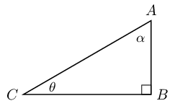

- Define the reciprocal angles in terms of sin cos and tan (6)

- Use your calculator and calculate the following correct to 2 decimal places:

- cos 48º (2)

- 2sin35º (2)

- $\frac{1}{4}$ cos 27º (2)

- Fill in the following table: (9)

θ | 30º | 45º | 60º
cos θ
sin θ
tan θ

- Find the length of x in the following right-angled triangle using the appropriate trigonometric ratio (round your answer to two decimal places). (4)

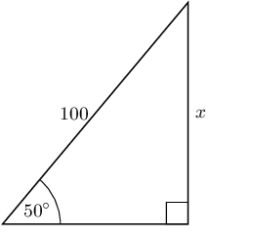

- Find the value of θ if 3 sin θ = 2.4 (3)

