



https://www.youtube.com/watch?v=SJ4_nONtYeY
WATCH FOR TESTIMONIALS

WATCH FOR TESTIMONIALS

Grade 10 Term 1 Test
88 marks
2 hours

Instructions:
- Answer all questions
- Write neatly and legibly
- Answer each section on a new page
- Do not leave any questions blank

Question 1: Exponents and Surds

- State the exponent rules (8)

- State the rules for surds (8)

- Simplify the following expressions with positive exponents: (6)
- $(\frac{1}{xy^{3}})$²

- $\frac{a^{2}b^{-2}c^{3}}{{ab}^{-1}c^{2}}$ x $\frac{(a^{2}b^{-2}c)^{-1}}{a^{-1}b^{2}c^{3}}$ ÷ $\frac{ab}{c^{4}}$

- $\frac{8^{2x+1}+ 4^{3x-1}}{2^{3x}}$
- Solve for x in the following equations: (4)
- 5^{3x} – 5^{3x – 1} = 4

- 3^{x}.4 + 5 = 25

- Determine the value without the use of a calculator: (4)
- ${49}^{\frac{3}{4}}$

- ${32}^{-\frac{2}{5}}$

- State whether the following is a surd or not: (3)
- $\sqrt{56}$

- $\sqrt{2}$

- $\sqrt[3]{81}$

- Simplify the following expressions: (4)
- (4 - $2\sqrt{5}$)(5 - $3\sqrt{5}$)

- $\frac{\sqrt{8}-\sqrt{2}}{\sqrt{50}}$

- Solve for x in the following: (4)
- $\sqrt{-x-1}$ = x + 1

- $\sqrt[3]{4+x}$ = 3

Question 2: Equations and Inequalities

- Solve the following equation by completing the square. Leave your answer to two decimal places if necessary: x² – 3x = -5 (6)

- Solve the following quadratic equation by completing the square. Leave your answer in simplest surd form.
ax² + bx + c = 0 (6)

- Solve for x: x(x – 1) = 4(3x – 10) (3)

- Solve the following equation: -3p² + 7p – 4 = 0 (3)

- Solve for a in the following equation. Consider all restrictions on the variables: (3)
$\frac{a}{a-2}$ = $\frac{1}{a-3}$ - $\frac{2}{2-a}$

- Solve for x and y: (6)
x – 2y = -7 and x² + xy + y² = 21

- In the diagram below, the functions of y = $\frac{4}{x}$ + 2 and y = x – 1 are represented. Points P and Q are the points of intersection of the two graphs. Find the coordinates of P and Q by solving the equations simultaneously. (6)
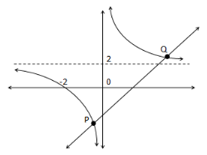

- Solve the following inequalities. Represent your solution in interval notation and on a number line: x³ + x² ≥ 6x
(4)

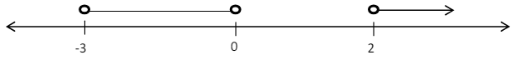

- Without solving for x, determine the nature of the roots: 2x² + 5x + 10 = 0 (4)

Question 3: Number Patterns

- Consider the pattern: 44, 60, 76, …
- Write down the next two terms of the pattern (2)

- Determine the formula for T_{n} (4)

