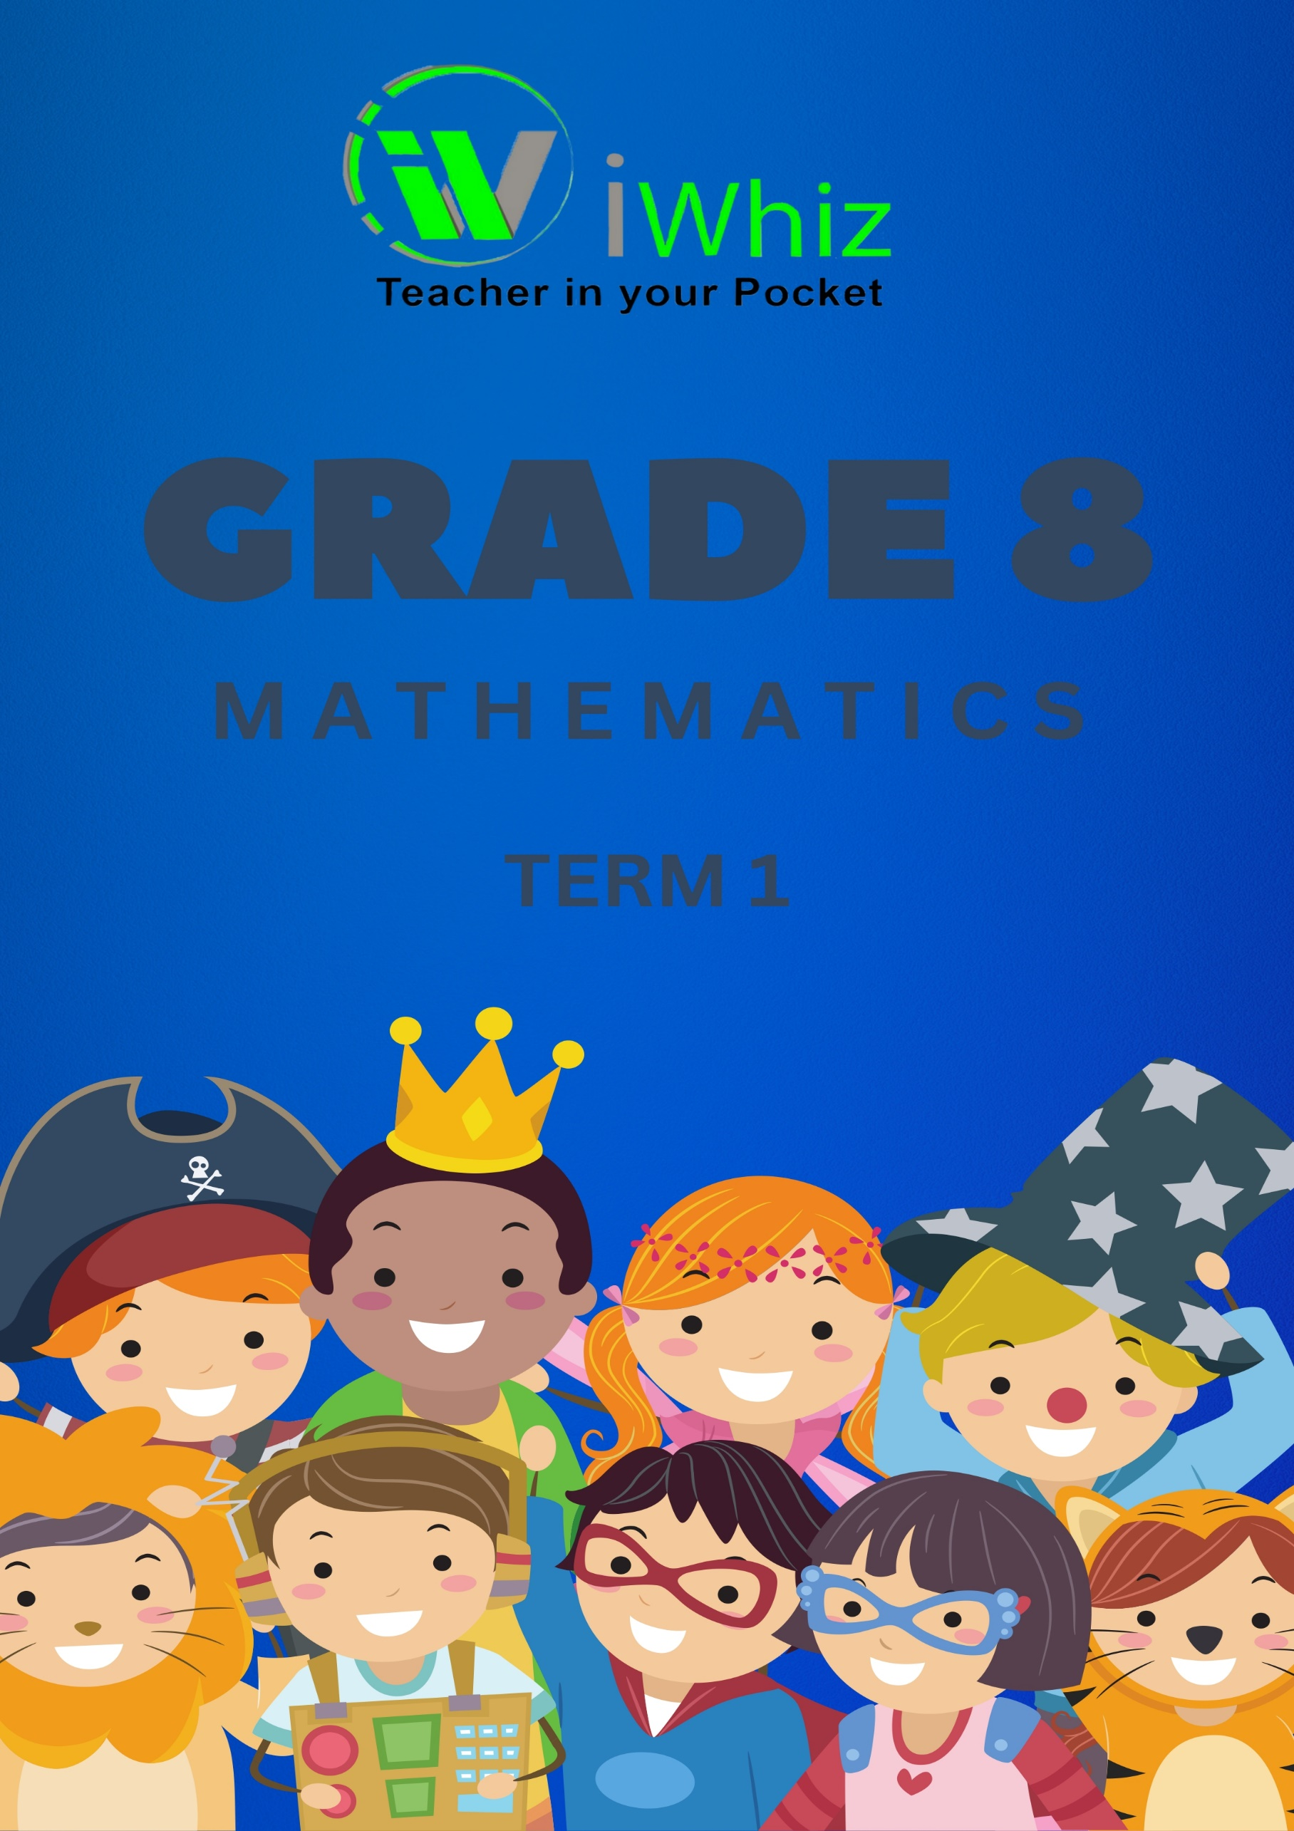


https://www.youtube.com/watch?v=SJ4_nONtYeY
WATCH FOR TESTIMONIALS

WATCH FOR TESTIMONIALS

Grade 8 Mathematics
60 marks
1 hour 30 minutes

Question 1: Numbers, Operations and Relationships (17 marks)

1.1. The general form of abc is: (1)
a. 100a + 10b + c
b. 100b + 10c + a
c. 100c + 10a + b
d. None of the above

1.2. The generalised form of 129 is: (1)
a. 100+90+2
b. 100+20+9
c. 100+2+9
d. None of the above

1.3. The usual form of 100 × 7 + 10 × 1 + 8 is: (1)
a. 108
b. 708
c. 718
d. 170

1.4. Which of the following numbers are not divisible by 5? (1)
a. 20
b. 125
c. 122
d. 200

1.5. Which of the following numbers are divisible by 10? (1)
a. 99
b. 45
c. 110
d. 75
1.6. Which of the following are divisible by 2? (1)
a. 98
b. 99
c. 101
d. 121

1.7. $\frac{x^{8}}{y^{6}}$ = (3)

$\frac{x^{8}}{y^{6}}$

  - (2³)⁴ = (2)

= 2¹²
= 4096

1.9. (-2)³ – (-2)⁴ = (2)

= -8 – (16)
= -24

1.10. (2³)³ = (2)

= 512

1.11. 9³ x 9⁴ = (2)

Question 2: Patterns, Functions and Algebra (10)

COLUMN A | ANSWER | COLUMN B
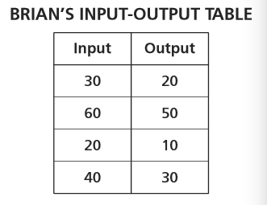 |  | A. 30
add 2, subtract 1, add 2, subtract 1 starting with the number 20 |  | B. 43 and 57
What number belongs in the blank?  18,24, ___,36,42 |  | C. Add 4
What is the rule for this pattern?  32,36,40,44 |  | D. This pattern is increasing by 2 blocks every term
What are the next 2 numbers of this pattern?  23, 27, 31, 35, ___, ___ |  | E. 58
What are the missing numbers in this pattern?  22, 29, 36, ___, 50, ___ |  | F. 285
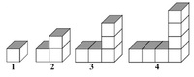 |  | G. Rule: Subtract 10
210, 225, 240, 255, ____, __6__  What is the sixth number in the pattern? |  | H. 39 and 43
34, 40, 46, ____, ____  What is the fifth number in the pattern? |  | I. Geometric Patterns
Patterns that use shapes to show a specific rule |  | J. 20, 22, 21, 23, 22

Question 3: Space and Shape (10)

COLUMN A | ANSWER | COLUMN B
A cube has x faces |  | A. A tent
A cone has x vertices |  | B. Square
A sphere has x faces |  | C. Any shape
An example of a cone is a: |  | D. 1
The top view of a cone looks like this: |  | E. Triangle
The top view of a cube looks like a: |  | F. Rectangle
The top view of a cuboid looks like a: |  | G. 8
The side-view of a cone appears as: |  | H. 6
The base of a prism is: |  | I. None
If a polyhedron has 6 vertices and 12 edges. What is the number of faces it has? |  | J. A circle

Question 4: Measurement (13)

- Given a right-angled triangle and the lengths of its three sides are 3, 4 and 5. These three positive integers are known as a Pythagorean triple denoted by (3, 4, 5), as they satisfy the equation stated by the Pythagorean theorem. If I multiply each of the number by 10, will the resulting numbers, namely 30, 40 and 50 be another Pythagorean triple? (1)
- True
- False
- A Pythagorean prime is any prime number that is also the length of the hypotenuse of a Pythagorean triple. The first few Pythagorean primes are 5, 13, 17, 29... What is the formula used to generate Pythagorean primes? (Given that n is a subset of positive integers). -> 4n + 1 (1)
- True
- False
- The Cartesian coordinate system uses the Pythagorean theorem to find the distance between 2 points (1)
- True
- False
- Complete the table below: (10)
COLUMN A | ANSWER | COLUMN B
P = 4s |  | A. Area of a rectangle
P = 2l + 2b |  | B. Quadrilateral
A = l² |  | C. Area of a triangle
A = l x b |  | D. Area of a circle
A = 0.5b x h |  | E. Perimeter of a square
d = 2r |  | F. Circumference of a circle
c = 2∏r |  | G. Diameter
A = ∏r² |  | H. Triangle
3 sides |  | I. Perimeter of a rectangle
4 sides |  | J. Area of a square

Question 5: Data Handling (10)
5.1. Complete the following table: (10)

COLUMN A | ANSWER | COLUMN B
Probability of getting number 5 in throwing a dice |  | A. 1
Probability of obtaining three heads in a single throw of a coin |  | B. 0.95
Probability of occurrence of two sure independent events |  | C. Cube
No chance of happening |  | D. $\frac{1}{6}$
As much chance of happening as not |  | E. 0.02
Very likely to happen |  | F. Cuboid
Very little chance of happening |  | G. 0
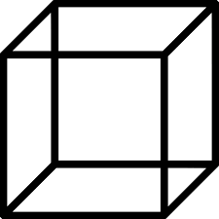 |  | H. Triangular Prism
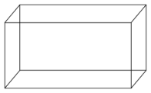 |  | I. 0.5
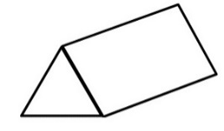 |  | J. Impossible

