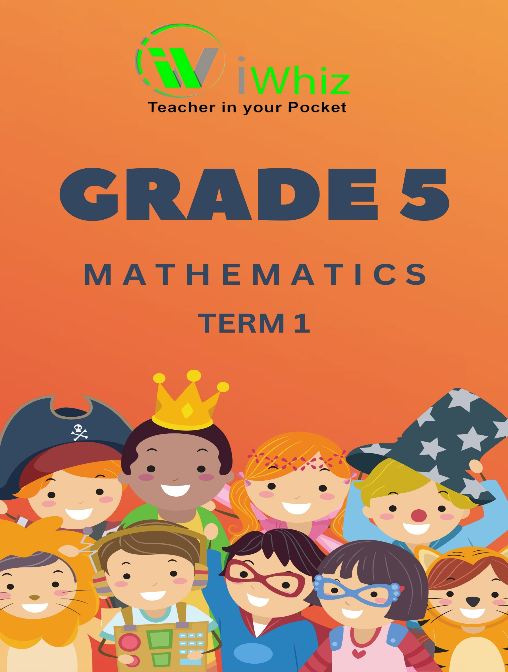



https://www.youtube.com/watch?v=SJ4_nONtYeY
WATCH FOR TESTIMONIALS

WATCH FOR TESTIMONIALS

Instructions
- Read all the instructions carefully.
- Question 1. consists of 15 multiple-choice questions. You must circle the correct. Answer.
- Answer questions 1 to 15 in the spaces of frames provided in the table.
- All work must be shown on the question paper and must not be done on rough paper.
- The test duration is 90minutes.
- The test is out of 60 marks.
- The use of a calculator is not allowed,
- There are three sections.

Question 1:
Circle the correct answer (15 marks)
- 462 473 rounded off to the nearest 5 is… (1)
- 462 470
- 462 475
- 462 479
- 462 480

- The value of the underlined digit in 321 931 is… (1)
- 2HTh
- 20 000
- 2 000
- Ten Thousand

- Which three numbers will complete the number pattern? (1)
312; 318; 324; 330; ; ; ;354.
- 336; 342; 346
- 332; 342; 348
- 336; 342; 348
- 336; 344; 348

- It is now 11:45. What time will it be in 1 hour and 50 minutes later? (1)
- 12:35
- 01:35
- 00:35
- 13:35

- Which one of the following numbers is not a factor of 54? (1)
- 2
- 4
- 9
- 6

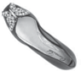
- Which view of the show below is shown? (1)
- front view
- back view
- side view
- top view

- The item that occurs the most in a data set is called the… (1)
- mean
- mode
- median
- range

- Write down the multiple of 49 between 50 and 100. (1)
- 49
- 99
- 98
- 88

- Complete: 6 x (2 + 4) = (6 x 2) + ( ) (1)
- (6 × 3)
- (6 × 4)
- (6 × 5)
- (6 × 6)

- Complete: 1 + (3 + 5) = (1 + 3) + ( ) (1)
- 5
- 6
- 2
- 3

- Write down the missing number in $\frac{9}{12}=\frac{}{4}$ (1)
- $\frac{8}{4}$
- $\frac{3}{4}$
- $\frac{6}{4}$
- $\frac{4}{4}$

- The simplest form of writing 600 000 + 400 + 20 + 50 000 + 3 + 7000 is: (1)
- 647 253
- 657 423
- 654 325
- 674 253

- Which number comes next in the number pattern 15; 25; 40; 60; ? (1)
- 70
- 75
- 80
- 85

- Which number is 40 000 more than 54 562? (1)
- 94 652
- 14 562
- 94 562
- 84 562

- Convert 500 g to kilograms. (1)
- 500 kg
- 0,5 kg
- $\frac{1}{6}kg$
- $5kg$

Question 2
Matching Activity
Match each question in Column A with the correct answer from Column B. Write the correct answer next to each question number. (15 marks)
Column A | Column B | Answers
- 25 × 4 | - 6
- 36 ÷ 6 | - 5000
- 7 × 8 | - 2.5m
- The fraction of ½ in decimal form | - 500
- 3³ (3 × 3 × 3) | - 100
- 5 more than 75 | - 90
- The value of the 5 in 5 623 | - 30
- Double of 45 | - 4:15
- ⅓ of 18 | - 6
- The sum of angles in a triangle | - 56
- 250 cm in meters | - 80
- Half of 1 000 | - 27
- ¾ of 40 | - 180°
- The next number in 3, 6, 9, | - 12
- The time on a clock when it is quarter past 4 | - 0.5

Question 3
Answer the following short questions
(20 marks)

- Which of the numbers 1, 6, 9, 7, 8 is a factor of 21? (2)

- Which of the following numbers 46, 49, 72, 68, 54 are multiples of 3? (2)

- Write down 2 fractions that are smaller than $\frac{1}{2}$ (2)

- Which fractions are equal to $\frac{2}{4}$ ? (2)

- Answer the following questions and give a reason for your answer. (2)
- 74 rounded off to the nearest 10 = ________________
- 3 097 rounded off to the nearest 1000 = ____________

- Ann is a flower seller. Today she sold 1 403 flowers and yesterday she sold 2 364 flowers. How many more flowers did she sell yesterday than today? (3)

- Sandille sells beads at the craft market. The table shows how many beads she sold during a 5-day festival.

Monday | Tuesday | Wednesday | Thursday | Friday
1 213 | 643 | 812 | 417 | 2068

- How many beads did she sell altogether on Monday, Tuesday, and Wednesday? (3)

- How many more beads did she sell on Friday than on Wednesday? (3)

- Arrange the following numbers from smallest to biggest. (1)
36 589, 35 698, 38 569, 39 958

Total Marks: 50

