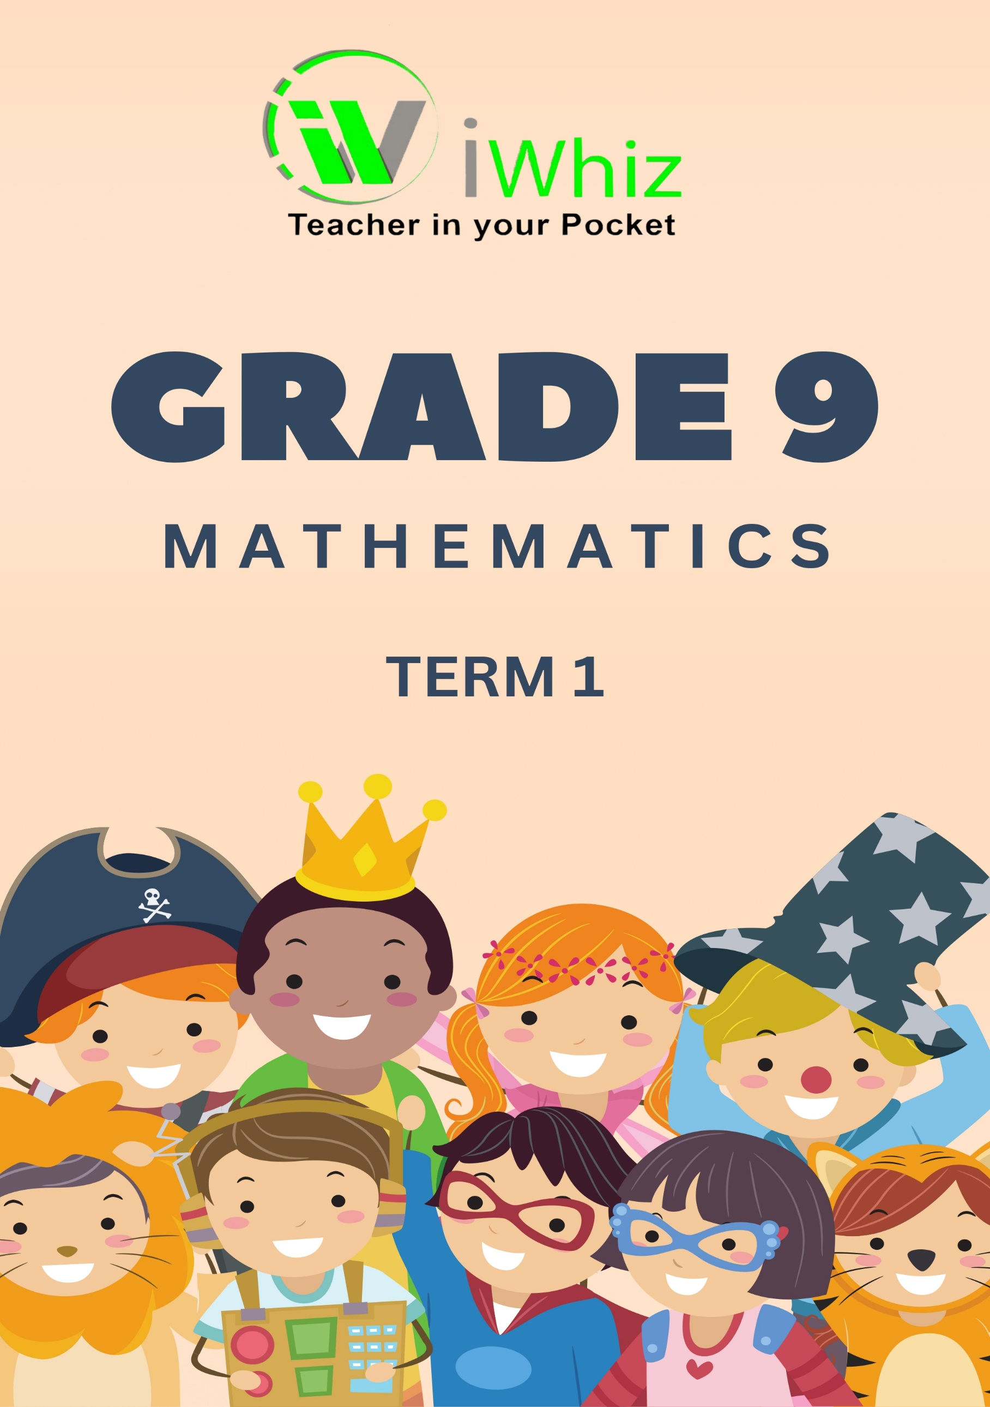



https://www.youtube.com/watch?v=SJ4_nONtYeY
WATCH FOR TESTIMONIALS

WATCH FOR TESTIMONIALS

Grade 10 Term 1 Test
100 marks
2 hours

Instructions:
- Answer all questions
- Write neatly and legibly
- Answer each section on a new page
- Do not leave any questions blank

Question 1: Numbers, Operations and Relationships

1.1. Simplify: $\sqrt{4^{2}}$ (1)
- 16
- 4
- 2
- 8

1.2. Simplify 4,8 ÷ 0,2 = (1)
- 2,4
- 240
- 0,24
- 24

1.3. (x – 3)² = (1)
- x² – 9
- x² + 9x – 9
- x² – 6x + 9
- x² – 6x – 9

1.4. If 2x + 8 = 16, then x = (1)
- 1
- -4
- 1,6
- 4

1.5. Determine the value of b in $\frac{3}{5}+\frac{2}{b}$ = 1 (3)

b = 5

1.6. Simplify without a calculator: (4)
(2x)³ x (-2x²)

8x³ x -2x²
= -16x⁵

1.7. Sandra borrowed R2 500 from her friend. They agreed that she will repay all the money over a certain period of time plus simple interest of 9% p.a. How long did it take her to repay all the money if the total interest paid was R675? (4)

1.8. Which number is bigger? (2)
$3\sqrt{2}$ or $2\sqrt{3}$

1.9. Factorise the following: (3)
a. 3p²q + 15pq² – 12pq

= 3pq (p + 5q – 4)

b. 3x (x – 3) + 2 (3 – x) (4)

= 3x (x – 3) – 2 (x – 3)
= (x – 3) (3x – 2)

Question 2: Patterns, Functions and Algebra

2.1. Numeric Patterns: (6)
a. Identify the next three terms in the sequence: 2, 6, 12, __, __, __.

20, 30, 42

b. What is the general term for the sequence 5, 10, 15, 20, ...?

a_{n} = 5n

2.2. Geometric Patterns: (6)
a. If each term in a geometric sequence is obtained by multiplying the previous term by 3, find the fifth term after 81.

243

b. Create a geometric pattern where the common ratio is 0.5, starting from 32.

32, 16, 8, 4, ….

2.3. Self-Created Patterns: (6)
a. Invent a numeric pattern and describe the rule for generating terms.

b. Develop a geometric pattern of your own and explain the underlying concept.

2.4 Constant Difference: (6)
a. Identify the constant difference in the sequence: 12, 16, 20, 24, ...

4

b. Determine the 10th term in a sequence with a constant difference of 3, starting from 7.

28

2.5. Constant Ratio: (6)
a. Find the common ratio for the geometric sequence: 2, 6, 18, 54, ...

3

b. Calculate the 6th term in a geometric sequence with a common ratio of 0.4, starting from 25.

25.6

2.6. Pattern in a Series: (4)
a. Investigate the sum of the first 10 terms in the sequence: 3, 7, 11, 15, ...

80

b. Determine the sum of the first 5 terms in a geometric sequence with a common ratio of 2, starting from 4.

124

2.7. Algebraic Rule Justification: (4)
a. Justify why the algebraic expression 3n – 1 represents a sequence with a constant difference.

Constant difference means each term increases by the same amount.

b. Explain the reasoning behind using 2^{n} as an algebraic representation for a geometric sequence.

2^{n} represents repeated doubling in a geometric sequence.

Question 3: Space and Shape

3.1. Triangles: (4)
a. Define an equilateral triangle.

b. Identify the type of triangle with two equal sides.

3.2. Quadrilaterals: (4)
a. What are the defining properties of a rectangle?

b. Distinguish between a square and a rhombus based on their properties.

3.3. Right-Angled Triangles: (4)
a. Provide the definition of a right-angled triangle.

b. Identify a triangle as right-angled if one angle measures 90 degrees.
3.4. Geometric Problem Solving with Similar Triangles: (4)
a. In a pair of similar triangles, if the length of one side in the first triangle is known, how can you find the corresponding side length in the second triangle?

b. If two triangles are similar and one triangle has a base of 8 cm with a corresponding side in the other triangle measuring 12 cm, what is the scale factor?

3.5. Combining Congruent and Similar Triangles: (4)
a. Can two triangles be both similar and congruent at the same time? Explain.

b. Given a quadrilateral with two pairs of opposite sides congruent and two pairs of opposite angles equal, can you conclude that the quadrilateral is a parallelogram?

Question 4: Measurement

4.1. Polygon Area and Perimeter: (4)
a. Calculate the area and perimeter of a rectangle with sides measuring 8 cm and 12 cm.

b. If the sides of the rectangle are doubled, what is the new perimeter, and how does the new area compare to the original area?

4.2. Circle Area and Perimeter: (4)
a. Determine the area and circumference of a circle with a radius of 5 cm.

b. If the radius is doubled, find the new circumference, and investigate how the new area compares to the original area.

4.3. Surface Area and Volume of a Rectangular Prism: (2)
a. A rectangular prism has dimensions of length 8cm, width 5cm, and height 3cm. Calculate its surface area and volume.

E9-Question 5: Data Handling

5.1. Pose a Question: Pose a question related to social, economic, or environmental issues that involves collecting numerical data. For example, you could ask about the relationship between household income and environmental sustainability. (2)

5.2. Select and Justify a Sample: Choose an appropriate sample for investigating the posed question in Answer 1. Explain why this sample is representative of the population you are interested in. (2)

5.3. Consider the test scores (out of 100) of a class of Grade 9 students in mathematics. Organize the data in a way that allows you to determine measures of central tendency and dispersion. Additionally, explore how the data can be organized according to more than one criteria. (4)

