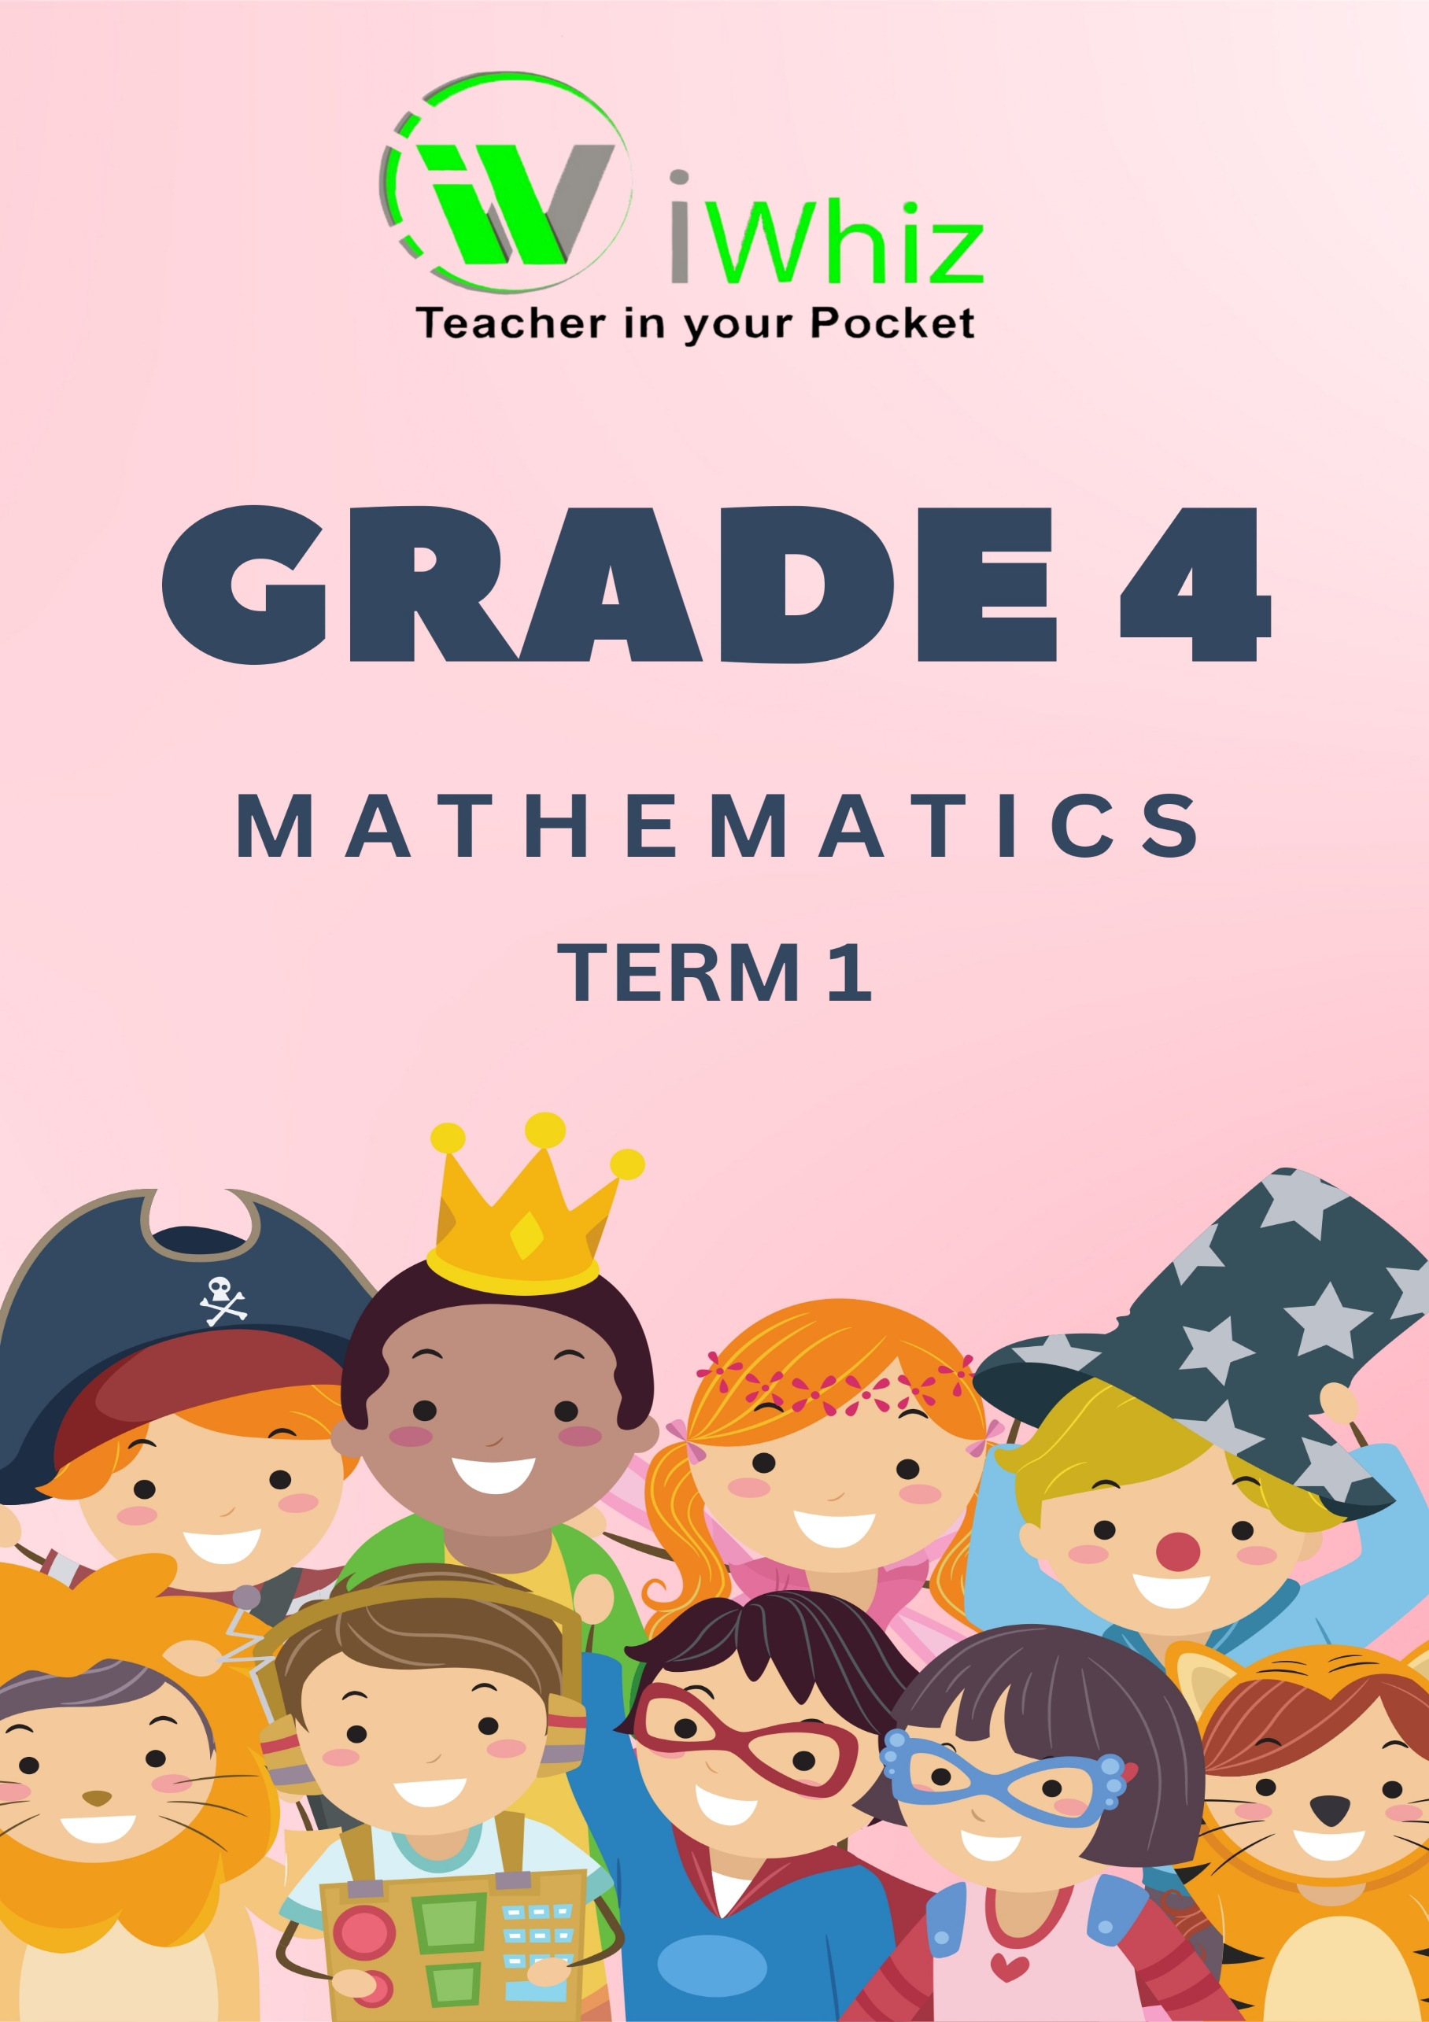


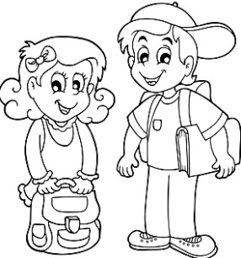
Grade 4 Mathematics Term 1 Test
Good Luck Friends
Total Marks: 100
Time: 1 hour 30 minutes

Section A: Number Patterns and Operations (30 marks)
Question 1: Solve the following: (5 marks)
a) 547 + 263 = ___________________
b) 894 - 367 = ___________________
c) 45 × 6 = _____________________
d) 144 ÷ 12 = ____________________
e) 36 + 87 - 52 = ___________________________

Question 2: Write the following numbers in expanded form. (5 marks)
a) 503 __________________________________________________________________________________
b) 804 ___________________________________________________________________________________
c) 276 ____________________________________________________________________________________
d) 1,009 __________________________________________________________________________________
e) 502 ___________________________________________________________________________________

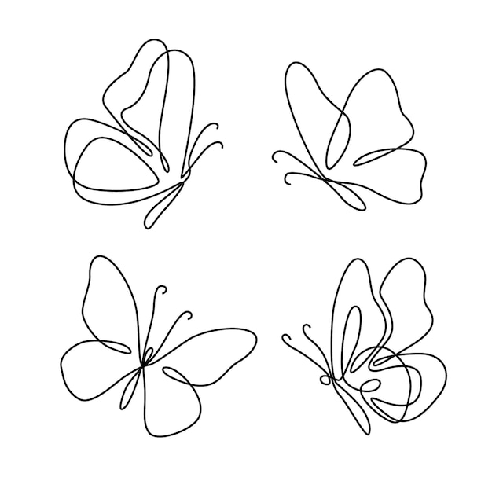
Question 3: Complete the number patterns. (Fill in the blanks) (10 marks)
a) 20, 40, __________, 80, __________, __________
b) 72, 66, 60, __________, __________
c) 5, 10, 15, __________, 25
d) 100, 90, 80, __________, 60, __________
e) 120, 140, 160, __________, __________
Question 4: Multiply and divide the following: (10 marks)
a) 48 × 9 = ___________________________
b) 36 ÷ 4 = ___________________________
c) 56 ÷ 7 = ___________________________
d) 132 × 2 = ___________________________
e) 84 ÷ 12 = ___________________________
Section B: Fractions and Decimals (20 marks)
Question 5: Colour the following fractions. (5 marks)
a) Shade $\frac{3}{4}$ of a shape.

b) Shade $\frac{1}{2}$ of a rectangle.

c) Colour $\frac{2}{5}$ of a shape.

d) Colour $\frac{4}{6}$ of a square.

e) Shade $\frac{1}{3}$ of a circle.

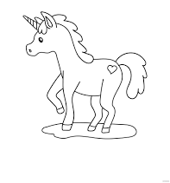

Question 6: Simplify the following fractions. (5 marks)
a) $\frac{4}{8}$ ___________________
b) $\frac{6}{12}$ ___________________
c) $\frac{5}{10}$ ___________________
d) $\frac{10}{15}$ ___________________
e) $\frac{8}{16}$ ___________________
Question 7: Convert the following fractions to decimals. (5 marks)
a) $\frac{1}{2}$ ___________________
b) $\frac{3}{4}$ ___________________
c) $\frac{1}{5}$ ___________________
d) $\frac{2}{3}$ ___________________
e) $\frac{5}{10}$ ___________________
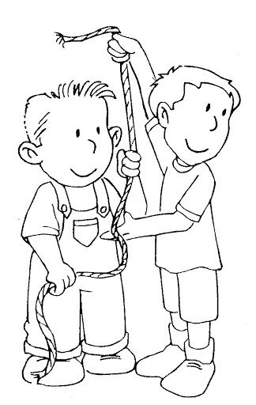
Question 8: Answer the following: (5 marks)
a) Which fraction is bigger: $\frac{2}{3}$ or $\frac{4}{5}$? ___________________
b) Which fraction is smaller: $\frac{3}{6}$ or $\frac{4}{8}$? ___________________
c) Write the decimal form of $\frac{3}{4}$ ___________________
d) Add $\frac{1}{4}$ + $\frac{2}{4}$ = ? ___________________
e) Subtract $\frac{5}{6}$ - $\frac{2}{6}$ = ? ___________________
Section C: Measurement and Time (25 marks)
Question 9: Convert the following: (5 marks)
a) 3 kilograms = _______ grams
b) 4 meters = _______ centimetres
c) 1500 millilitres = _______ litres
d) 5 litres = _______ millilitres
e) 8 hours = _______ minutes
Question 10: Answer the following questions: (10 marks)
a) What is the time on the clock shown below?
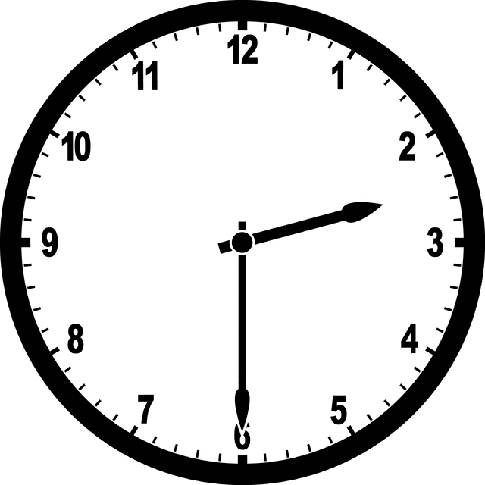 Answer:____________________________________________________________
b) If a train leaves at 10:45 AM and arrives at 12:30 PM, how long is the journey?
c) How many minutes are in 3 hours?
d) A movie starts at 3:15 PM and ends at 5:00 PM. How long is the movie?
e) How many days are there in 3 weeks?

Question 11: Measure the following: (10 marks)
a) Use your ruler and draw a line of 10 cm length.
b) Measure the length of a pencil (in centimetres)
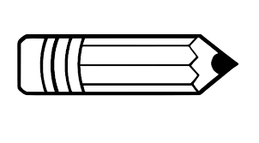
.Answer: ________________________________
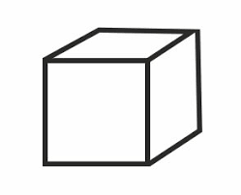
c) If a box is 20 cm wide and 30 cm long, what is the perimeter of the box? ___________________
d) If a rope is 5 metres long, how many centimetres is it?
e) How many millilitres are in a bottle that can hold 1 litre?

Section D: Geometry (15 marks)
Question 12: Name the following shapes (5 marks)
a) A shape with four equal sides and four right angles.

b) A shape with three sides and three angles.
c) A shape with no straight sides and is round.
d) A shape with four sides, but not all equal.

e) A shape with six equal sides.

Question 13: Match the following: (5 marks)
1. Circle |  | a. 3 sides
2. Square |  | b. 4 equal sides
3. Triangle |  | c. Round shape
4. Rectangle |  | d. 4 sides, opposite sides equal
5. Hexagon |  | e. 6 sides

Question 14: Calculate the perimeter and area of the following shapes (5 marks)
a) Rectangle with length 8 cm and width 5 cm.

b) Square with side 4 cm.

c) Triangle with base 6 cm and height 3 cm.

d) Circle with radius 7 cm.

e) Rectangle with length 12 cm and width 3 cm.

Section E: Word Problems (10 marks)
Question 15: Solve the following word problems: (10 marks)
a) A farmer has 245 apples. He gives away 73 apples. How many apples does he have left?
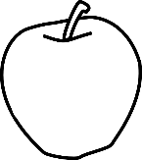

b) Sarah bought 3 packs of markers. Each pack has 12 markers. How many markers did Sarah buy in total?

c) A bus travels 120 kilometres every day. How far does the bus travel in 7 days?


d) A book costs 48 cents. How much would 6 books cost?
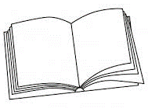

e) A baker has 60 cookies. He puts them into boxes with 10 cookies in each box. How many boxes does he have?


Total: 100 marks

