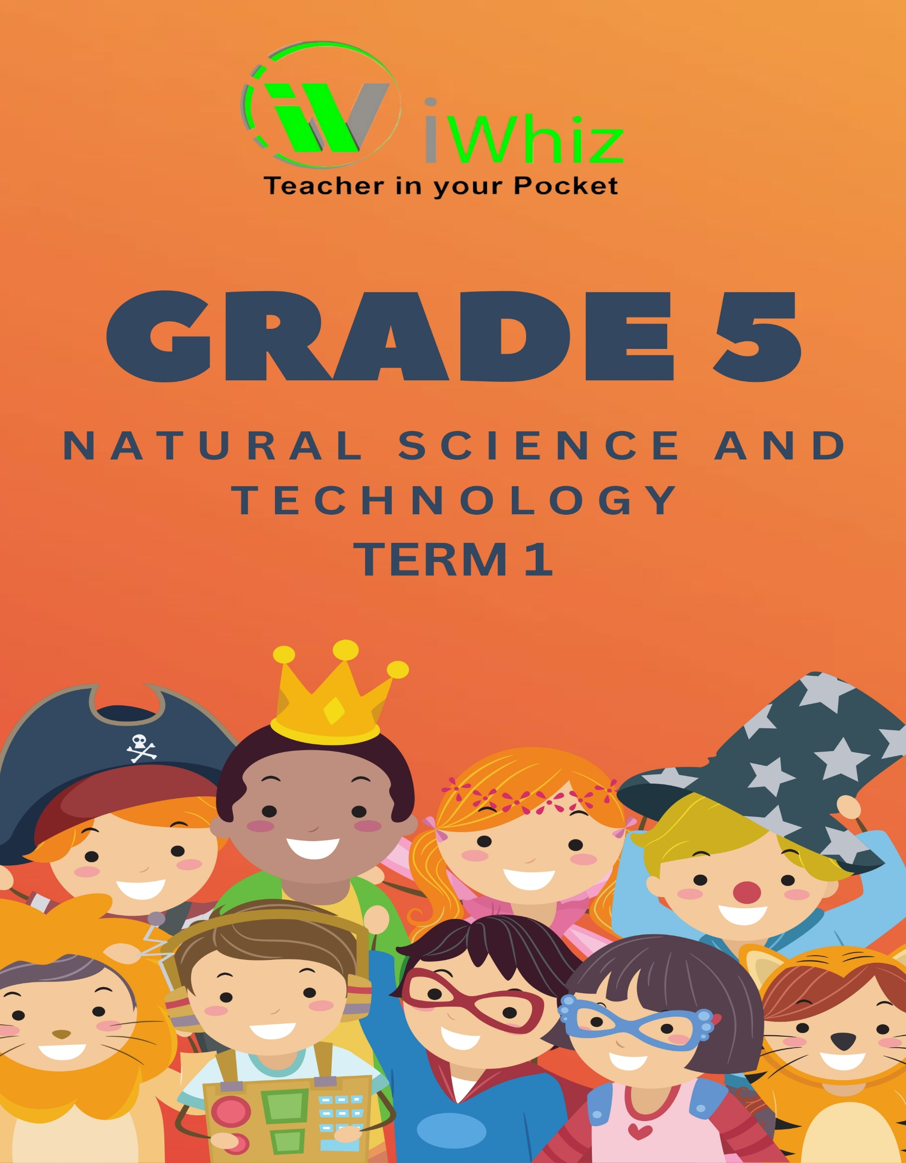
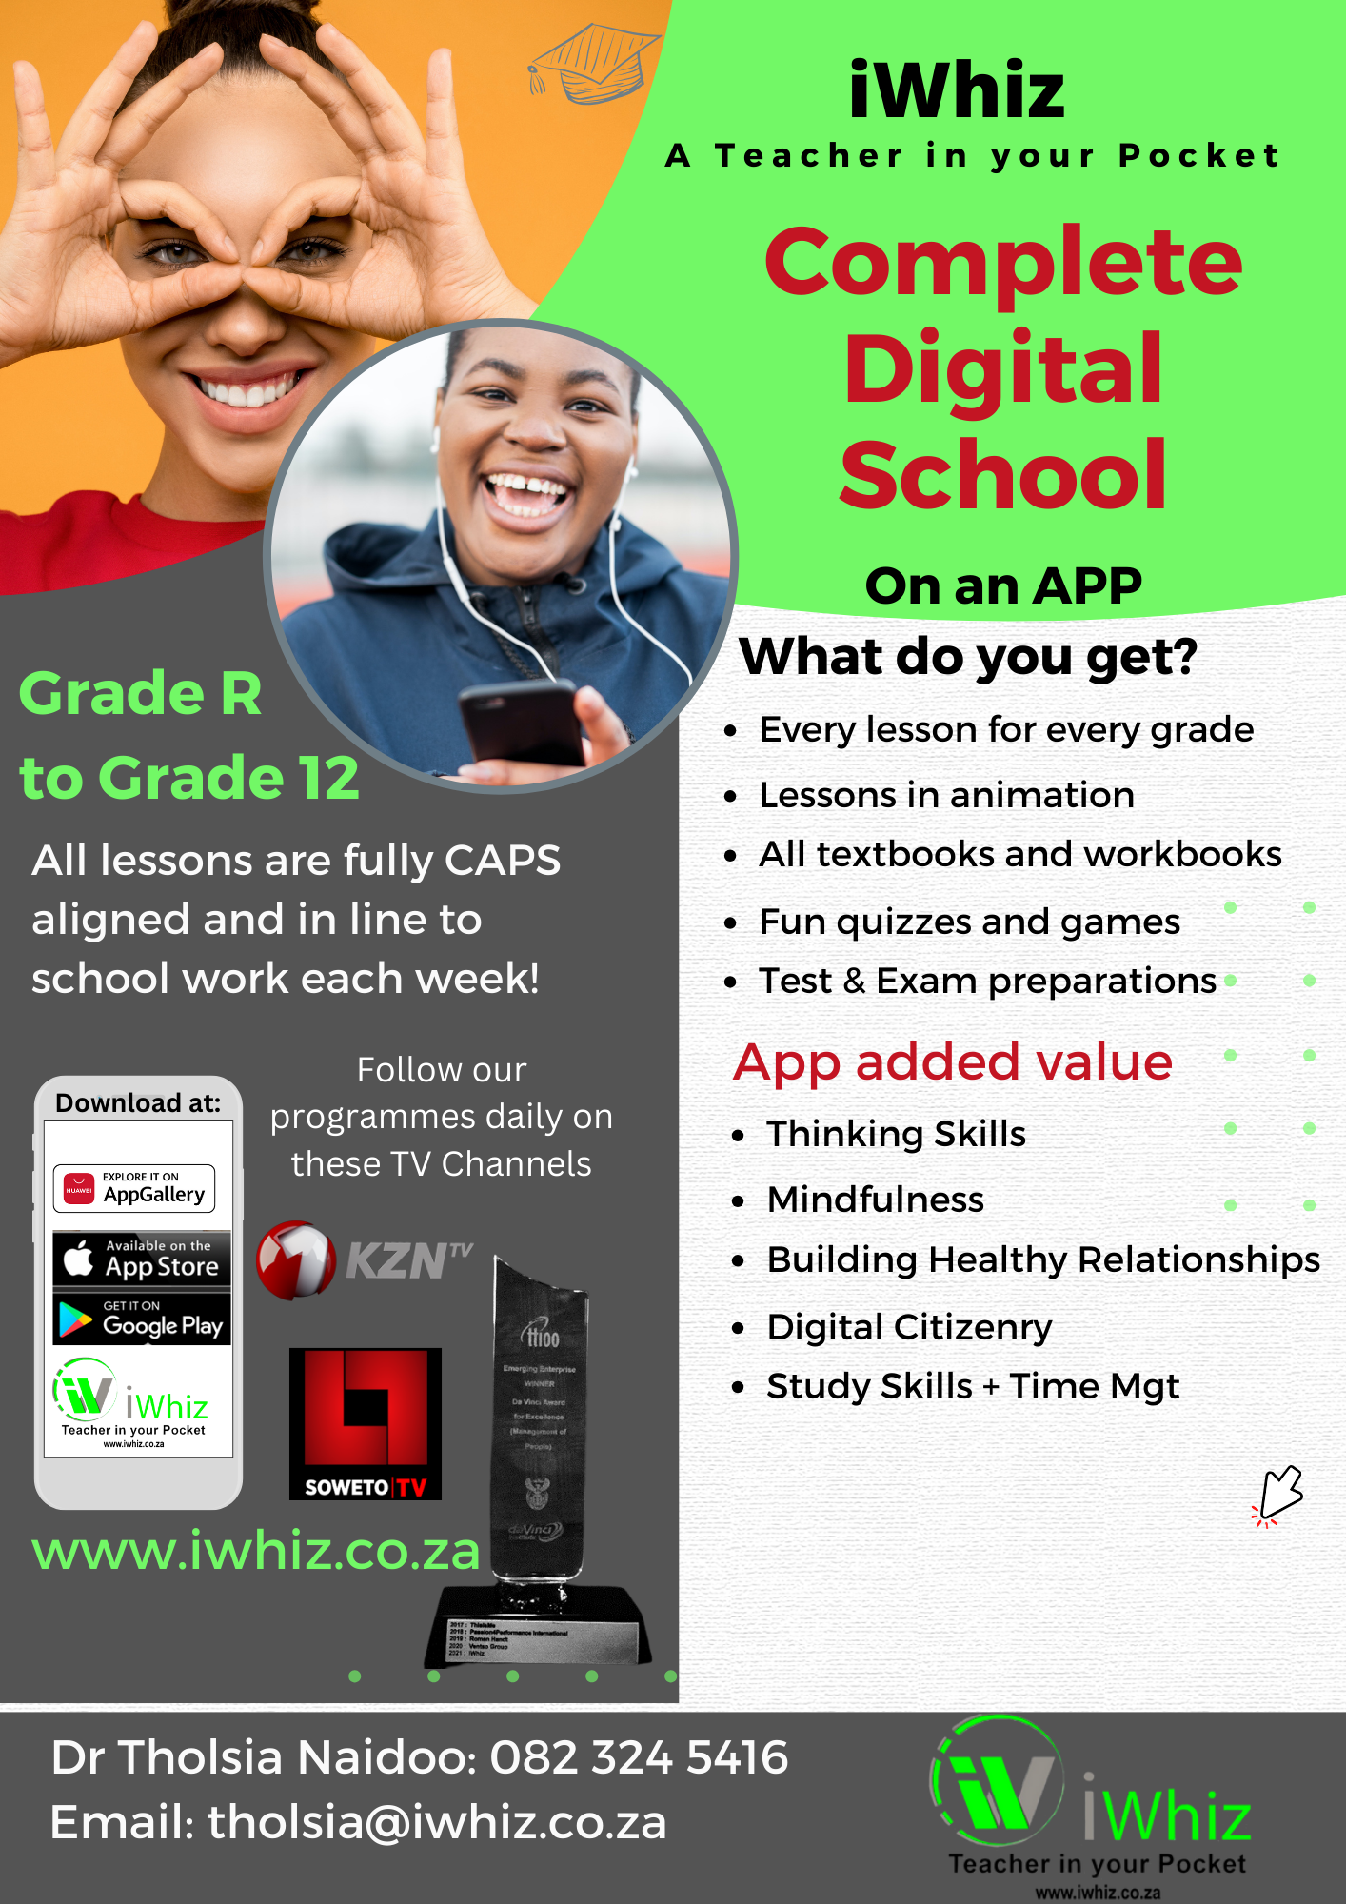

https://www.youtube.com/watch?v=SJ4_nONtYeY
WATCH FOR TESTIMONIALS

WATCH FOR TESTIMONIALS

Test Instructions:
- Read all questions carefully before attempting to answer them.
- Answer all questions in the spaces provided.
- Multiple Choice Questions: Select one correct answer and circle the letter corresponding to your choice. For example, a) or b).
- Matching Questions: Match the items from Column A with the correct answers in Column B by writing the letter next to each number in Column A.
- Short Answer Questions: Write your answers clearly and concisely in the spaces provided. For each question, ensure your response is relevant and correct.
- Ensure neat handwriting to avoid misinterpretation of your answers.
- Do not leave any questions unanswered. If you do not know the answer, make your best guess.
- Marks are allocated as indicated next to each question. Make sure to manage your time efficiently.
- Use a pencil for any sketches or diagrams where applicable.
- Check your work before submitting the test to ensure all questions have been answered and all instructions followed.

Question 1: Multiple choice
Select one correct answer and make a circle around the correct letter.
  - Which one of the following is NOT a property of metal? (1)
- They are strong
- They are shiny
- They break easy
- They are ductile

  - Which metal is NOT magnetic? (1)
- Brass
- Nickel
- Steel
- Iron

1.3 A radio changes electrical energy into____________energy. (1)
- Light
- Heat
- Movement
- Sound

  - South Africa’s main power stations use_____________. (1)
- Water
- Wind
- Sun
- Coal

  - The energy input for an electrical lightbulb is___________ (1)
- Light
- Heat
- Electricity
- Stored

  - When there is a fire in the house you must__________. (1)
- Play with matches
- Use fuel to put out the fire
- Get out of the house
- Open a window

  - One of the disadvantages of iron is that it__________ (1)
- Rusts
- It’s shiny
- It’s a soft metal
- It’s a polymer

  - A fish’s habitat is_____________ (1)
- Savana
- Water
- Desert
- In the mountains

  - A generator_________. (1)
- Creates heat energy
- Creates light energy
- Creates electrical energy
- Creates sound energy

  - Which one of the following is NOT part of a torch’s electrical circuit? (1)
- Plastic wires
- Light bulb
- Switch
- Batteries

  - Which of the following is a renewable energy source? (1)
- Coal
- Oil
- Solar energy
- Natural gas

  - What is the main function of the roots of a plant? (1)
- To produce flowers
- To absorb water and nutrients
- To make food for the plant
- To support the plant above the ground

  - Which of these materials is best for making a waterproof raincoat? (1)
- Cotton
- Wool
- Polyester
- Rubber

  - What is the process by which plants make their own food using sunlight? (1)
- Respiration
- Germination
- Photosynthesis
- Transpiration

1.5 Which of the following is NOT a habitat for living organisms? (1)
- Desert
- Forest
- Moiuntain
- Plastic bottle

Question 2: Matching
Match each item in Column A with its corresponding item in Column B. Write the letter of the correct match from Column B next to each number in Column A. Max marks: 10
Column A | ANSWERS | Column B
1. Feeding relationship between plants and animals. |  | A. Climate
2. Found naturally in a particular area. |  | B. Herbivores
3. Place of living for plants & animals. |  | C. Food chain
4. Plants eaters |  | D. Omnivore
5. Weather conditions of an area. |  | E. Biodiversity
6. The process where plants make their own food |  | F. Oxygen
7. The gas that humans breathe in |  | G. Carnivore
8. The change of water from liquid to gas |  | H. Photosynthesis
9. An animal that primarily eats meat |  | I. Indigenous
10. An animal that hunts and eats other animals |  | J. Evaporation

Question 3: Short Questions
Answer all the short questions in the spaces provided. Write your answers clearly and concisely.

Choose the correct answer from the given Max Marks: 25
Heart and lungs | Endoskeleton | Skull | exoskeleton | Omnivores | Carnivores

- Type of skeleton in a human being is an (2)

- Rib cage protects (2)

- Brain is protected by (2)

- Crab and insect has (2)

- Animals which feed on both meat and grass are called (2)

- Skeletons are used to: (3)

- Three types of skeletons: (3)

Explain the following

- Energy (2)

- Habitat (2)

- Invertebrate animals (2)

- When living things excrete, they……. (2)

- Living things undergo ____________life process. (1)

Total marks: 50

