

GRADE 7
SOCIAL SCIENCES: HISTORY
TERM 1
DURATION : 1 HOUR
MARKS: 50
INSTRUCTIONS:

- Answer ALL the questions in the spaces provided on this question paper.
- Write neatly and legibly.
QUESTION 1

https://www.youtube.com/watch?v=SJ4_nONtYeY
WATCH FOR TESTIMONIALS

WATCH FOR TESTIMONIALS

GRADE 7 SOCIAL SCIENCE TEST – TERM 1
TOTAL: 80 MARKS
TIME: 1 HOUR 30 MINUTES

INSTRUCTIONS:
- Read all questions carefully.
- Answer all questions in the spaces provided.
- The paper consists of two sections: History (40 marks) and Geography (40 marks).
- Manage your time well:
  - Section A (History) – 45 minutes
  - Section B (Geography) – 45 minutes
- Multiple-choice questions (MCQs) are 1 mark each.
- Use clear and neat handwriting.

SECTION A: HISTORY (40 MARKS)
TOPIC: THE KINGDOM OF MALI AND THE CITY OF TIMBUKTU
Question 1: Multiple Choice (5 marks)

- Who was the famous ruler of the Mali Empire?
a) Shaka Zulu
b) Mansa Musa
c) Julius Caesar
d) Genghis Khan

- Timbuktu was famous for its:
a) Gold mines
b) Libraries and scholars
c) Military strength
d) Large population

- The Mali Empire became wealthy due to:
a) Trade in salt and gold
b) Farming cotton
c) Manufacturing weapons
d) Selling slaves

- What religion was widely practiced in Mali?
a) Hinduism
b) Islam
c) Christianity
d) Buddhism

- The great Mosque of Djinguereber was built in:
a) Cairo
b) Timbuktu
c) Johannesburg
d) Rome

Question 2: Short Answer Questions (10 marks)
Answer the following in full sentences.
- Name two important trade goods of Mali. (2)

- What role did scholars play in Timbuktu? (2)

- How did the geography of Mali help it become wealthy? (2)

- Why was Mansa Musa’s pilgrimage to Mecca significant? (2)

- What impact did Mali have on African history? (2)

Question 3: Source-Based Question (10 marks)
Study the following illustration of Mansa Musa’s wealth and trade routes, then answer the questions.
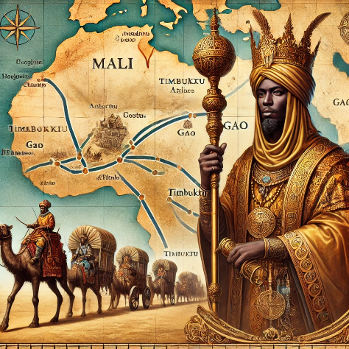
- What does the image suggest about Mansa Musa’s wealth? (2)

- Why were trade routes important for Mali? (2)

- How did Mali’s wealth influence other countries? (2)

- What are some of the goods seen in the picture? (2)

- What role did camels play in trade? (2)

Question 4: Paragraph Writing (15 marks)
Write a short paragraph (8-10 sentences) on "The Importance of Timbuktu in African History". Include information on its trade, scholars, and culture. (15)

SECTION B: GEOGRAPHY (40 MARKS)
TOPIC: MAP SKILLS AND LATITUDE & LONGITUDE
Question 5: Multiple Choice (5 marks)

- What is the name of the imaginary line that divides the Earth into Northern and Southern Hemispheres?
a) Tropic of Capricorn
b) Equator
c) Prime Meridian
d) Tropic of Cancer

- Lines of longitude run from:
a) East to West
b) North to South
c) Diagonally
d) In circles

- What does a map scale help with?
a) Measuring distances
b) Showing elevation
c) Telling time
d) Predicting weather

- What symbol represents mountains on a map?
a) A blue line
b) A triangle
c) A star
d) A square

- What is the purpose of a compass rose on a map?
a) To show direction
b) To measure distance
c) To display time zones
d) To count population

Question 6: Short Answer Questions (10 marks)
- Define latitude and longitude. (2)

- What is the function of a key/legend on a map? (2)

- What is the difference between a political map and a physical map? (2)

- Why is the Prime Meridian important? (2)

- What is the use of a globe in Geography? (2)

Question 7: Source-Based Question (10 marks)
Study the given world map with latitude and longitude lines and answer the questions.
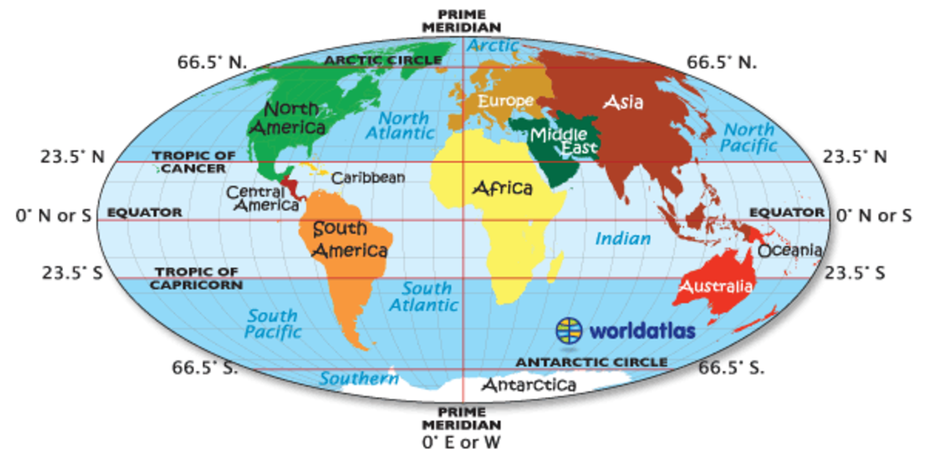
- Name the main line of latitude in the center of the map. (2)

- Identify the main line of longitude. (2)

- Which continents does the Equator pass through? (2)

- Which ocean is found at 0° longitude and 0° latitude? (2)
- Why do we use coordinates in mapping? (3)

Question 8: Practical Map Work (15 marks)
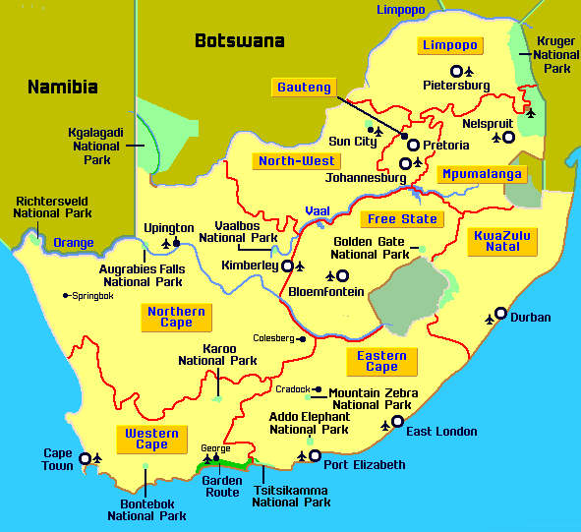
- Identify three major cities on the map. (6)

- What is the capital city of South Africa? (2)

- Name two provinces located along the coastline. (4)
- In which direction is Johannesburg from Cape Town? (2)

