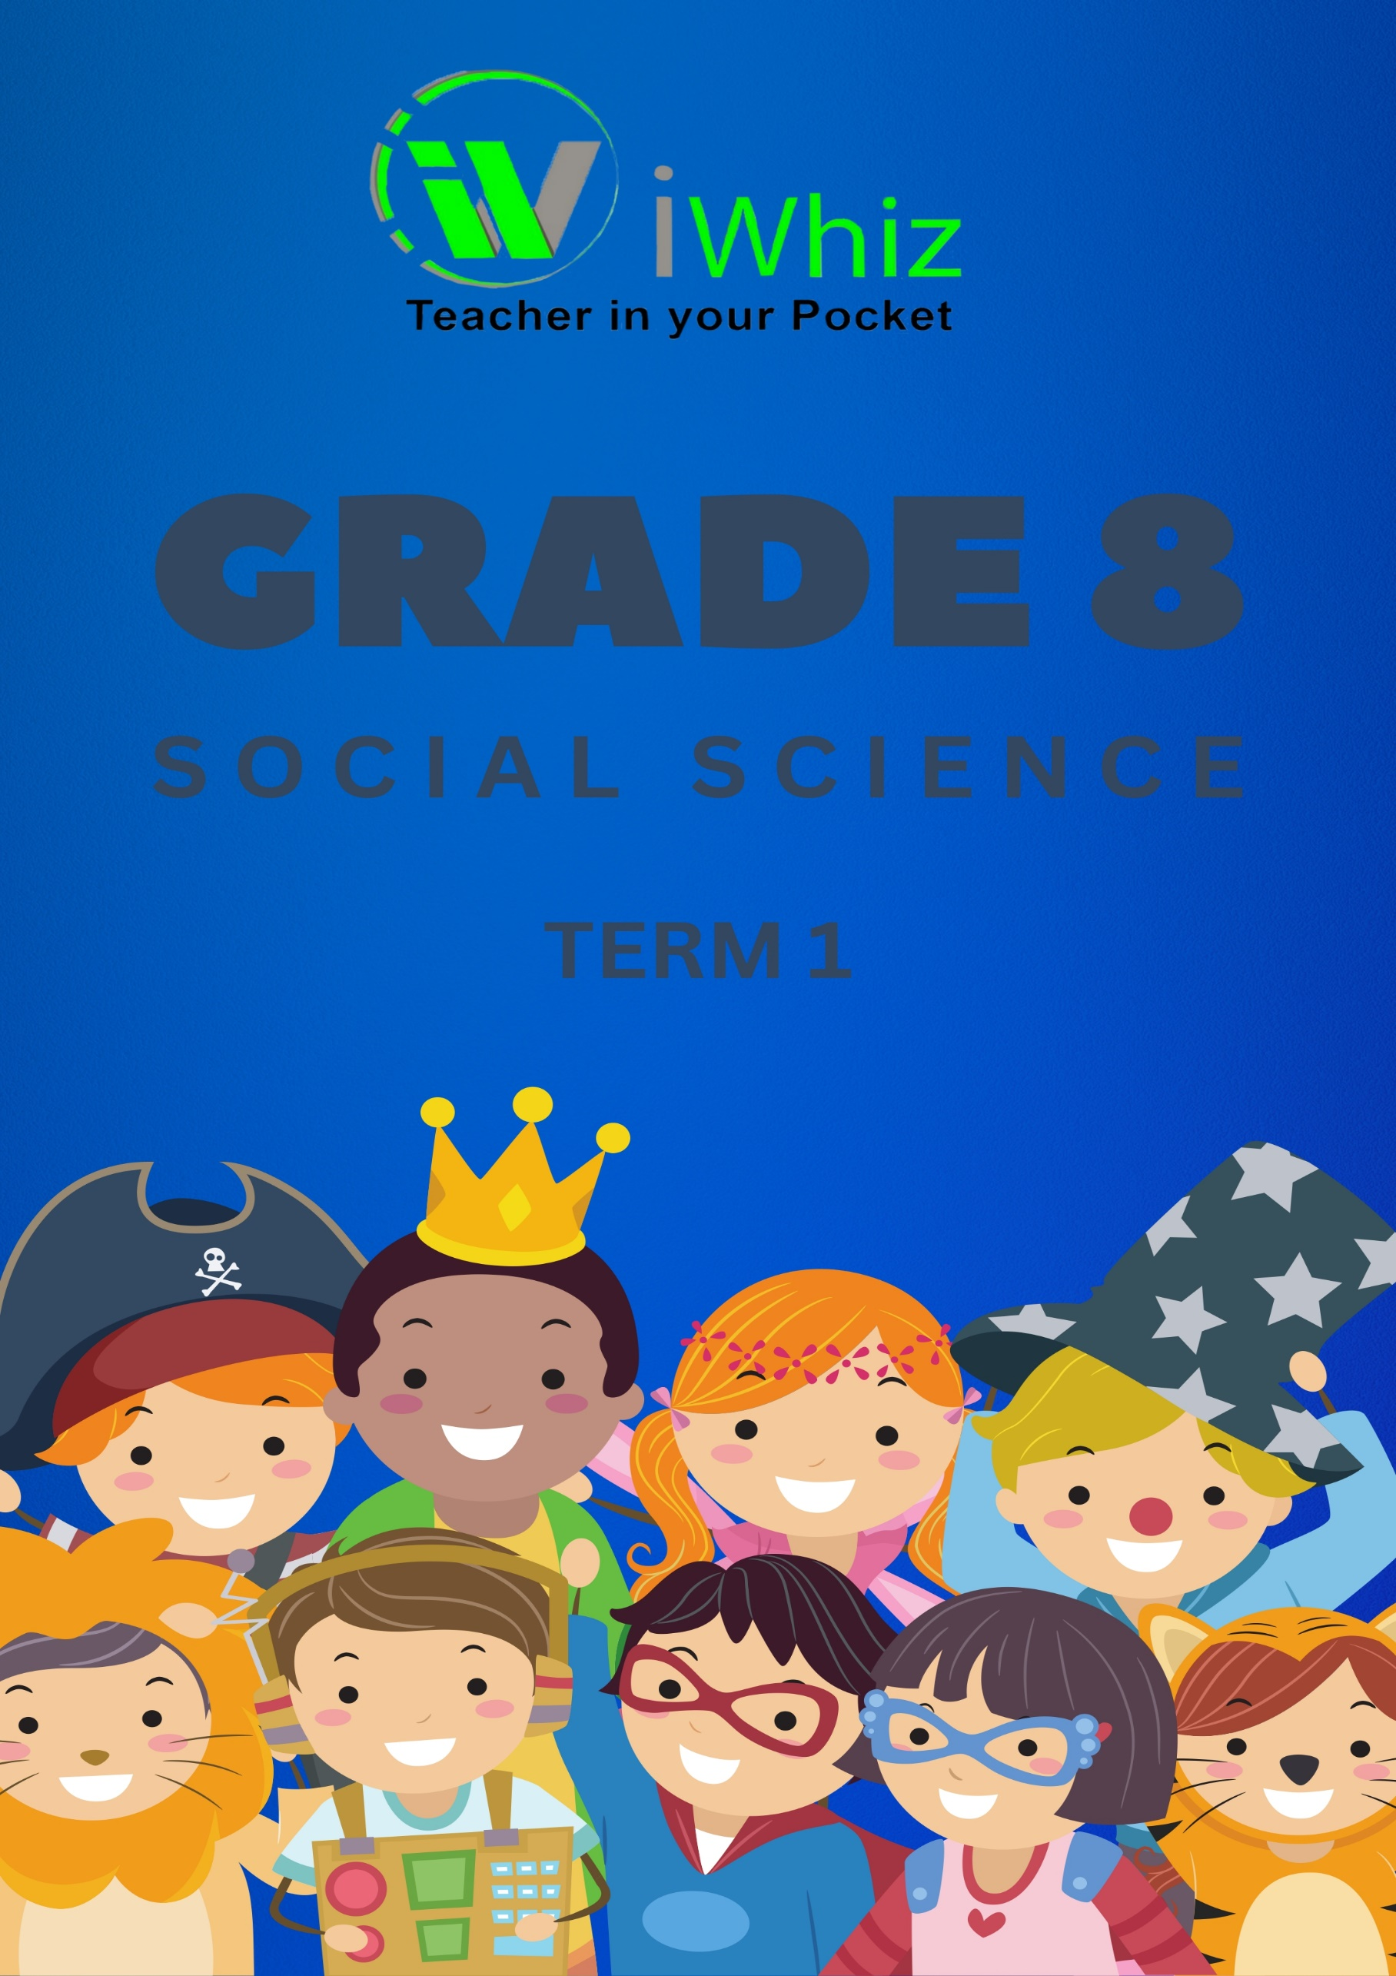



https://www.youtube.com/watch?v=SJ4_nONtYeY
WATCH FOR TESTIMONIALS

WATCH FOR TESTIMONIALS

Grade 8 Social Science Test: Term 1
Duration: 1 hour 30 minutes
Total Marks: 80
Instructions:
- Answer all questions.
- Write neatly and legibly.
- Use a pencil for drawings or illustrations, and a pen for writing your answers.
- Read each question carefully before answering.
- The use of a calculator is not allowed.
- Write your answers in the spaces provided.
- Make sure to finish all sections within the time frame provided.

SECTION A: HISTORY (40 marks)
Question 1: Multiple Choice Questions (10 marks)
- The term "Apartheid" refers to:
a) A political party in South Africa
b) A policy of racial segregation
c) A system of democracy
d) A type of government in Europe
- Who was the first black president of South Africa?
a) Nelson Mandela
b) Thabo Mbeki
c) Jacob Zuma
d) FW de Klerk
- The Battle of Isandlwana (1879) was fought between:
a) The Zulu and British forces
b) The Boers and British forces
c) The Zulu and Dutch forces
d) The Xhosa and Zulu forces
- Which of the following was a key reason for the British colonization of South Africa?
a) Economic interests and resources
b) Religious conflict
c) Exploration
d) Agricultural needs
- The main aim of the Voortrekkers was:
a) To spread Christianity
b) To establish an independent republic
c) To negotiate with the British government
d) To fight the Zulu Kingdom
- The Bantu Education Act was passed in which year?
a) 1948
b) 1953
c) 1961
d) 1966
- The African National Congress (ANC) was founded in:
a) 1912
b) 1948
c) 1955
d) 1976
- The Great Trek refers to:
a) The movement of black Africans to the cities
b) The migration of Afrikaners to the interior of South Africa
c) The mass migration of slaves to South Africa
d) The resistance to British rule by Africans
- Who was the leader of the ANC at the time of the Sharpeville Massacre in 1960?
a) Oliver Tambo
b) Nelson Mandela
c) Walter Sisulu
d) Albertina Sisulu
- The term "Homelands" refers to:
a) Areas where white people lived in South Africa
b) Areas designated for black South Africans under Apartheid
c) Townships for black South Africans
d) Areas of the country where European settlers lived

Question 2: Short Answer Questions (10 marks)
(2 marks each)
- Describe the significance of the Sharpeville Massacre in the anti-apartheid movement.

- What were the main causes of the Anglo-Zulu War?

- Explain the impact of the Bantu Education Act on South African society.

- What role did women play in the struggle against apartheid?

- How did the discovery of gold and diamonds influence the development of South Africa?

Question 3: Essay Question (10 marks)
(10 marks)
Discuss the main causes and consequences of the Anglo-Boer War (1899-1902). Include the impact on both the British and Boer populations and the role of African people during the war.

SECTION B: GEOGRAPHY (40 marks)
Question 4: Multiple Choice Questions (10 marks)
- The largest river in Africa is:
a) Niger River
b) Congo River
c) Zambezi River
d) Nile River
- The country that is located on the Horn of Africa is:
a) Egypt
b) Somalia
c) Kenya
d) Nigeria
- The term "climate" refers to:
a) Weather conditions over a short period of time
b) Long-term weather patterns
c) Daily temperature changes
d) Ocean currents
- The Kalahari Desert is located in:
a) Northern Africa
b) Southern Africa
c) Western Africa
d) Central Africa
- Which of the following is a tropical rainforest?
a) Sahara Desert
b) Congo Basin
c) Kalahari Desert
d) Nile River Valley
- The Cape of Good Hope is located in which country?
a) Namibia
b) South Africa
c) Mozambique
d) Kenya
- Which African country has the largest population?
a) South Africa
b) Nigeria
c) Egypt
d) Ethiopia
- The Great Rift Valley is located in:
a) Western Africa
b) Eastern Africa
c) Central Africa
d) Southern Africa
- Which of the following is the primary reason for deforestation in Africa?
a) Industrialization
b) Agriculture
c) Mining
d) Urbanization
- The Sahara Desert is located in which region of Africa?
a) North Africa
b) East Africa
c) West Africa
d) Central Africa

Question 5: Map Skills (10 marks)
Study the map below and answer the questions that follow.
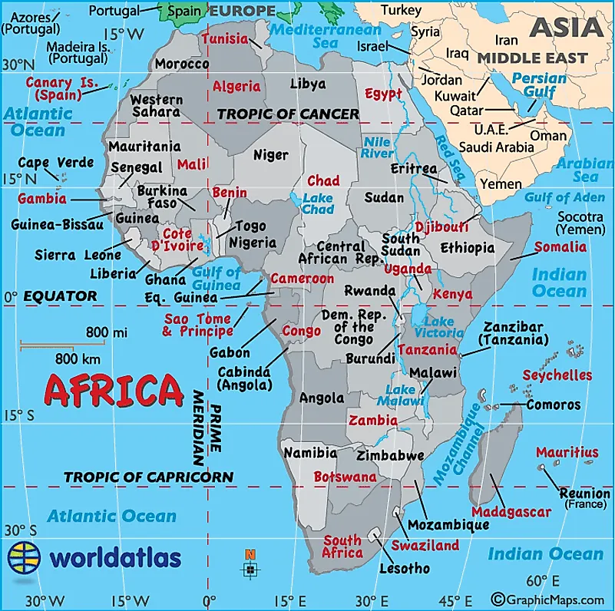
- Name the country located to the north of South Africa. (1 mark)

- Identify the country that is located in the Horn of Africa. (1 mark)

- Which desert is located in the northern part of Africa? (1 mark)

- What is the capital city of Egypt? (1 mark)

- Name three rivers that flow into the Mediterranean Sea. (3 marks)

- Identify the lake located near the equator in the eastern part of Africa. (1 mark)

- Which ocean lies to the east of Africa? (1 mark)

Question 6: Short Answer Questions (10 marks)
(2 marks each)
- Define the term "ecosystem" and explain its importance to the environment.

- What are the major causes of desertification in Africa?

- Describe the impact of climate change on agriculture in Africa.

- How does the physical geography of Africa influence its economic activities?

- Explain how the population distribution in Africa is affected by physical geography.

