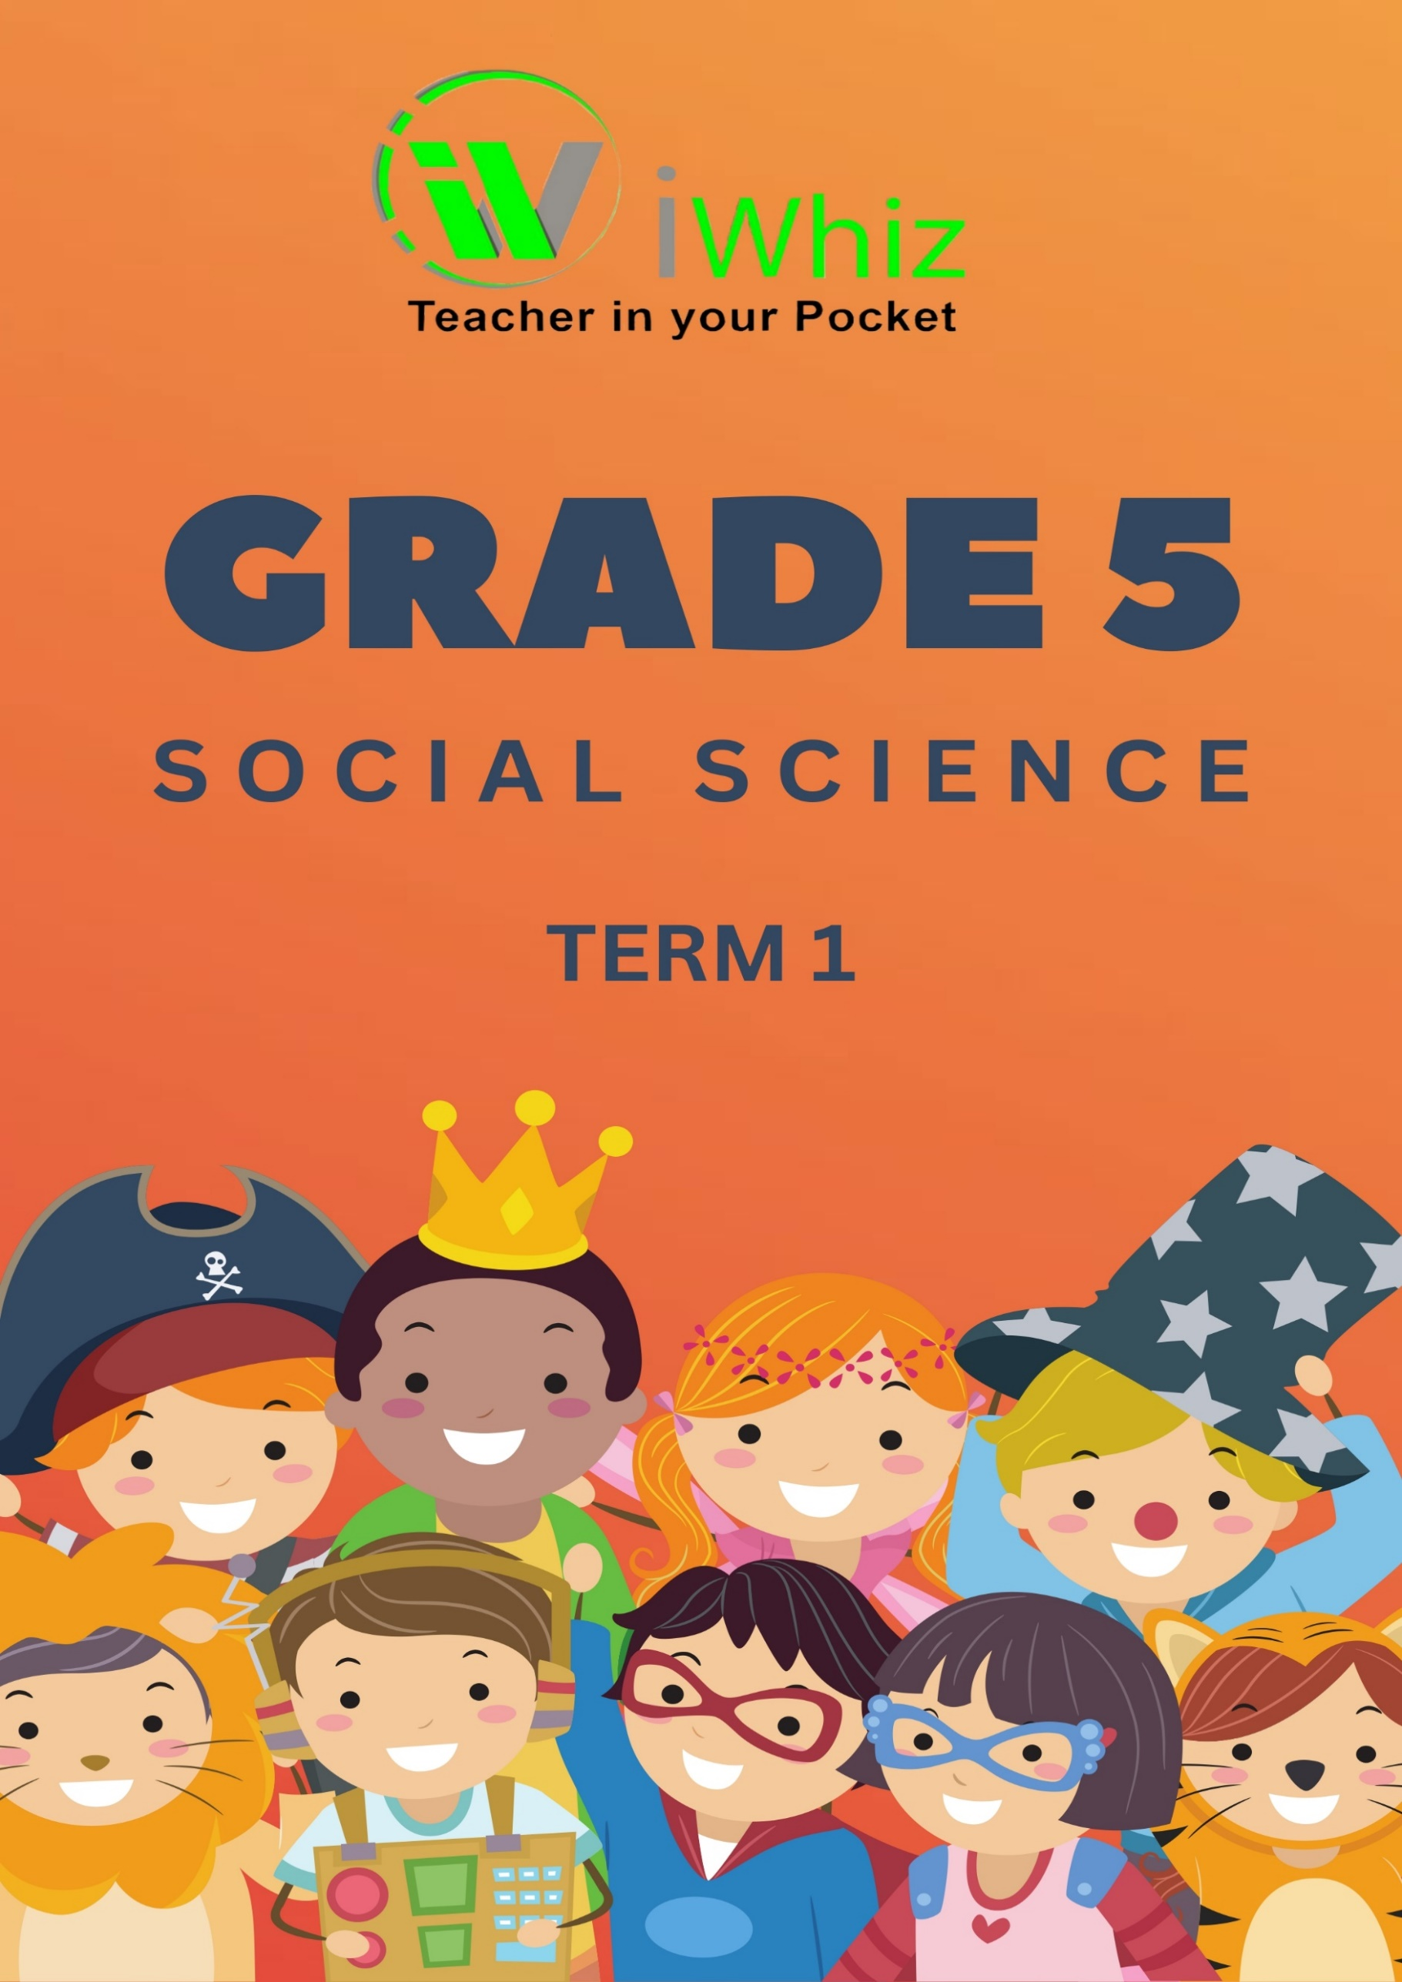


https://www.youtube.com/watch?v=SJ4_nONtYeY
WATCH FOR TESTIMONIALS

WATCH FOR TESTIMONIALS

Instructions
- Read each question carefully before selecting your answer.

- For multiple-choice questions (Question 1):
  - Circle only one correct answer per question.

- For the matching section (Question 2):
  - Match the correct answer from Column B to Column A by writing the correct letter next to each number.

- For the short-answer questions (Question 3):
  - Write your answers in full sentences where required.
  - Answer all parts of the question for full marks.

- Check your work before submitting it to ensure all questions are answered

- Total marks: 50
Question 1
Multiple choice. Circle the correct answer
- What is the largest statue in the world? (1)

  - The pyramids of Giza
  - The Temple of Luxor
  - The Sphinx
  - Zeus

- The Sphynx lost his nose in what year? (1)

  - 1378 CE
  - 2500 BCE
  - 1578 CE
  - 1238 CE

- What were the pyramids used for? (1)

  - to store food
  - to house prisoners

  - to keep all written records
  - the stone tombs
  - of the Pharaohs

- Who was allowed to go inside the temples? (1)

  - The Gods and he Pharaohs
  - Priests and Pharaohs
  - The people of Egypt
  - The Priests

- Some temples were built to line up with ____________________ that either rose or set at the harvest or sowing time. (1)
  - The sun
  - The moon
  - A star
  - A planet

- Which of the following is a primary source of history? (1)
- A textbook
- A photograph from the past
- A newspaper article
- A modern video

- What is the capital city of South Africa? (1)

- Pretoria
- Johannesburg
- Cape Town

- Durban

- Which of the following is a natural feature of the landscape? (1)

- A building
- A road
- A river
- A bridge

- In which year did Nelson Mandela become the President of South Africa? (1)

- 1990
- 1994
- 1999
- 2000

- Which of these is a traditional South African dish? (1)

- Sushi
- Bunny chow
- Pizza
- Burrito

- Which continent is directly north of South Africa? (1)
- Asia
- North America
- Africa
- Europe

- What does the word "heritage" refer to? (1)

- The future of a country
- Traditions, customs, and history passed down through generations
- A modern invention

- A new language spoken by people

- What is the main purpose of a map’s legend? (1)

- To show the main features of a map
- To explain the symbols used on the map
- To provide directions
- To tell the history of the area

- Which of the following is a physical feature on a map? (1)

- A school
- A river
- A shopping mall
- A traffic light

- What is the main reason early people in South Africa started farming? (1)

- To travel long distances
- To have a stable food supply
- To explore new lands
- To create big cities

Question 2: Matching
Match the items in Column A with the correct answers from Column B.
For each item in Column A, select the corresponding answer from Column B and write the letter next to the correct number. Max marks: 17
Column A | Column B | Answers
1. Precipitation | a. The natural movement of air of any velocity / speed.
2. Wind | b. Different forms in which water falls to the ground.
3. Temperature | c. Temperatures, wind and rainfall in an area on a particular day.
4. Weather | d. The average weather conditions for an area over a long period of time.
5. Annual rainfal | e. How hot or cold something is
6. Climate | f. The total amount of rain that falls in a place over one year.
7. Dr. Robert Broom | g. A famous black journalist and writer who spoke out against racial discrimination
8. Mapungubwe | h. Has a mix of cultures which is reflected in its names of the rivers, dams, and towns
9. Frances Baard | i. A symbol of leadership and power
10. The Free State | j. Was an anti-apartheid activist who fought to defend human rights
11. Golden rhinoceros | k. Was an anti-apartheid activist who fought to defend human rights
12. Sol Plaatje | l. Discovered Mrs. Ples
13. Subsistence  farming | m. Fruit grown on warm and wet areas.
14. Crop | n. Food that is prepared in factories and  packaged in boxes and plastic.
15. Subtropical fruit | o. Type of farming where one keeps animals.
16. Processed  foods | p. Farming to provide food for your family.
17. Stock farming | q. Plants farmers grow for their own use or for  sale.

Question 3
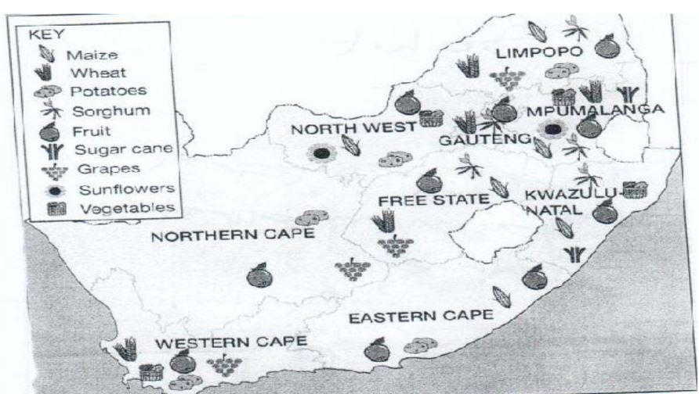
Study SOURCE A above and answer the questions that follow:

- Name THREE provinces that grow the most grapes. (3)

- Which province has a FEW crop farms? (1)

- In which TWO provinces are sugarcane grown? (2)

- Which TWO provinces produce sunflowers? (2)

Answer the following questions
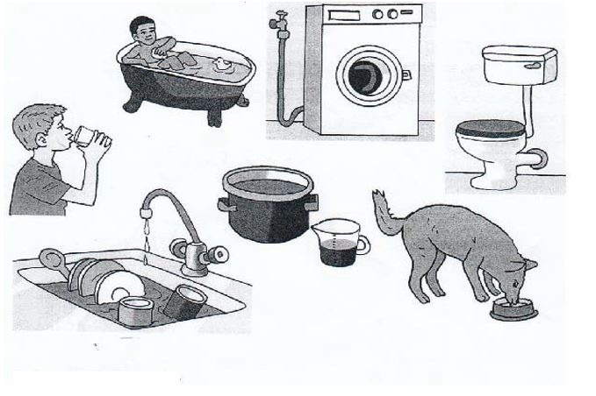

- Name any THREE ways in which water is used in this picture. (3)

- Explain why water is such an important resource. (2)

- Write a title (caption) for this picture. (1)

- Do you think the people who live in the house in the picture above live in
a rural or urban area? _______________________________ (1)

- Explain your answer in question 4. (3)

Total marks: 50

