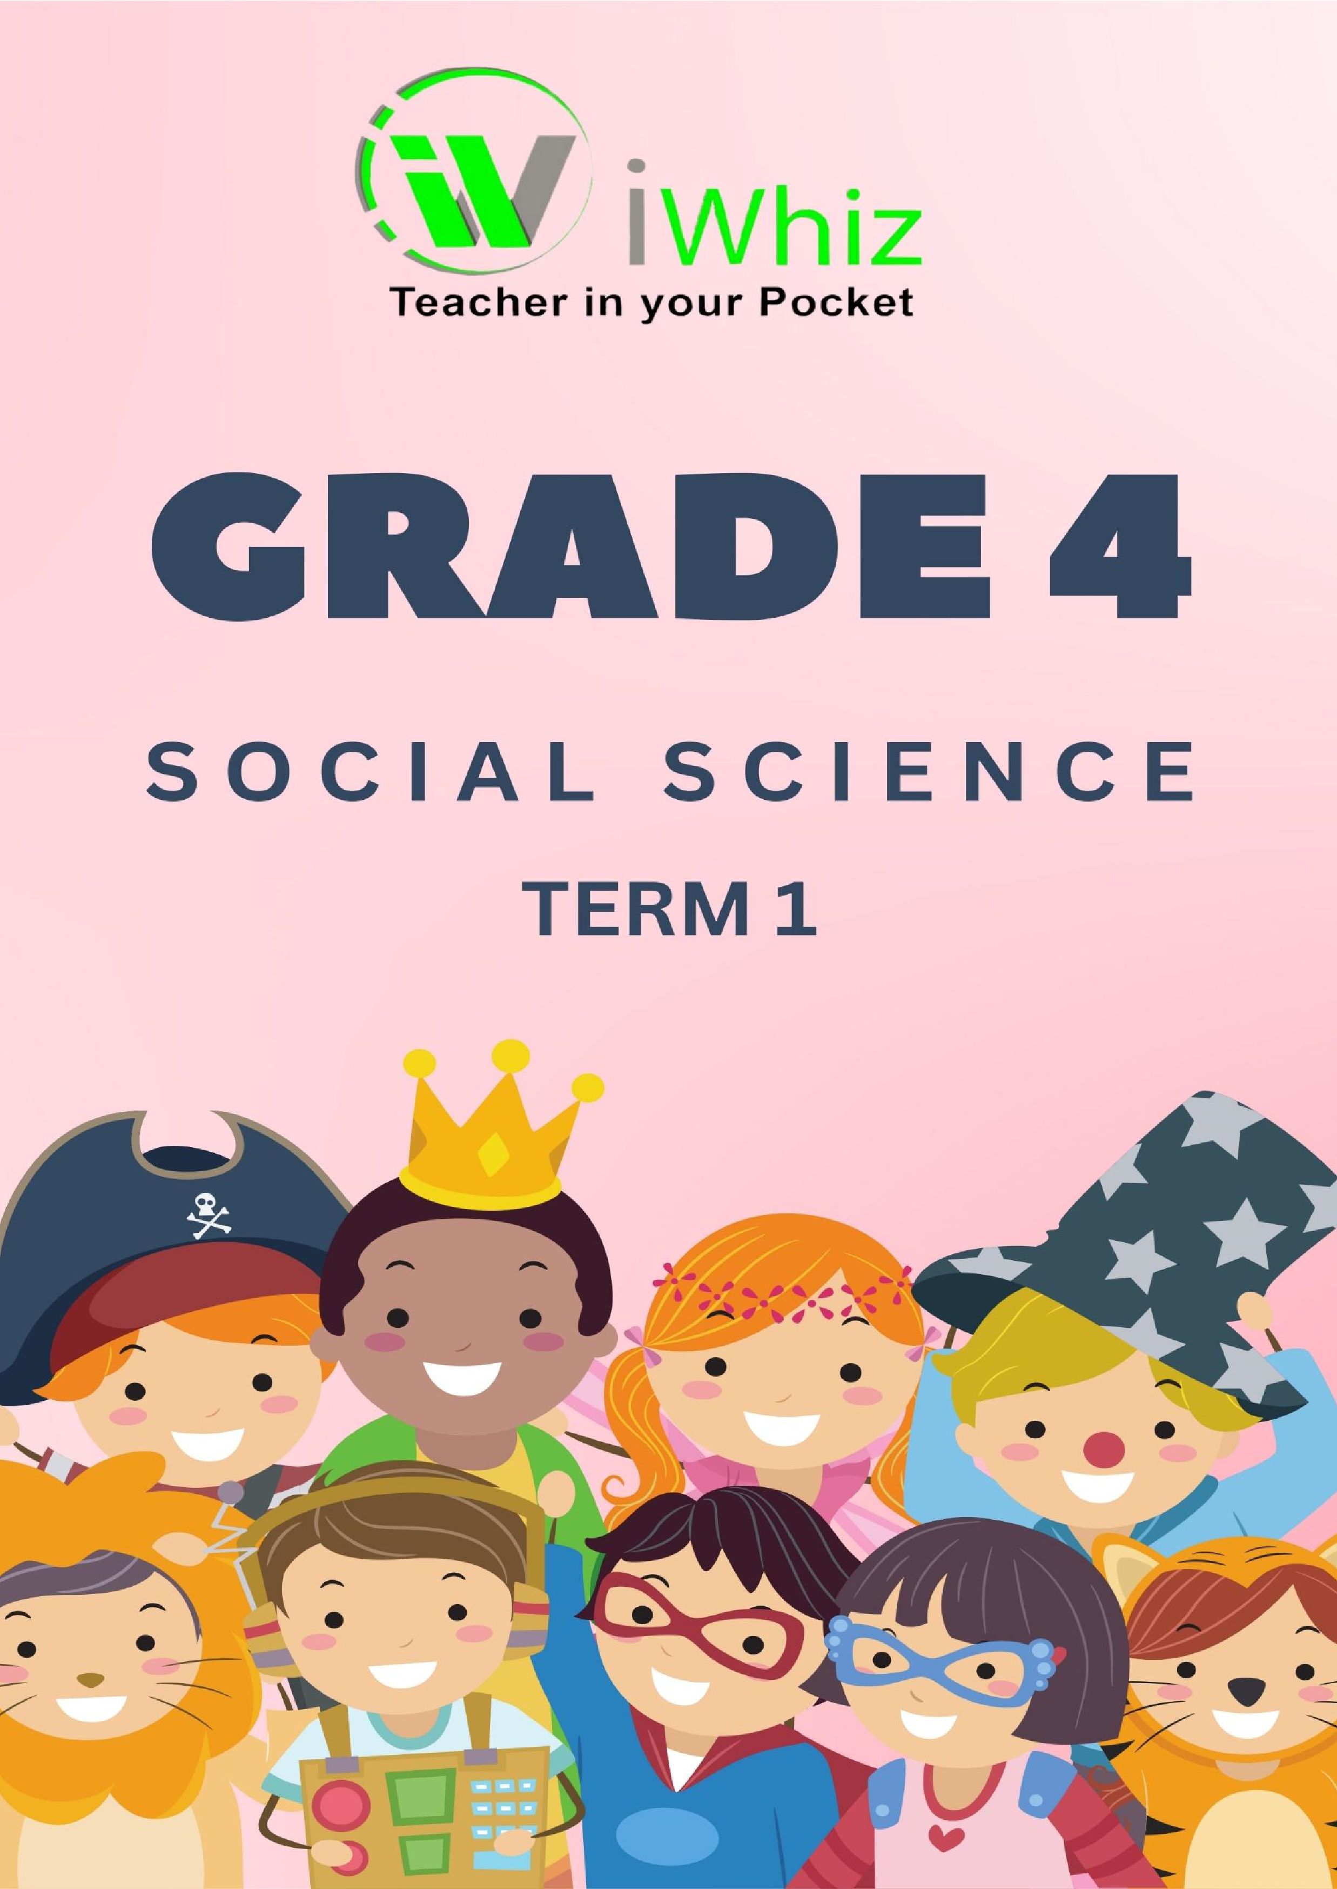


Grade 4 Geography (50 Marks)

Good Luck
Friends

Time: 1 hour
Instructions:
- Read all questions carefully.
- Answer in full sentences where needed.
- Check your spelling and punctuation.
Good luck!

Section 1: Multiple Choice Questions (MCQ) 15 Marks

Question 1: Places to Live
(Choose the correct answer by circling A, B, or C.)

- Which of the following is not a type of place where people live? (1)
- Village
- Train
- City

- What kind of place has many tall buildings, busy roads, and lots of people? (1)
- A farm
- A city
- A village
- Which of these places do farmers work? (1)
- School
- Farm
- Bank

- What is the main job of a teacher? (1)
- To build houses
- To take care of sick people
- To teach children
- Where do people buy food and clothes? (1)
- School
- Shop
- Garage
- What is a landmark? (1)
- A big tree, building, or place that helps people find their way
- A type of transport
- A small road
- What is an example of a natural landmark? (1)
- A tall mountain
- A school
- A train station
- If you tell someone to go straight, then turn left, what are you doing? (1)
- Giving directions
- Playing a game
- Buying something
- What is one thing all people need to survive? (1)
- Toys
- Water
- Cars
- Where do people go when they are sick? (1)
- School
- Shop
- Clinic
- What is a place of worship? (1)
- A place where people pray
- A place where cars are fixed
- A place where food is sold
- What do roads and footpaths help people do? (1)
- Watch TV
- Travel from one place to another
- Cook food
- What kind of building is used for keeping animals? (1)
- A barn
- A bank
- A factory
- What do people use energy for? (1)
- Sleeping
- Cooking, heating, and lighting
- Walking
- If someone lives in a small community with a few houses and a lot of open land, they live in: (1)
- Village
- City
- Train station

Section 2: Matching 10 Marks
(Match the words in Column A with their correct meaning in Column B.)

Column A |  | Column B
1. A place where people live |  | A. Water, food, shelter, healthcare
2. A landmark |  | B. A school
3. A place for sick people |  | C. A tall building, mountain, or river
4. A person who teaches students |  | D. A farm, village, town, or city
5. A road |  | E. A way to travel from one place to another
6. Something people need to live |  | F. A shop
7. A place where people learn |  | G. A teacher
8. A place where people buy things |  | H. A footpath or car road
9. A place where animals are kept |  | I. A barn
10. A place where people pray |  | J. A place of worship

Section 3: Short Answer Questions 25 Marks
- One-mark questions (1 mark each = 10 marks)

1. Name one type of place where people live. (1)

2. What is the job of a doctor? (1)

3. Where do children go to learn? (1)

4. What is one thing all people need? (1)

5. What should you look for when finding your way in a new place? (1)

6. Name one type of road. (1)

7. What kind of building sells food and clothes? (1)

8. What direction would you give if someone needs to turn the opposite way from left? (1)

9. Where do people get money and save money? (1)

10. What do we use energy for in our homes? (1)

B. Two-mark questions (15 marks)
- Describe the difference between a city and a village. (2)

- Why are landmarks important? (2)

- Write directions you could give someone to help them find their way to school from a defined
point. Draw the map showing the direction. | (2) + (1)
4. List two types of jobs that people do in a town. | (2)

5. Why do people need water? (2)

6. Name two human-made landmarks you might find in a city. | (2)

7. Why do people need shelter? (2)

